String s1 = "HELLO";

String s2 = "HELLO";

String s3 = new String("HELLO");

System.out.println(s1 == s2);

System.out.println(s1 == s3);

System.out.println(s1.equals(s2));

System.out.println(s1.equals(s3));

<https://www.programiz.com/java-programming/online-compiler/>

Java 8 : <https://quescol.com/interview-preparation/java-8-coding-interview-question>

<https://www.digitalocean.com/community/tutorials/java-programming-interview-questions>

https://blog.devgenius.io/java-8-coding-and-programming-interview-questions-and-answers-62512c44f062

# JDK | JRE | JVM

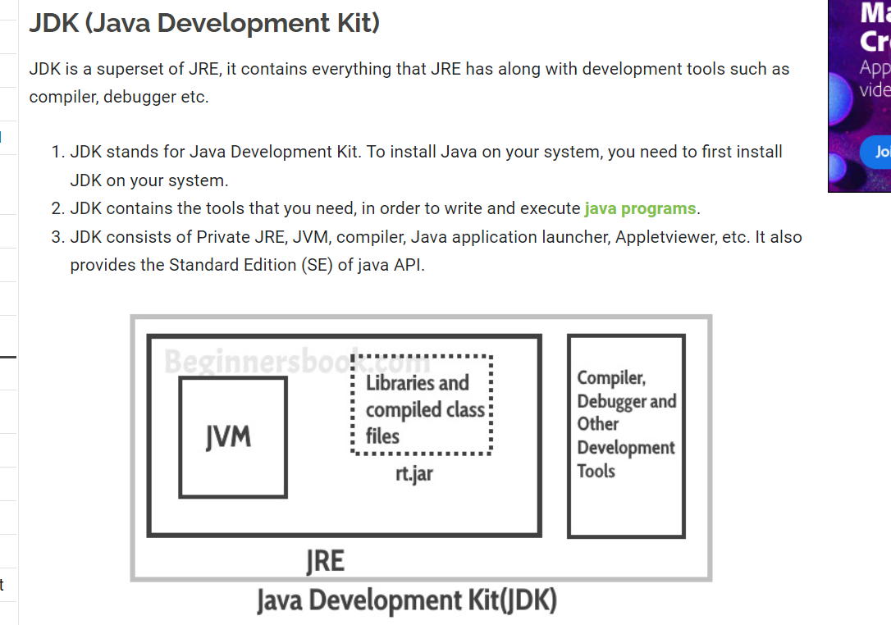

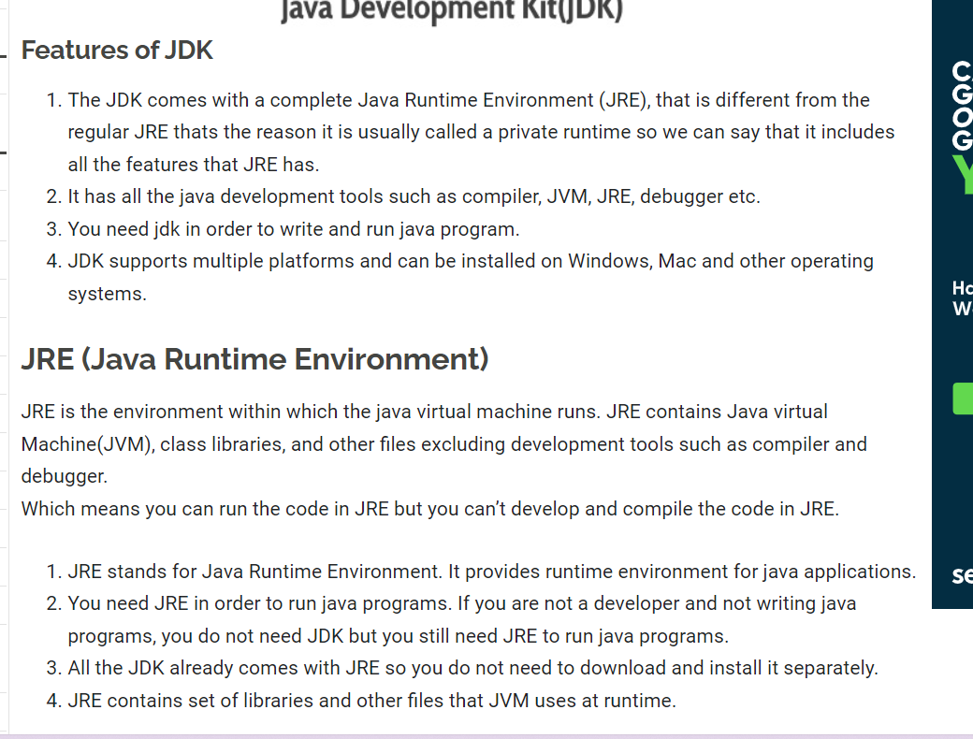

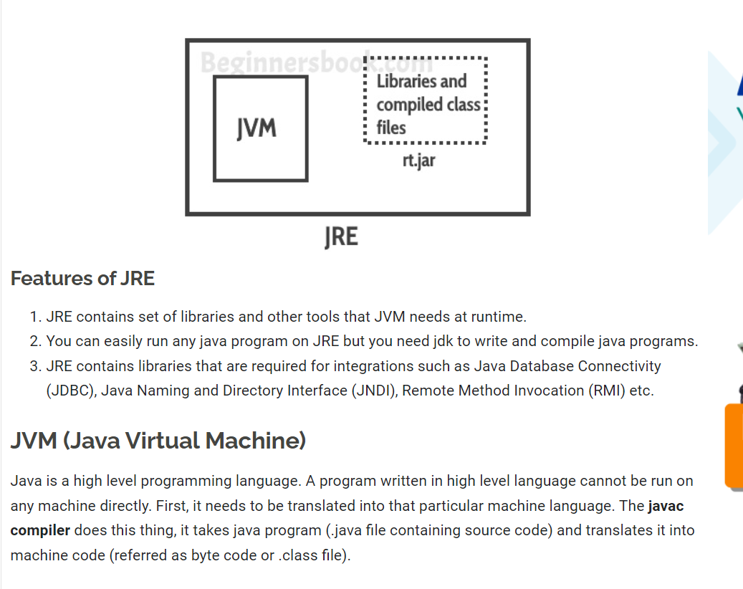

# Memory Management in Java

## **JVM Memory Structure**

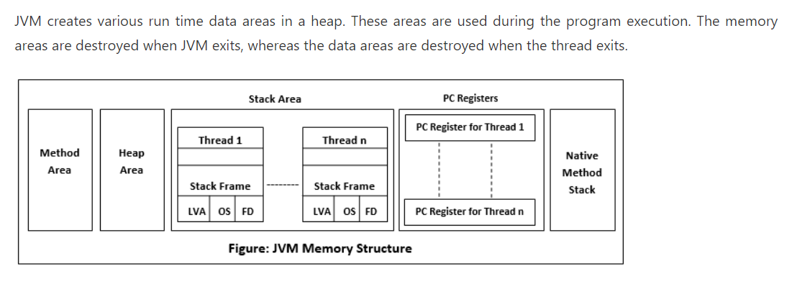

### Method Area

Method Area is a part of the heap memory which is shared among all the threads. It creates when the JVM starts up. It is used to store class structure, superclass name, interface name, and constructors. The JVM stores the following kinds of information in the method area:

* A Fully qualified name of a type (ex: String)
* The type's modifiers
* Type's direct superclass name
* A structured list of the fully qualified names of super interfaces.

### **Heap Area**

Heap stores the actual objects. It creates when the JVM starts up. The user can control the heap if needed. It can be of fixed or dynamic size. When you use a new keyword, the JVM creates an instance for the object in a heap. While the reference of that object stores in the stack. There exists only one heap for each running JVM process. When heap becomes full, the garbage is collected. For example:

StringBuilder sb= **new** StringBuilder();

The above statement creates an object of the StringBuilder class. The object allocates to the heap, and the reference sb allocates to stack. Heap is divided into the following parts:

* Young generation
* Survivor space
* Old generation
* Permanent generation
* Code Cache

### **Stack Area**

Stack Area generates when a thread creates. It can be of either fixed or dynamic size. The stack memory is allocated per thread. It is used to store data and partial results. It contains references to heap objects. It also holds the value itself rather than a reference to an object from the heap. The variables which are stored in the stack have certain visibility, called scope.

**Stack Frame:** Stack frame is a data structure that contains the thread?s data. Thread data represents the state of the thread in the current method.

* It is used to store partial results and data. It also performs dynamic linking, values return by methods and dispatch exceptions.
* When a method invokes, a new frame creates. It destroys the frame when the invocation of the method completes.
* Each frame contains own Local Variable Array (LVA), Operand Stack (OS), and Frame Data (FD).
* The sizes of LVA, OS, and FD determined at compile time.
* Only one frame (the frame for executing method) is active at any point in a given thread of control. This frame is called the current frame, and its method is known as the current method. The class of method is called the current class.
* The frame stops the current method, if its method invokes another method or if the method completes.
* The frame created by a thread is local to that thread and cannot be referenced by any other thread.

### **Native Method Stack**

It is also known as C stack. It is a stack for native code written in a language other than Java. Java Native Interface (JNI) calls the native stack. The performance of the native stack depends on the OS.

### **PC Registers**

Each thread has a Program Counter (PC) register associated with it. PC register stores the return address or a native pointer. It also contains the address of the JVM instructions currently being executed.

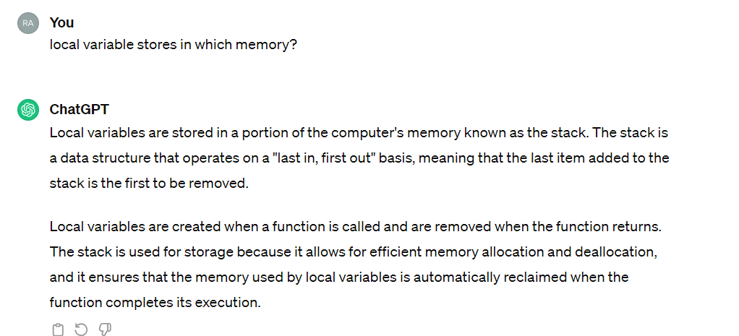

### MetaSpace

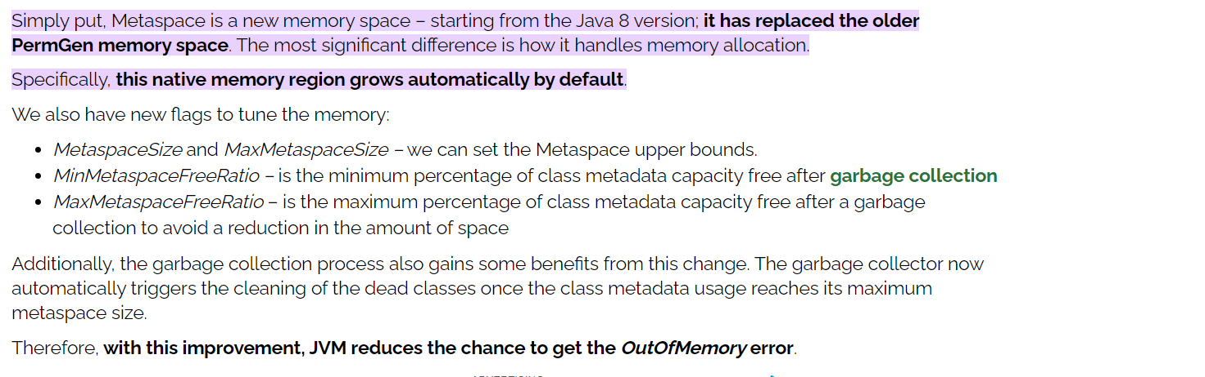

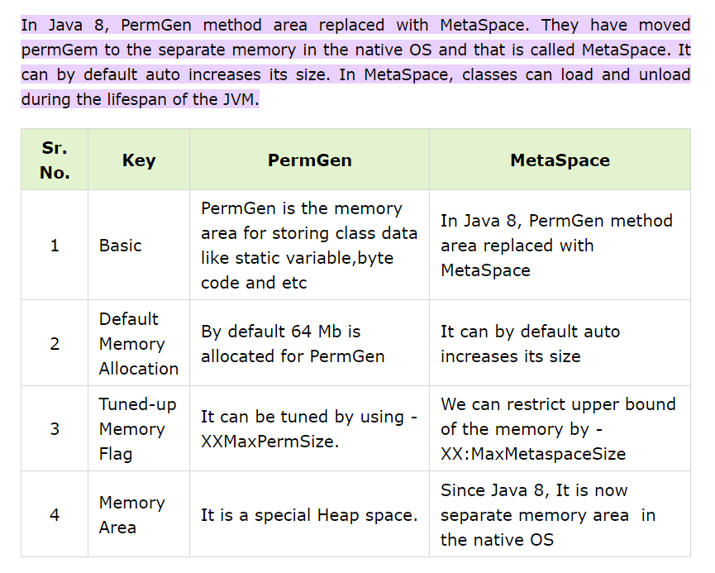

## garbage collection

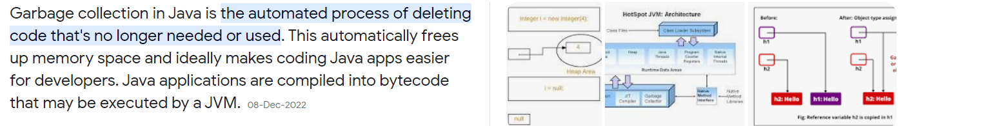

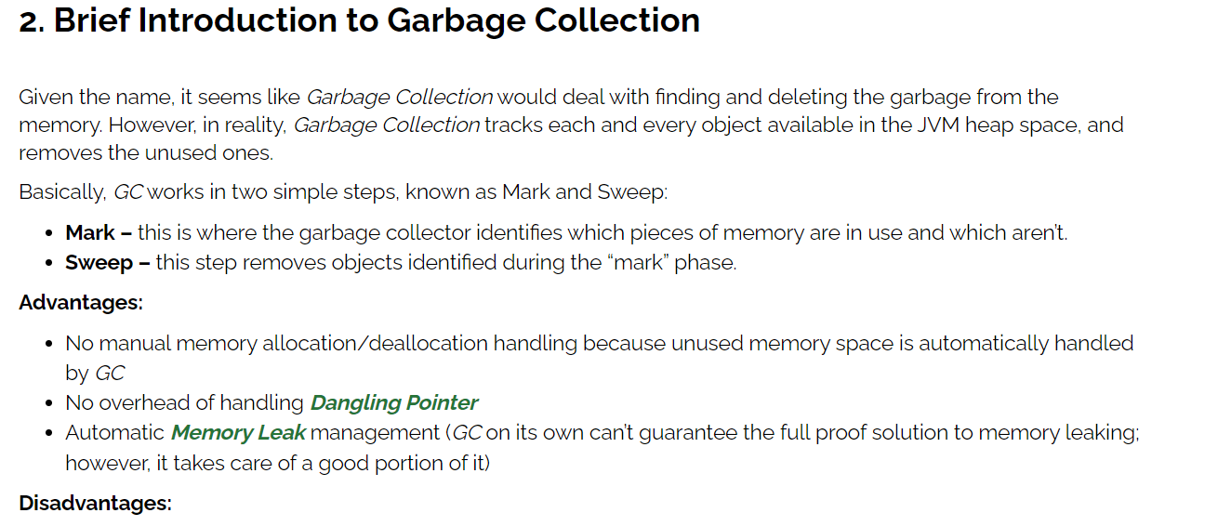

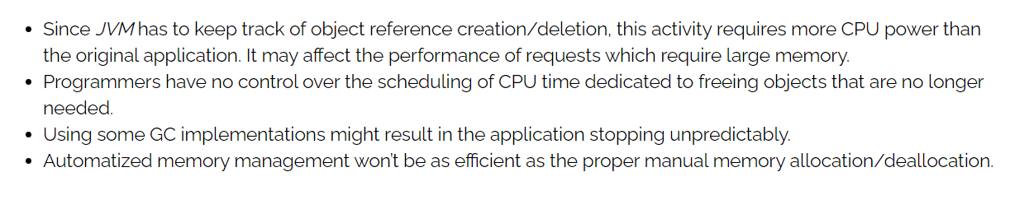

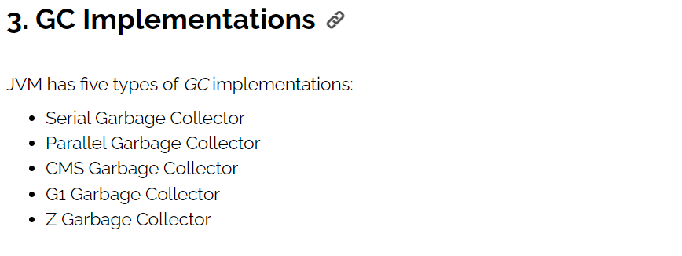

<https://www.baeldung.com/jvm-garbage-collectors>

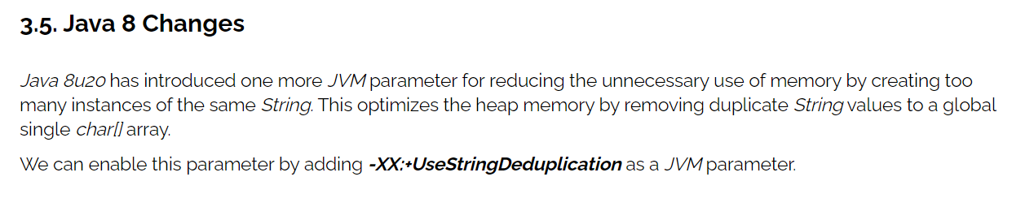

# Core Java

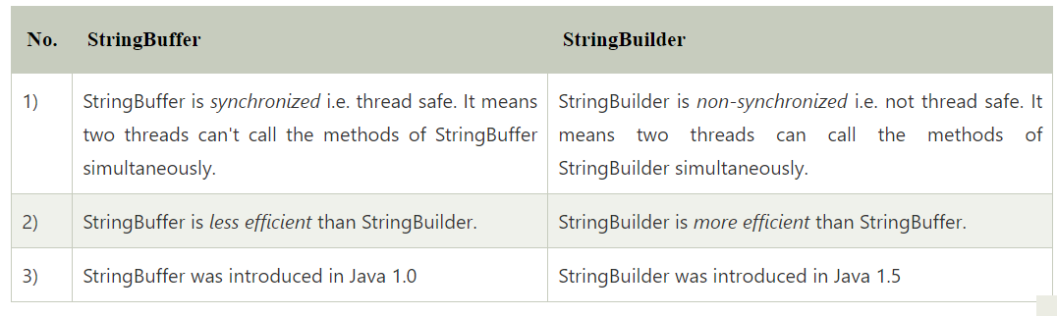

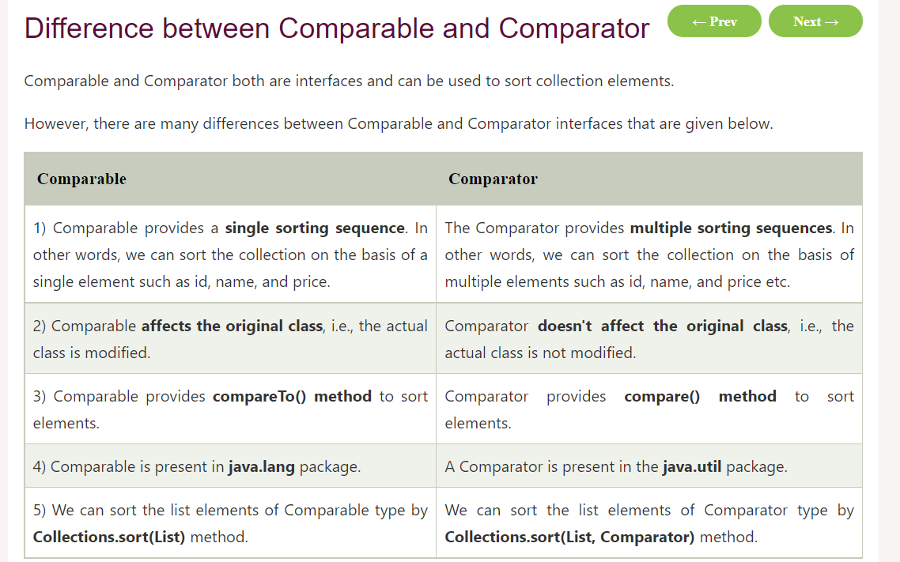

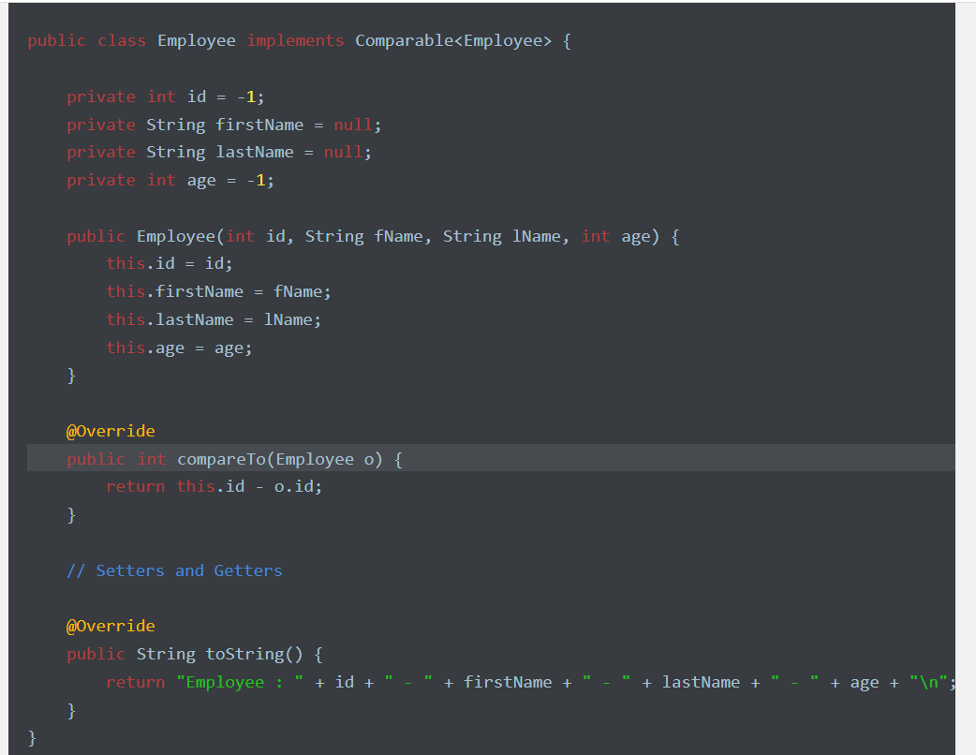

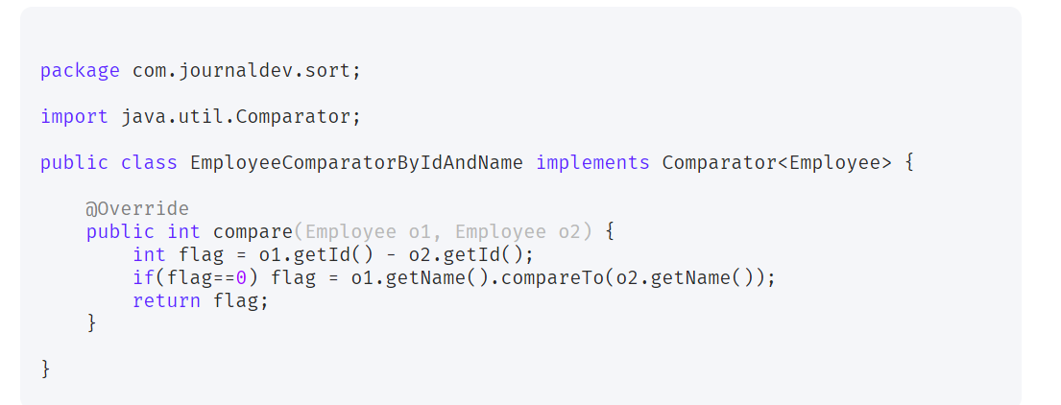

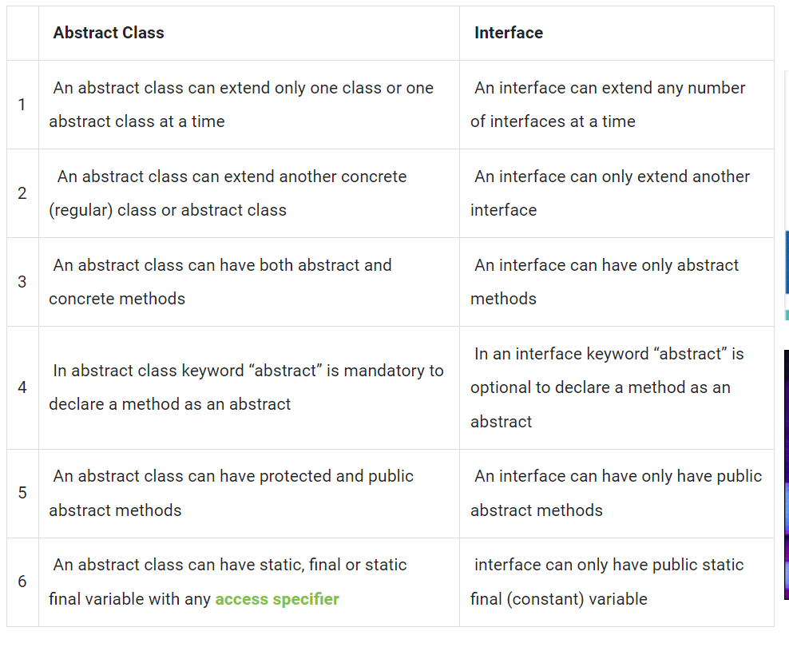

**marker interface**.

An empty interface is known as tag or marker interface. For example Serializable, EventListener, Remote(java.rmi.Remote) are tag interfaces, there are few other tag interfaces as well.

These interfaces do not have any field and methods in it. You must be thinking if they are empty why class implements them? What’s the use of it? Class implements them to claim the membership in a particular set. For example: If a class implements Serializable interface, it is claiming to be the member of Serializable classes, so if JVM (Java Virtual Machine) sees that a class is Serializable, it does some trick or special operation that helps in the serialization/de-serialization process.

Basically Tag interfaces are meaningful to the JVM (Java virtual machine). You can also create your own tag interfaces to segregate and categorize your code. It would improve the readability of your code.

This is how a tag interface looks:

package java.util;

public interface EventListener

{}

How to read the Property file from the java class

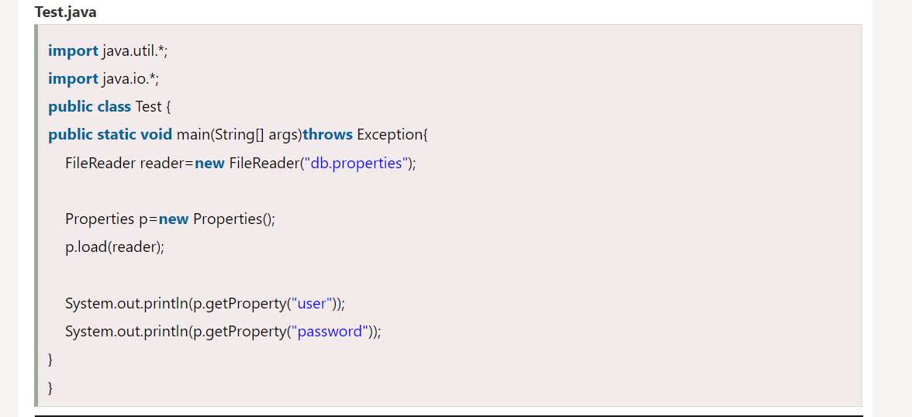

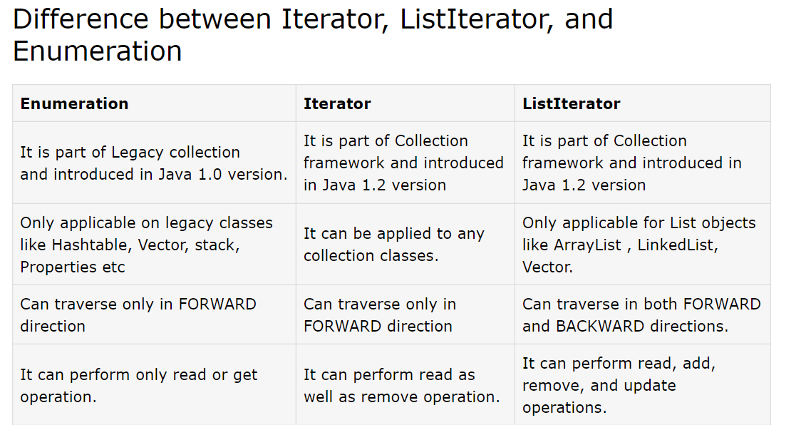

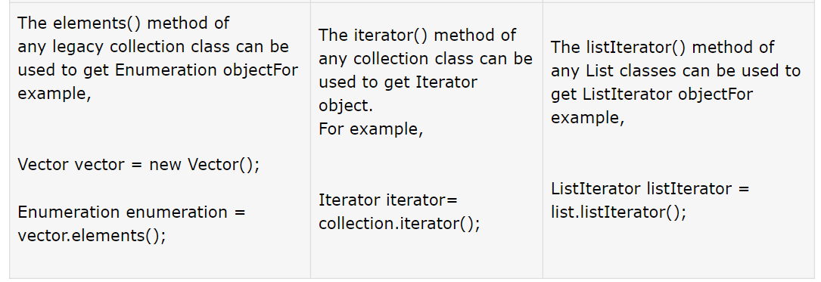

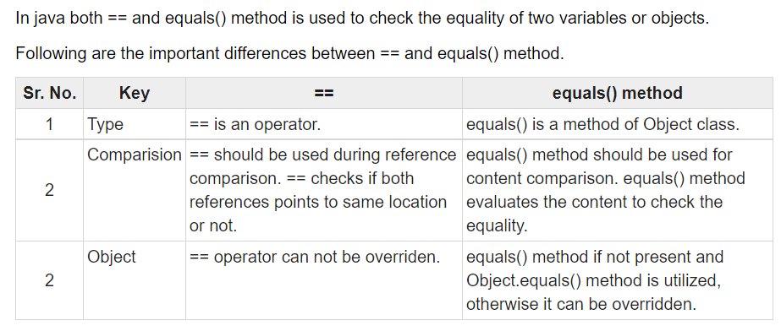

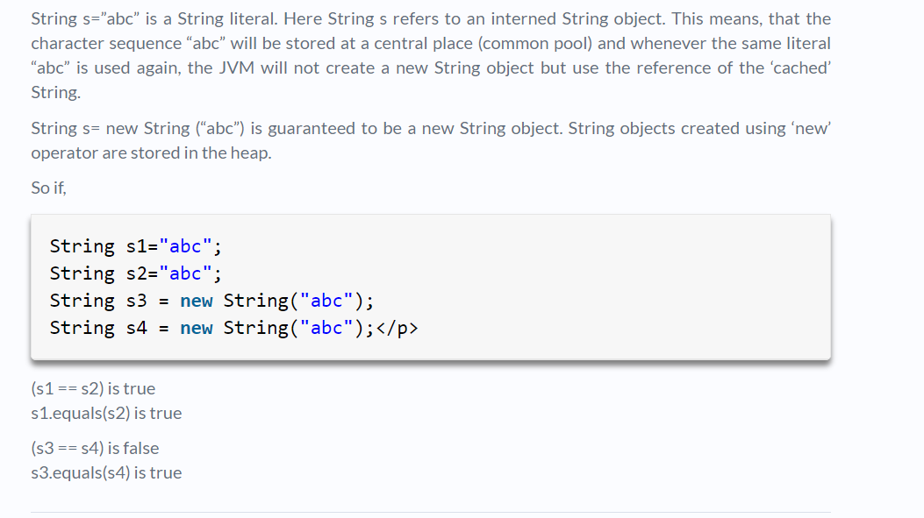

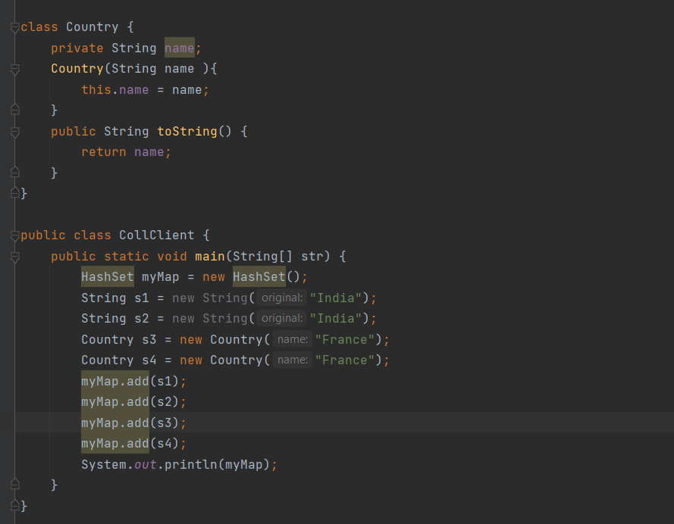

**options are :**

**A)France France India right answer**

**B)India India France France**

**C)India France**

**D)France France**

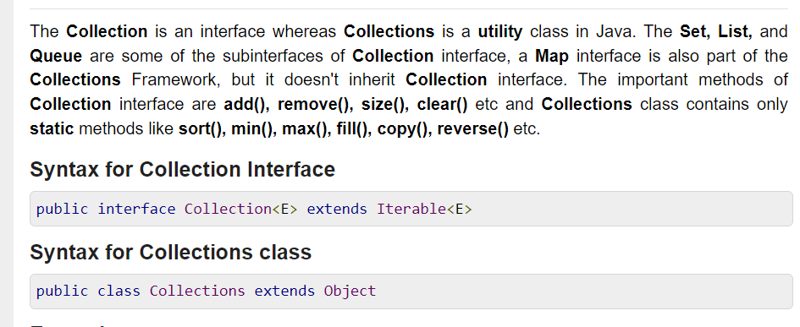

## Runnable Vs Callable

The Runnable interface is a functional interface and has a single run() method that doesn’t accept any parameters or return any values.

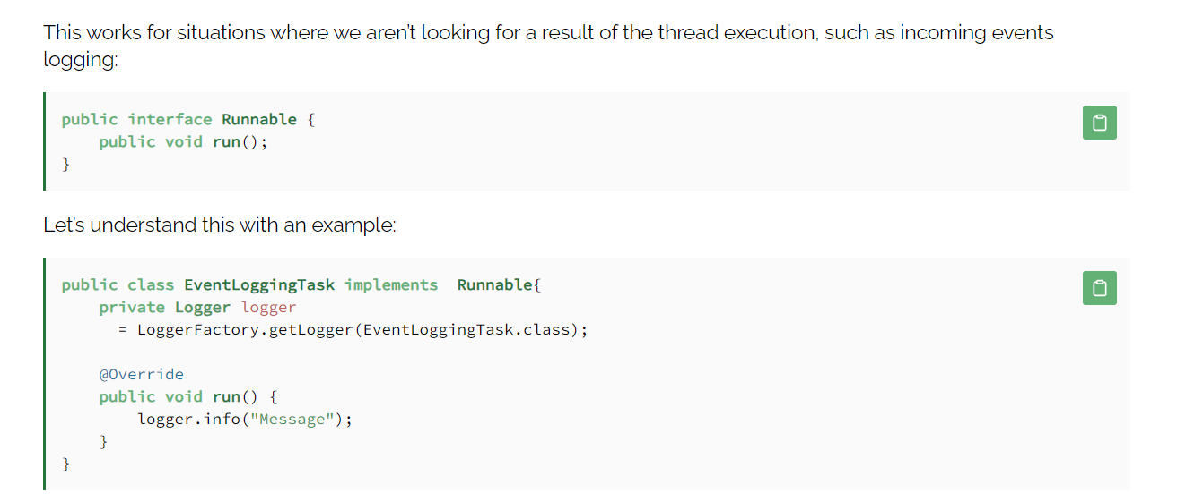

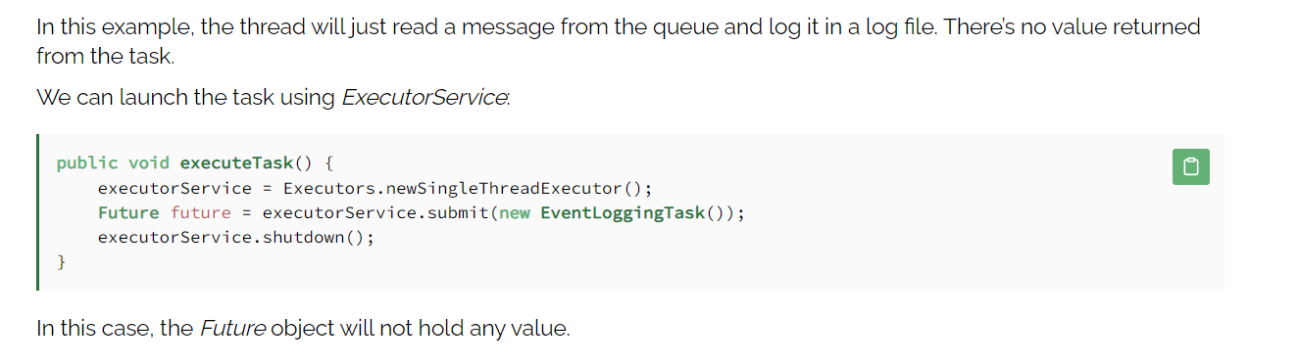

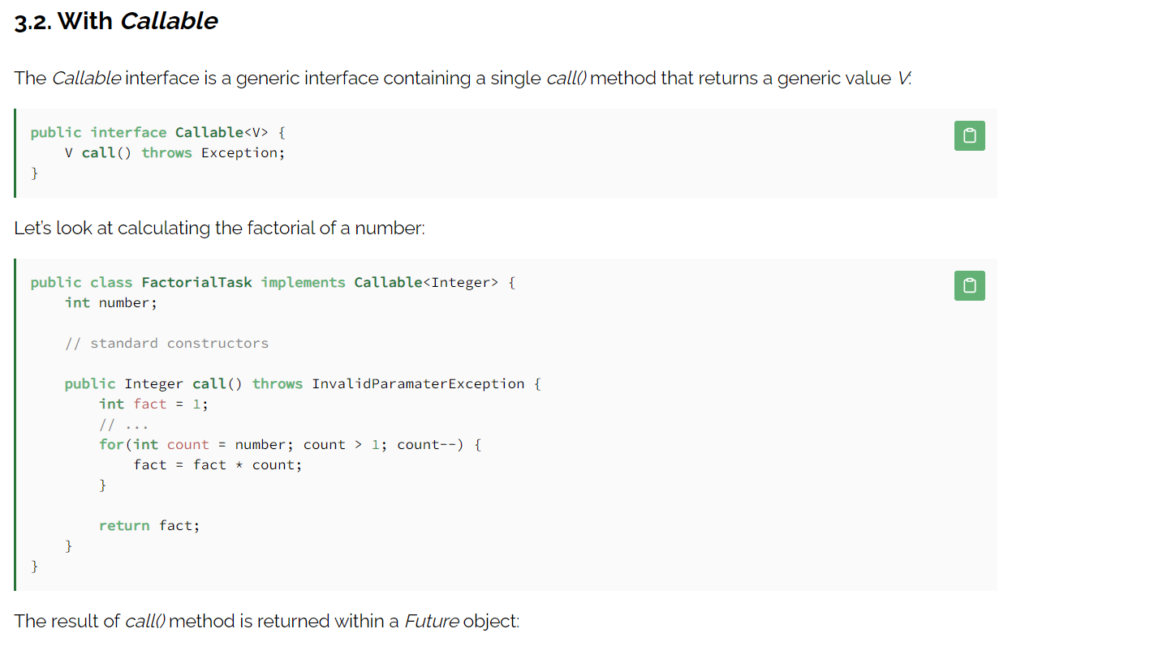

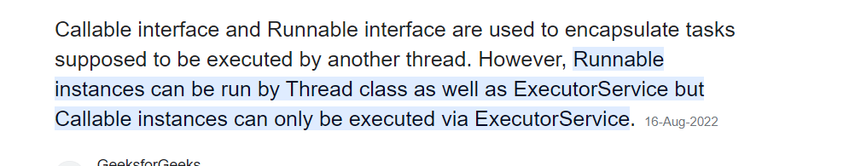

## ExecutorService

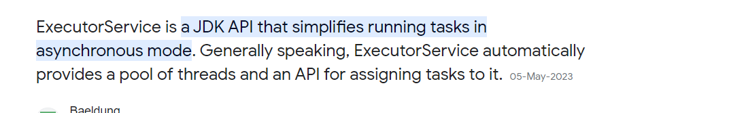

<https://www.baeldung.com/java-executor-service-tutorial#:~:text=ExecutorService%20is%20a%20JDK%20API,for%20assigning%20tasks%20to%20it>.

## HashCode() and equals()

<https://www.digitalocean.com/community/tutorials/java-equals-hashcode>

## Transient vs Volatile

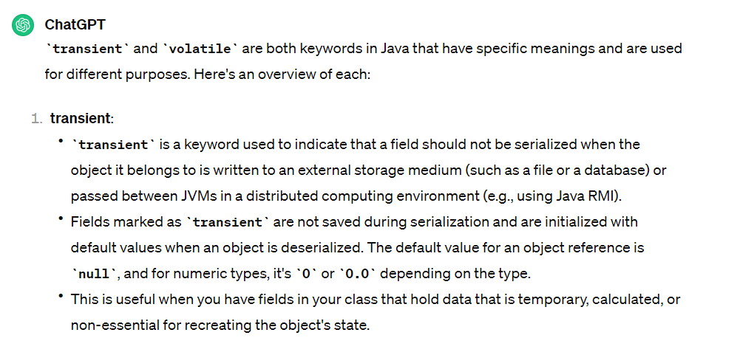

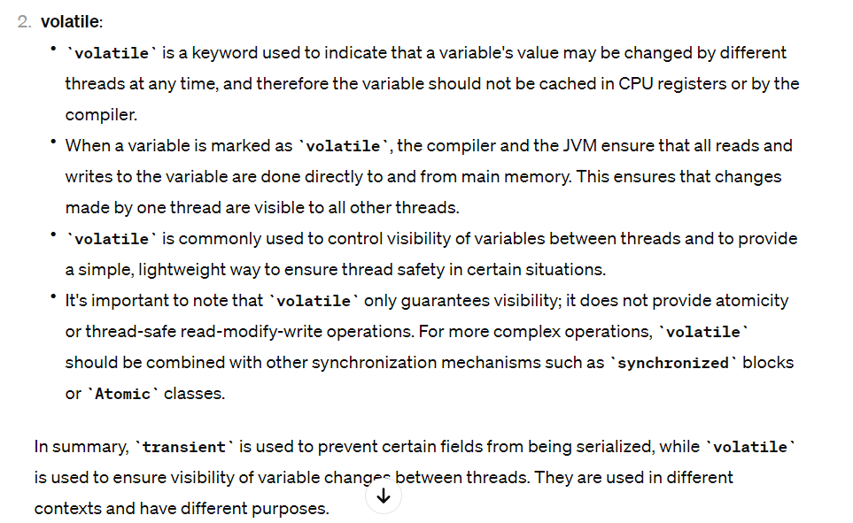

# Exceptions

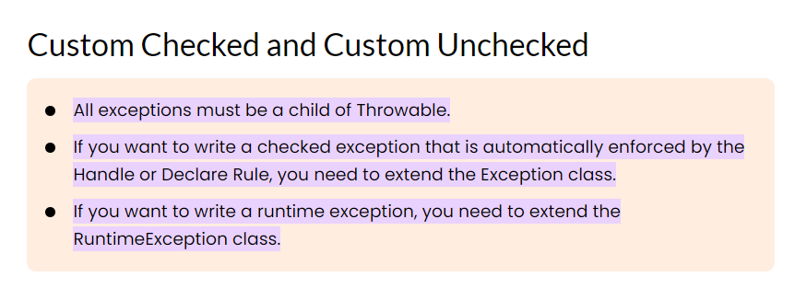

# Java 8 Features

## Lambda Expressions

Lambda expression is a new feature which is introduced in Java 8. A lambda expression is an anonymous function. A function that doesn’t have a name and doesn’t belong to any class. The concept of lambda expression was first introduced in LISP programming language.

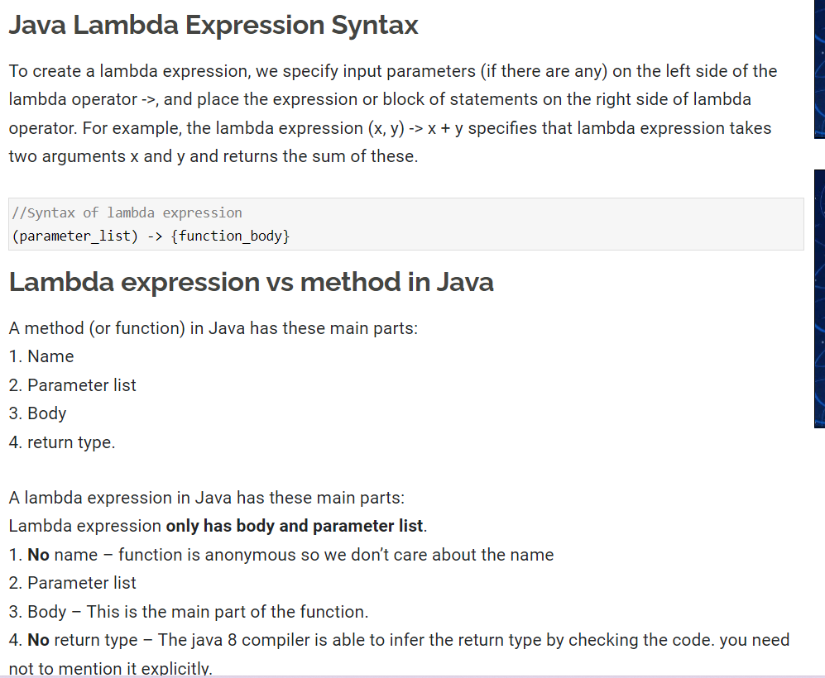

Where to use the Lambdas in Java

To use lambda expression, you need to either create your own functional interface or use the pre defined

## Functional interface

provided by Java. An interface with only single abstract method is called functional interface(or Single Abstract method interface), for example: Runnable, callable, ActionListener etc.

To use lambda expression in Java, you need to either create your own functional interface or use the pre defined functional interface provided by Java. While creating your own functional interface, mark it with @FunctionalInterface annotation, this annotation is introduced in Java 8. Although its optional, you should use it so that you get a compilation error if the interface you marked with this annotation is not following the rules of functional interfaces.

What are the rules of defining a functional interface?

The functional interface should have **Only one** abstract method. Along with the one abstract method, they can have any number of default and static methods.

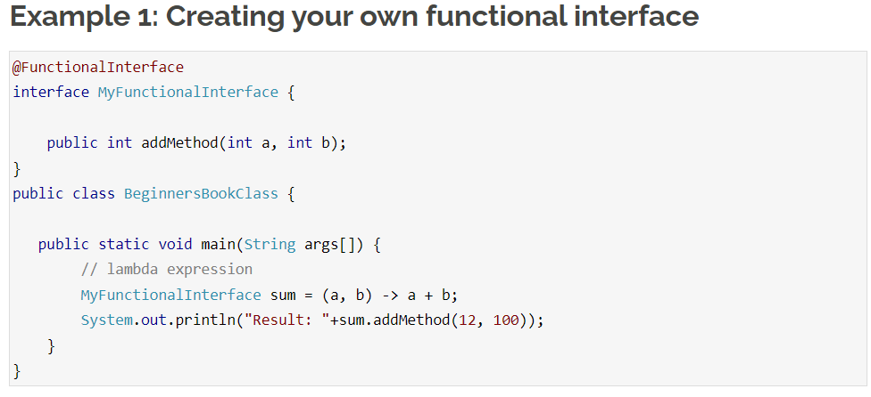

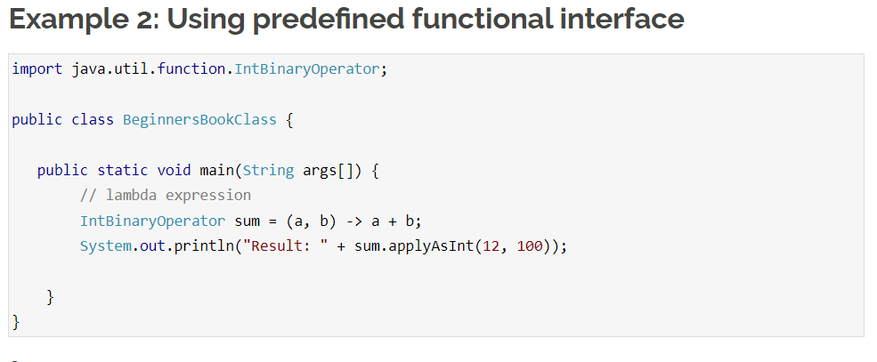

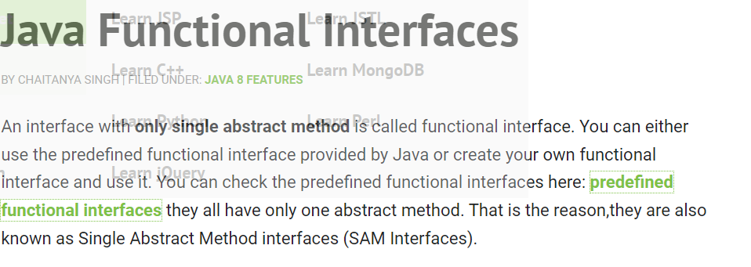

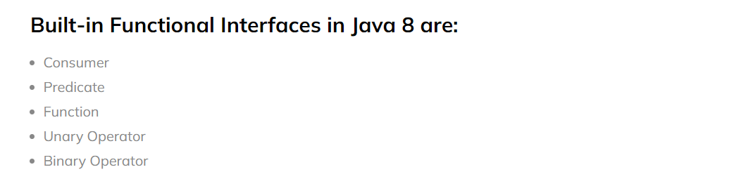

<https://blog.knoldus.com/functional-interfaces-in-java-8/>

## Method References

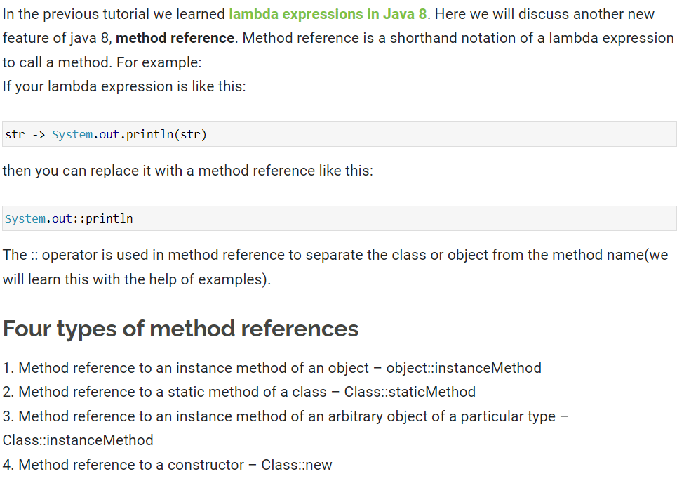

## StringJoiner

n java 8, a new class StringJoiner is introduced in the java.util package. Using this class we can join more than one strings with the specified delimiter, we can also provide prefix and suffix to the final string while joining multiple strings. In this tutorial we will see several examples of StringJoiner class and at the end of this guide, we will see the methods of StringJoiner class.

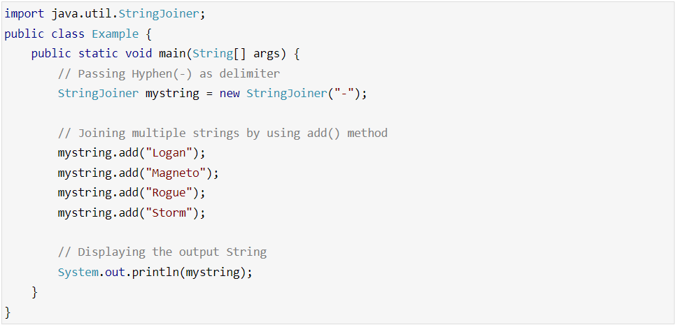

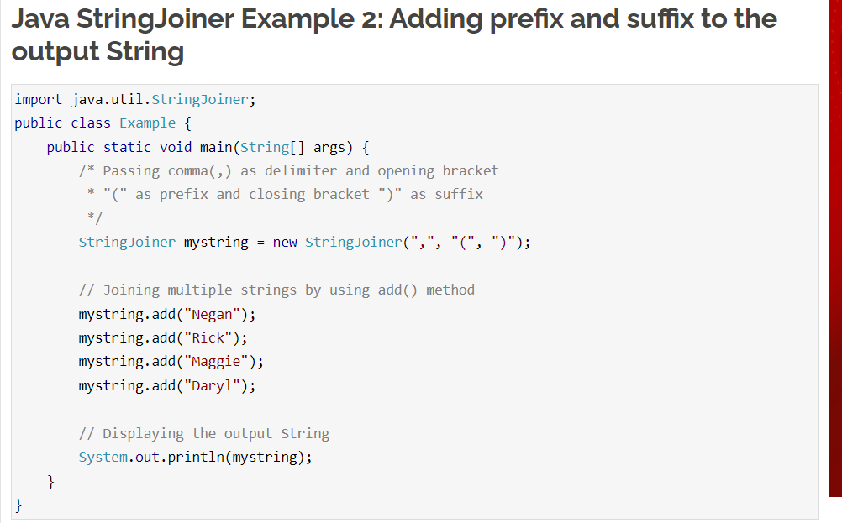

## Interface Changes – default method and static method

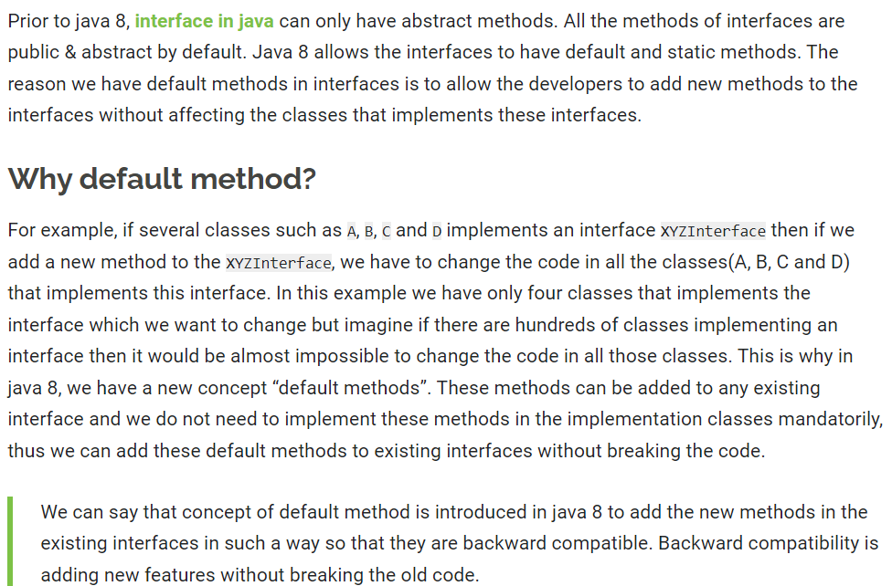

## ForEach() and filter()

In Java 8, we have a newly introduced forEach method to iterate over collections and Streams in Java. In this guide, we will learn how to use forEach() and forEachOrdered() methods to loop a particular collection and stream.

## Optional Class

In Java 8, we have a newly introduced Optional class in java.util package. This class is introduced to avoid NullPointerException that we frequently encounters if we do not perform null checks in our code. Using this class we can easily check whether a variable has null value or not and by doing this we can avoid the NullPointerException. In this guide, we will see how to work with Optional class and the usage of various methods of this class.

Before we see the example of Optional class, lets see what happens when we don’t use Optional class and do not perform null check.

## Arrays Parallel Sort

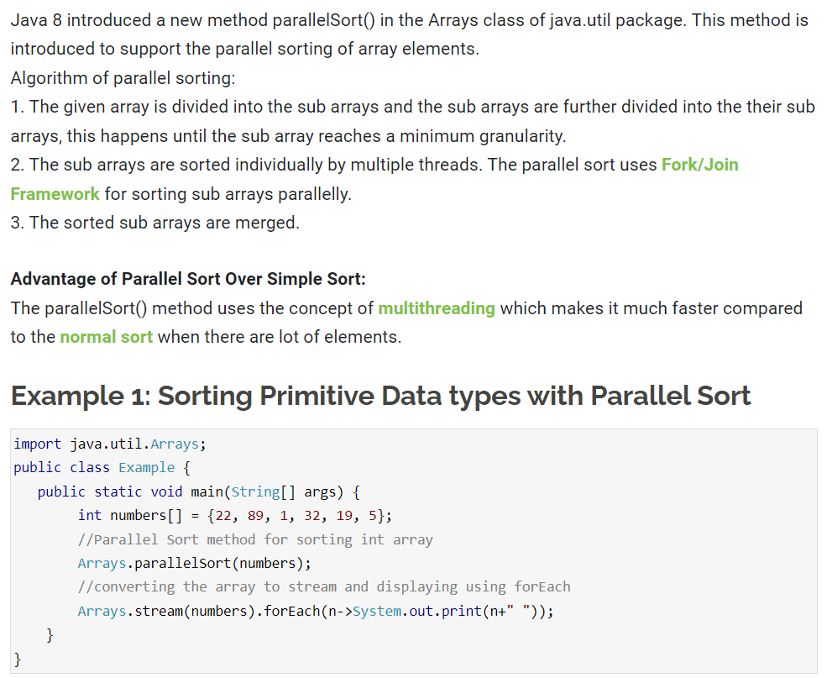

## Date Time API

Under the package java.time, Java 8 offers a new date-time API. The following are the most prominent classes among them:

Local: Simplified date-time API with no timezone management complexity.

Zoned: specialized date-time API that can handle several time zones.

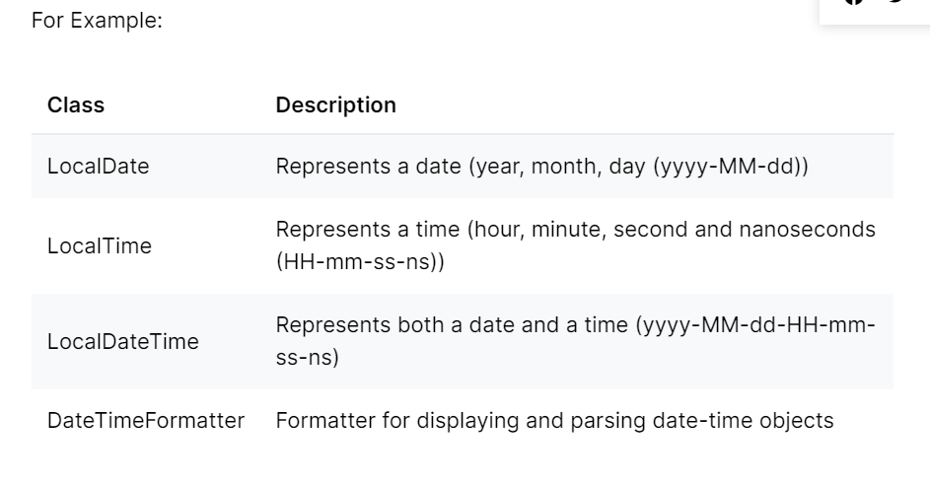

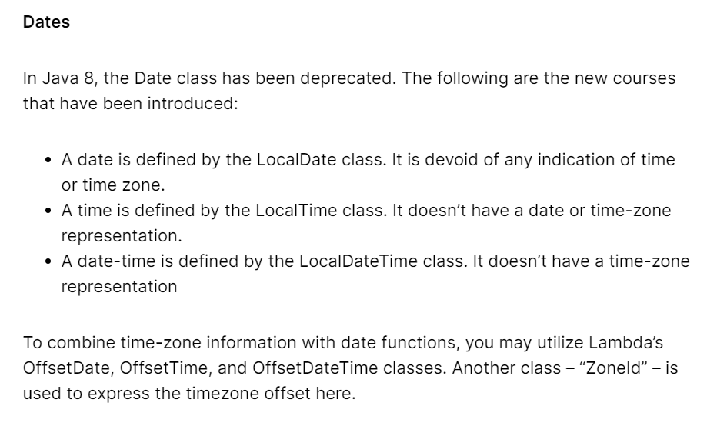

## Stream API

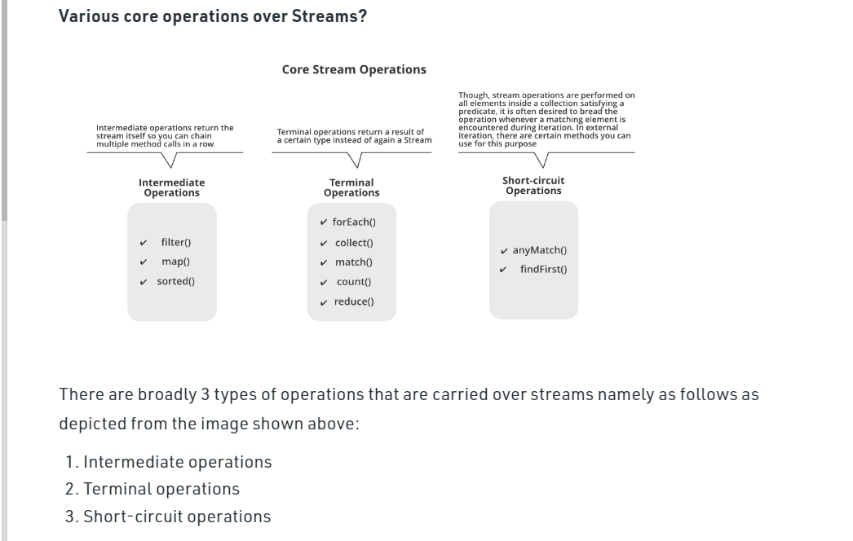

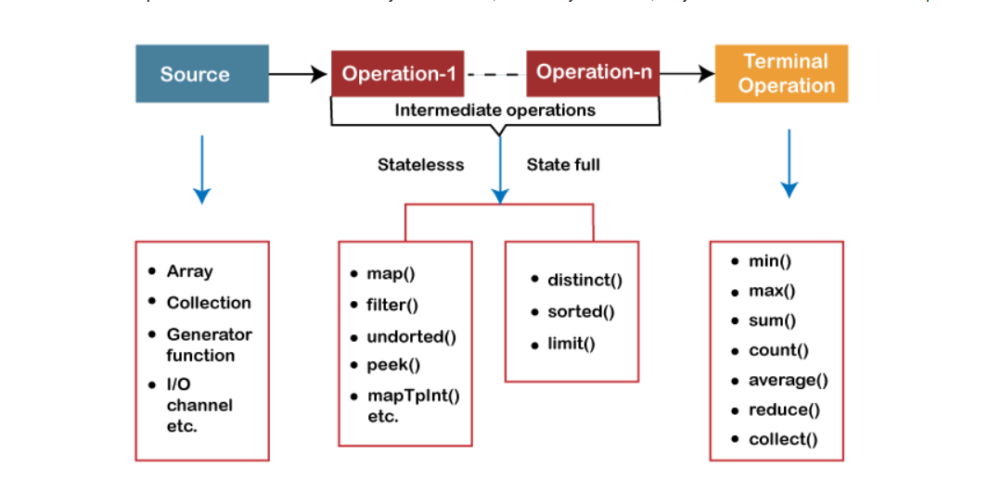

explain reduce operation in stream api

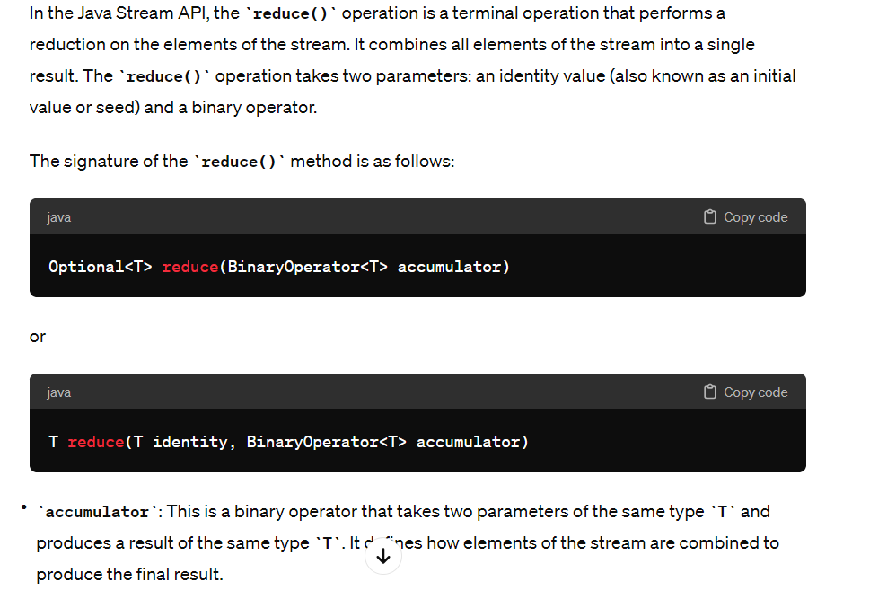

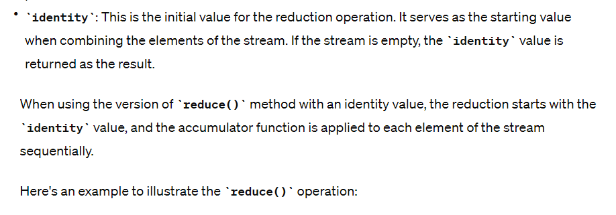

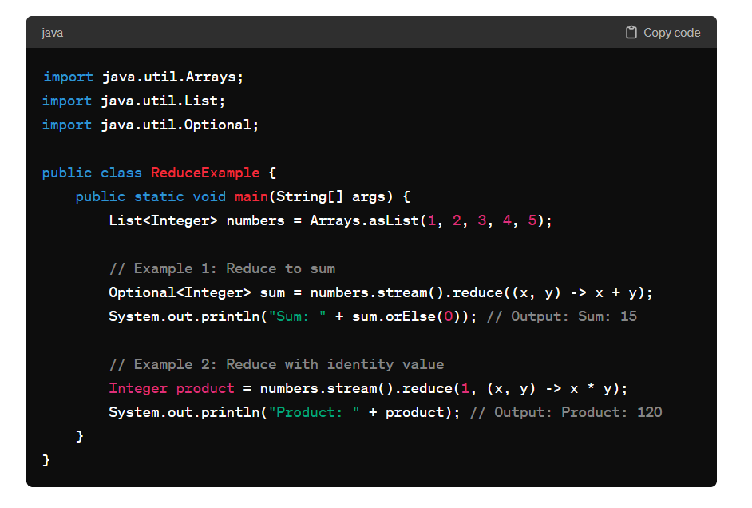

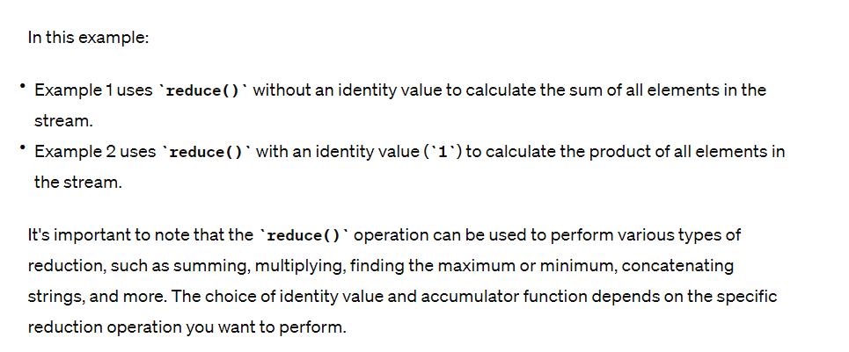

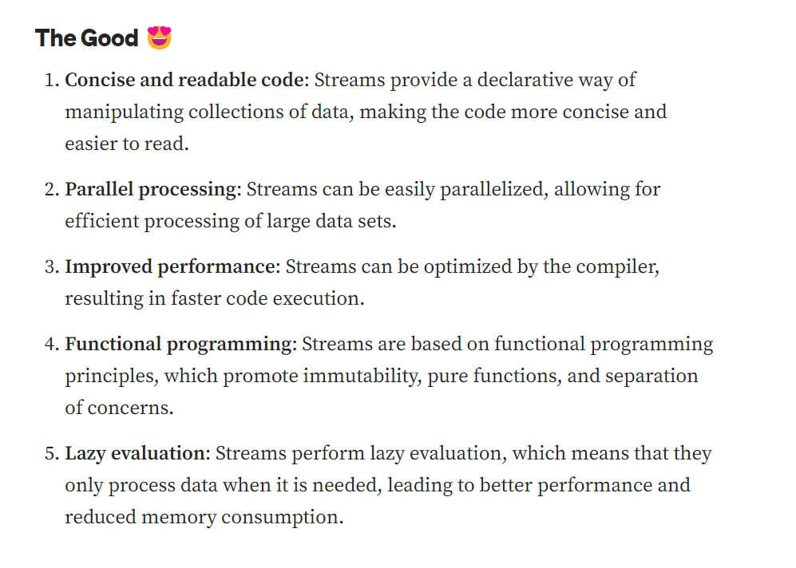

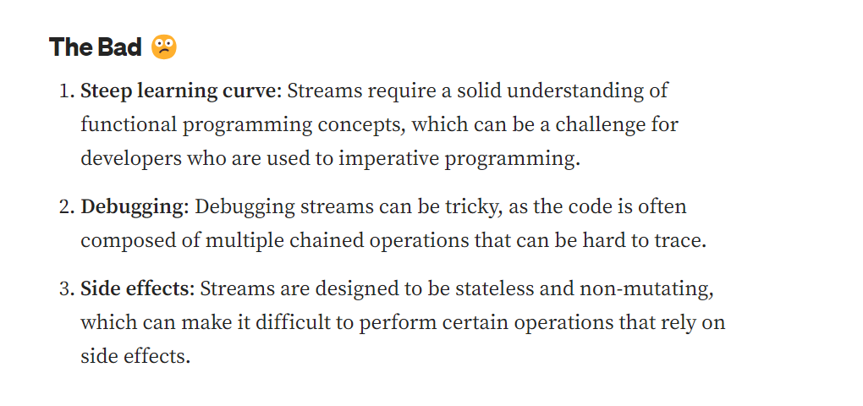

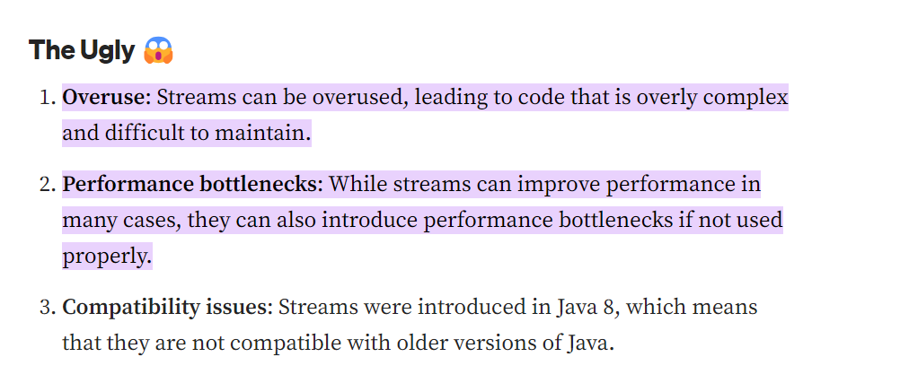

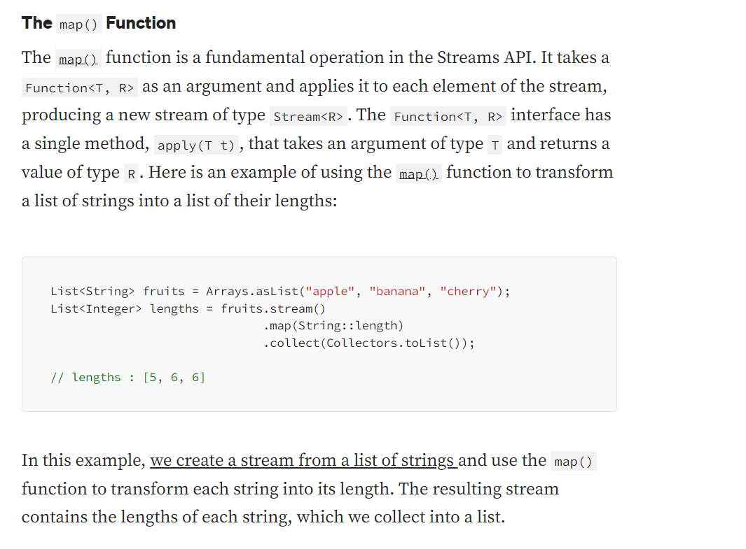

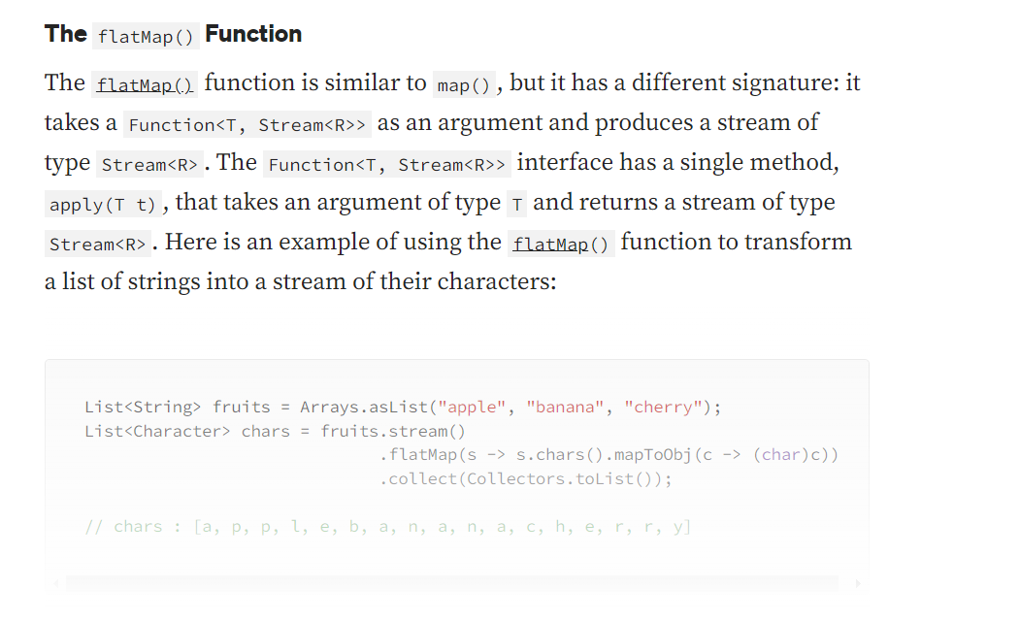

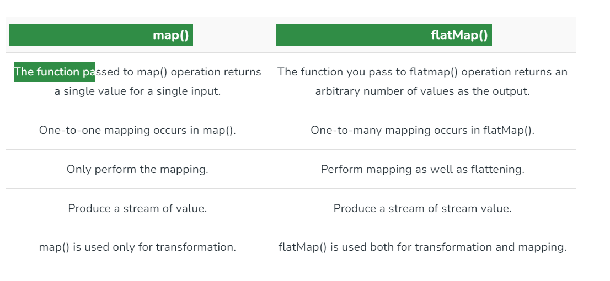

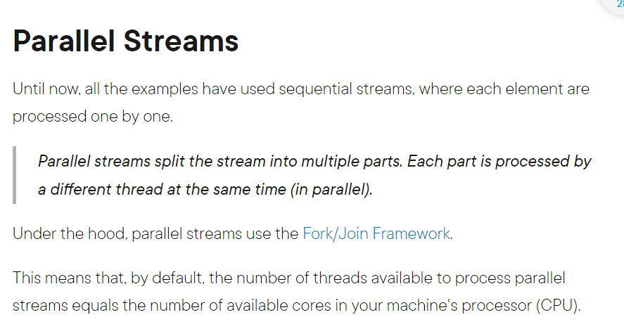

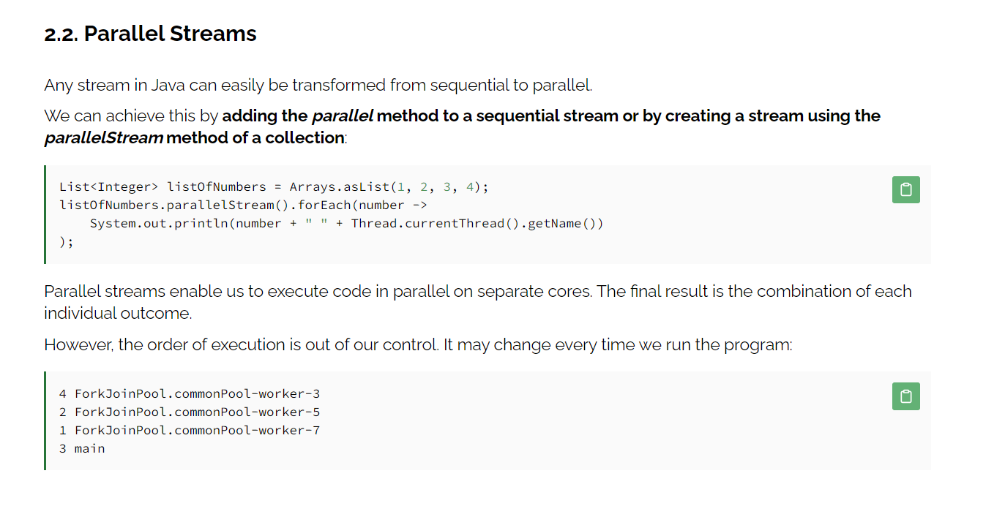

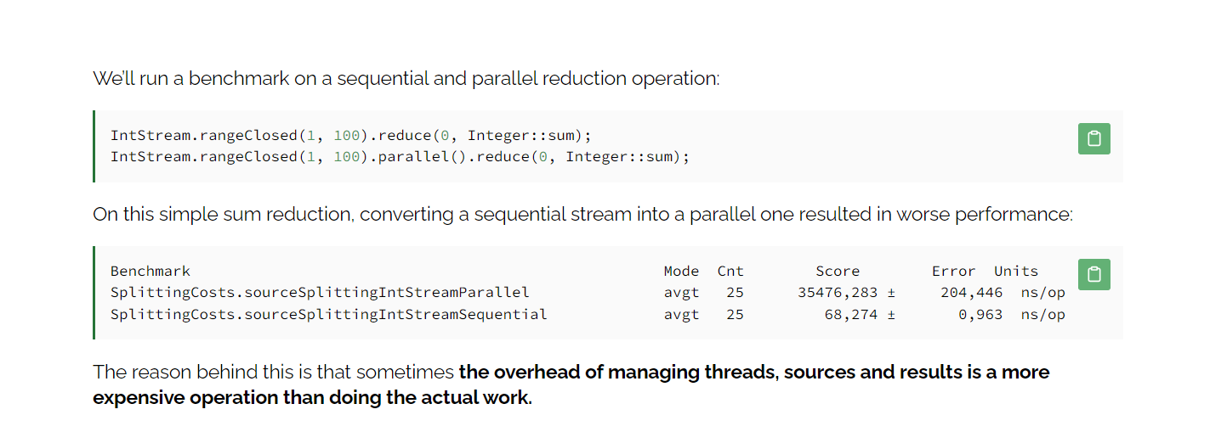

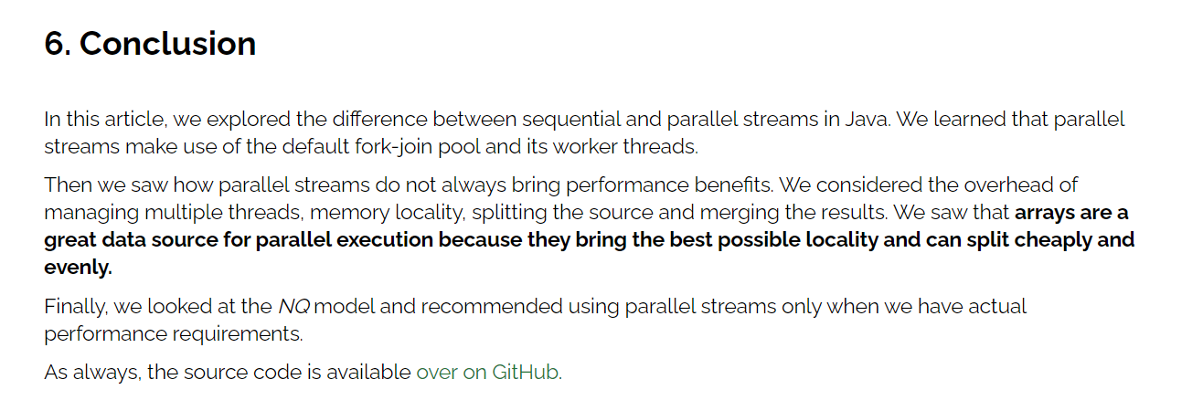

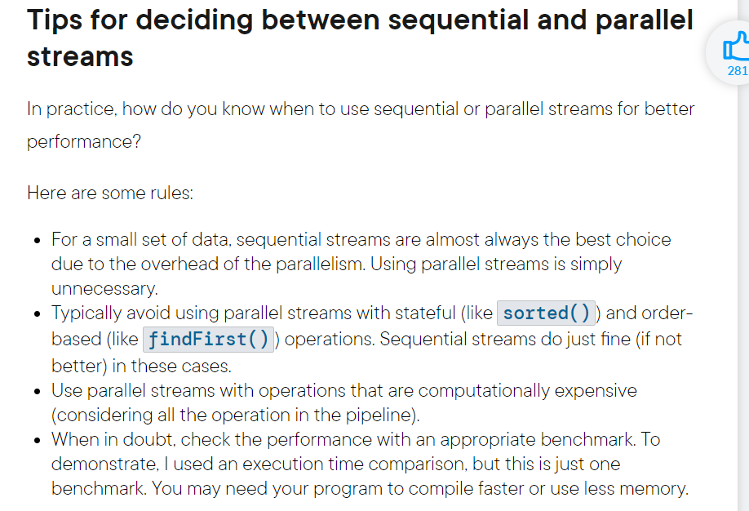

## Predicate

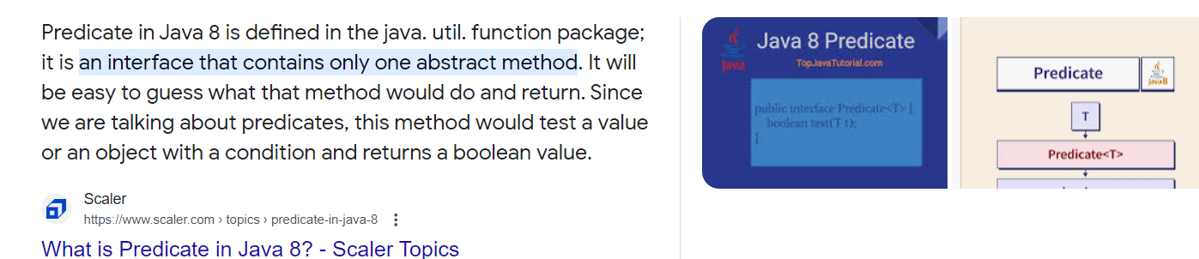

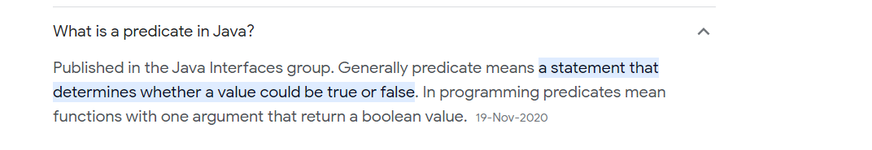

## Nashorn JavaScript

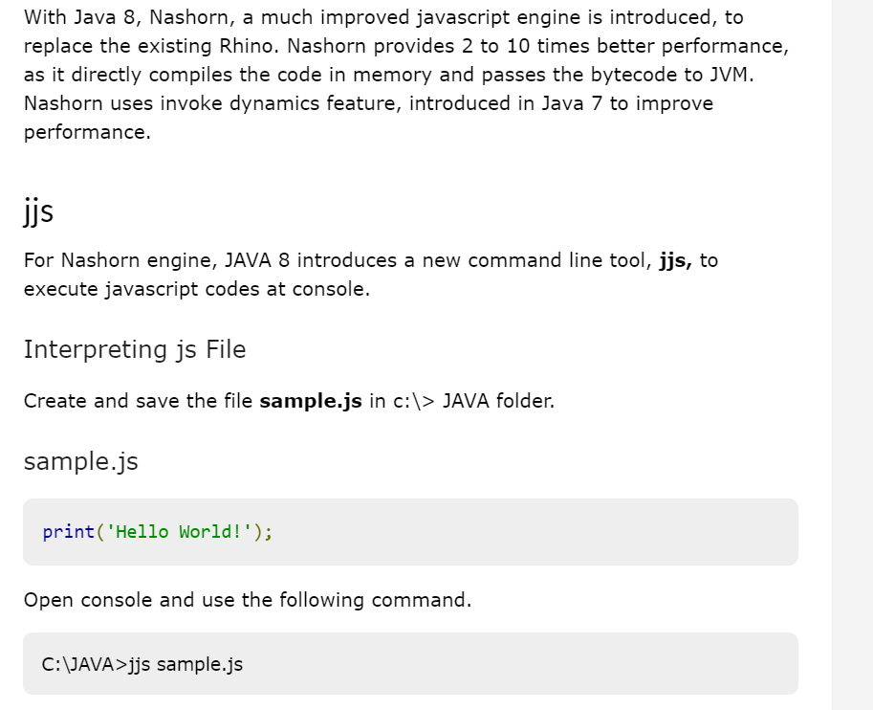

[**https://www.tutorialspoint.com/java8/java8_nashorn_java_script.htm**](https://www.tutorialspoint.com/java8/java8_nashorn_java_script.htm)

# Collections

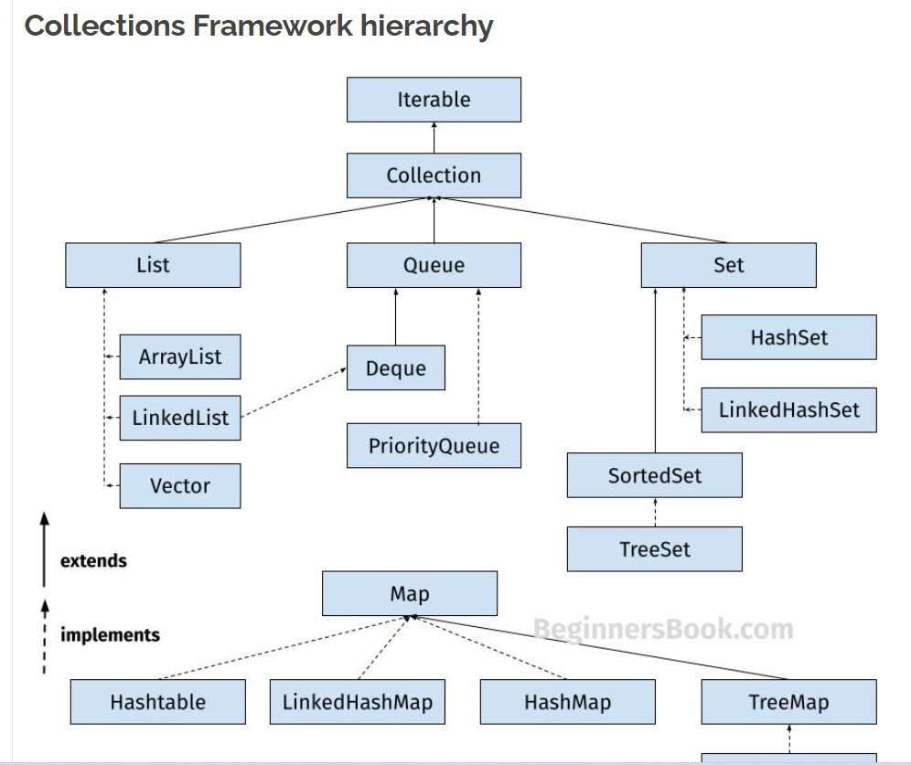

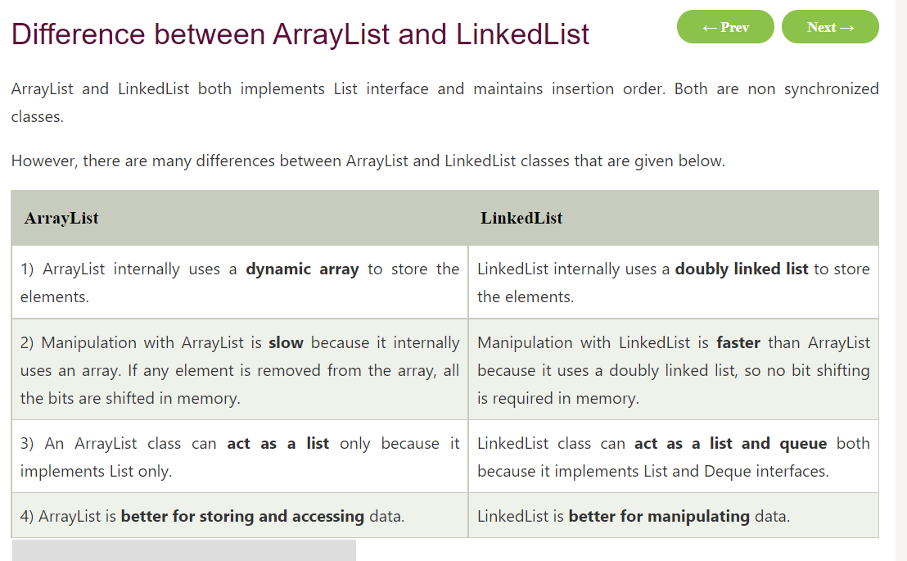

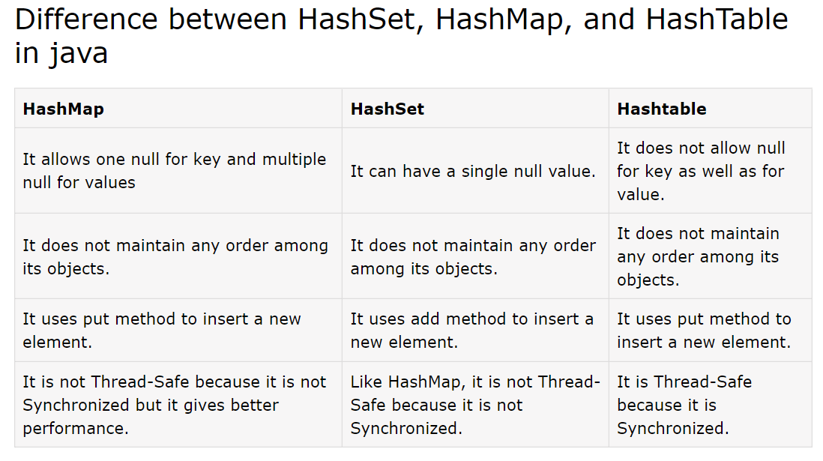

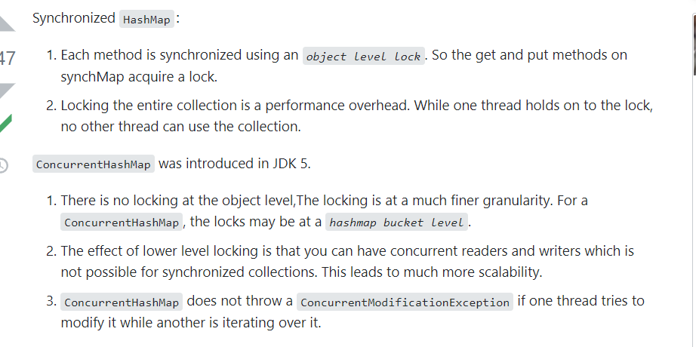

## Internal Implementation of HashMap

<https://www.javatpoint.com/working-of-hashmap-in-java>

User

hashmap improvements form java 7 to java 8

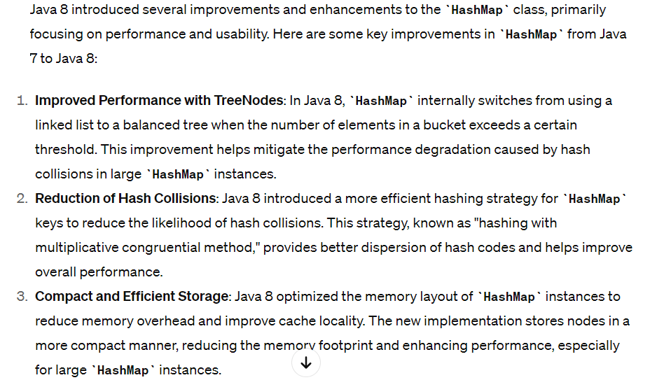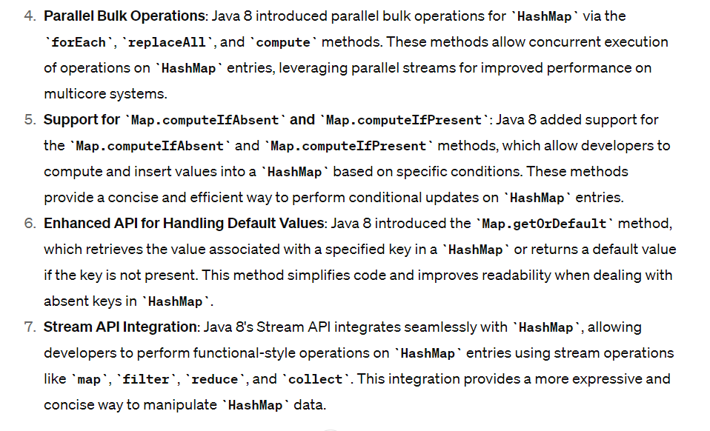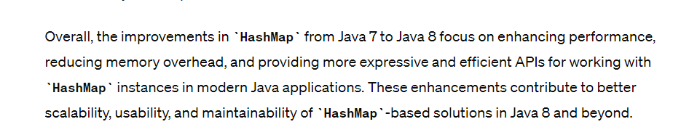

# Threads

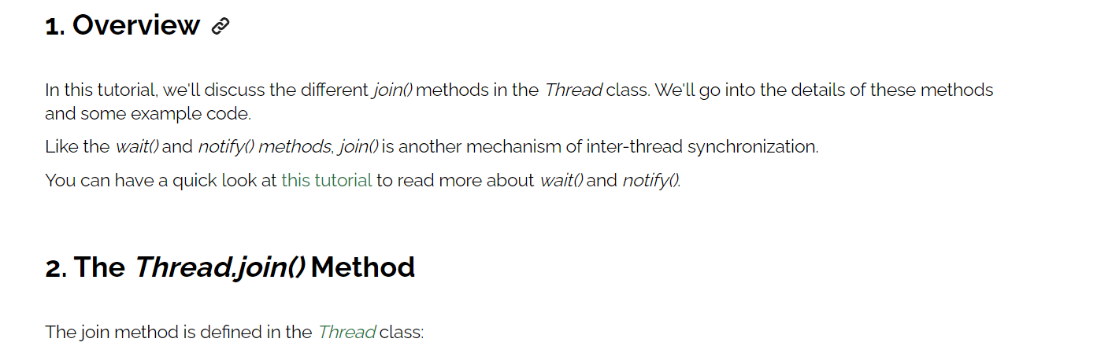

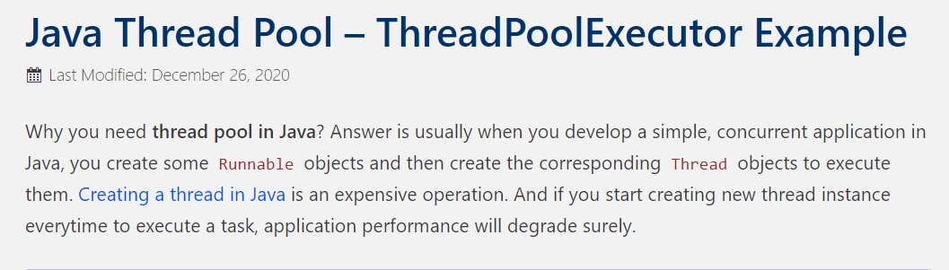

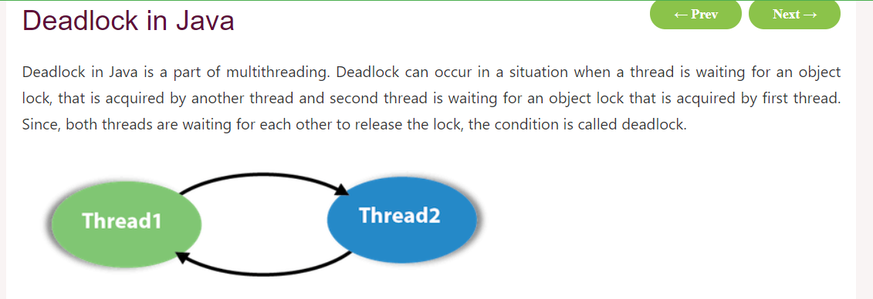

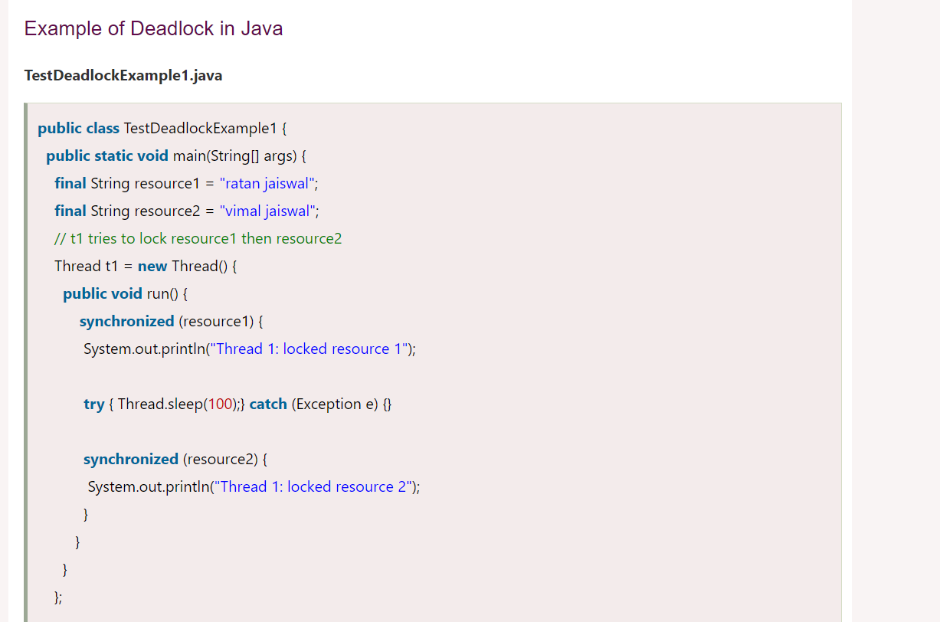

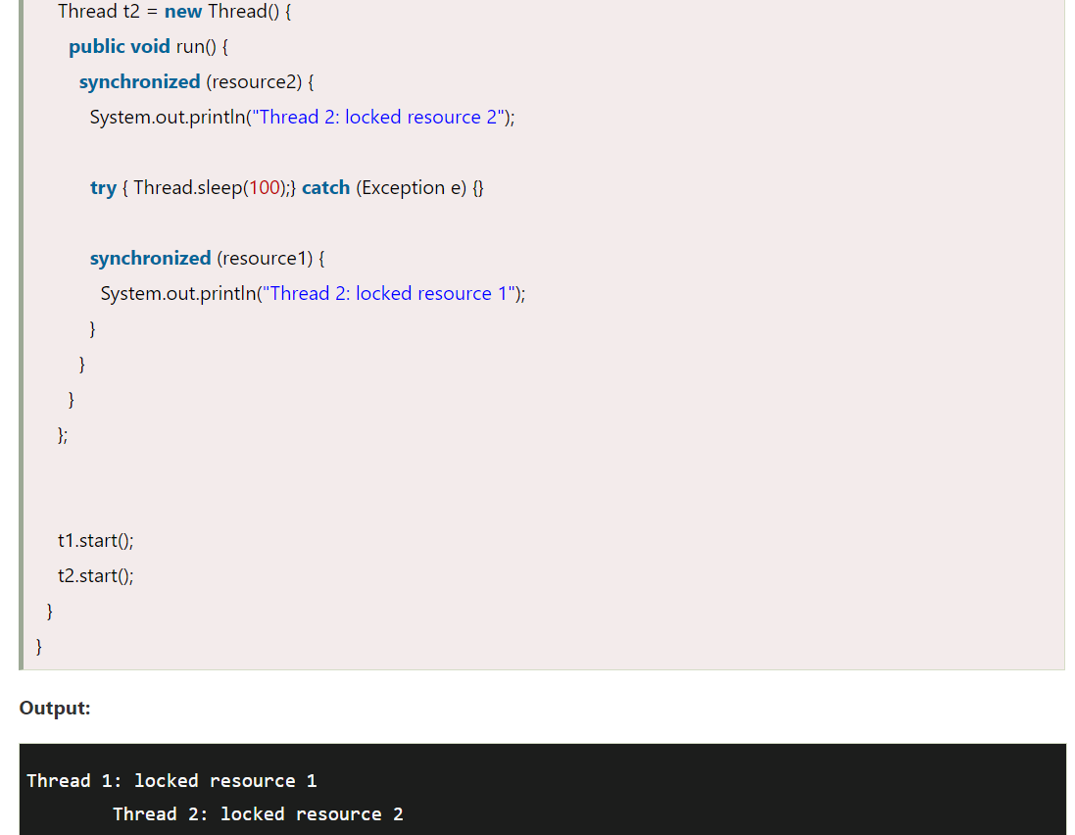

How to get current ongoing thread

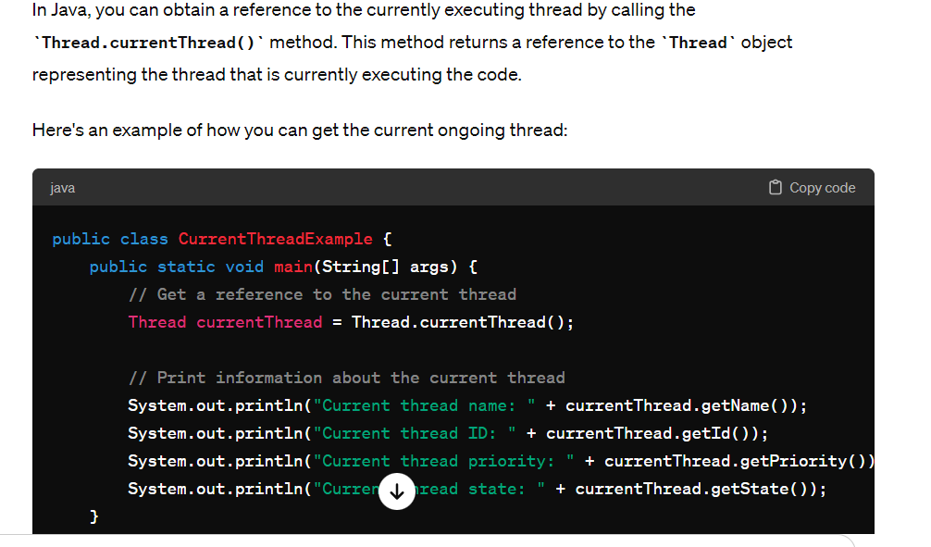

LifeCycle of threads

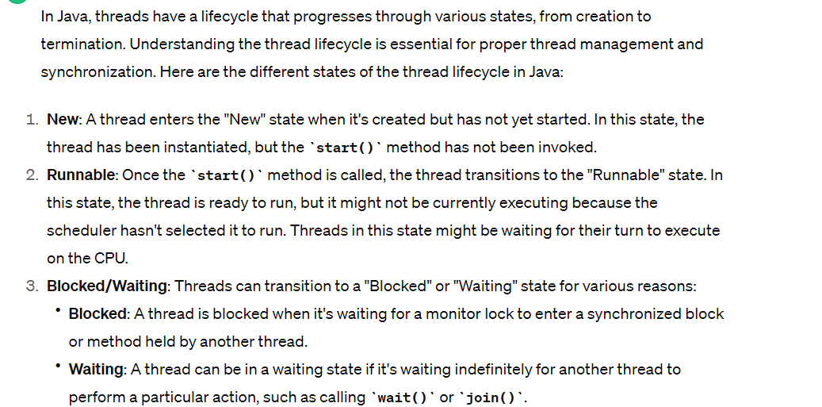

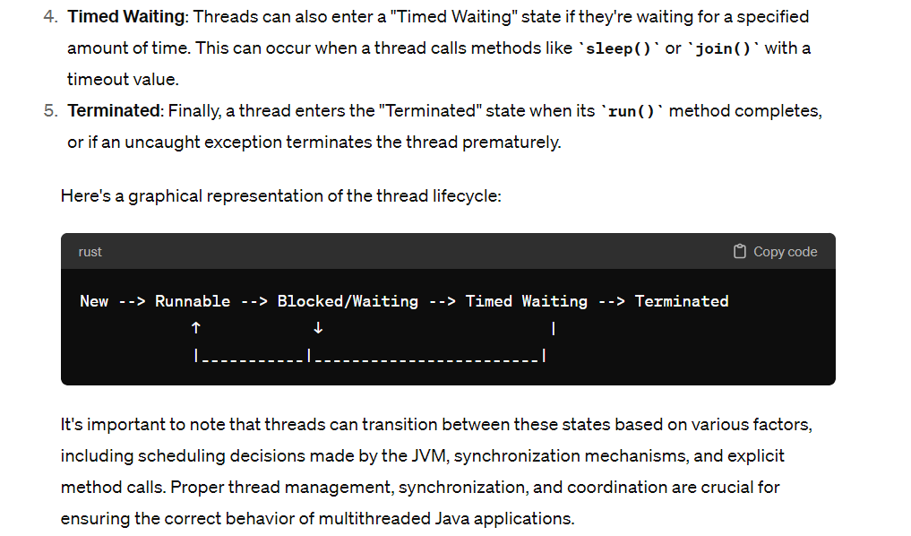

<https://beginnersbook.com/2013/03/multithreading-in-java/>

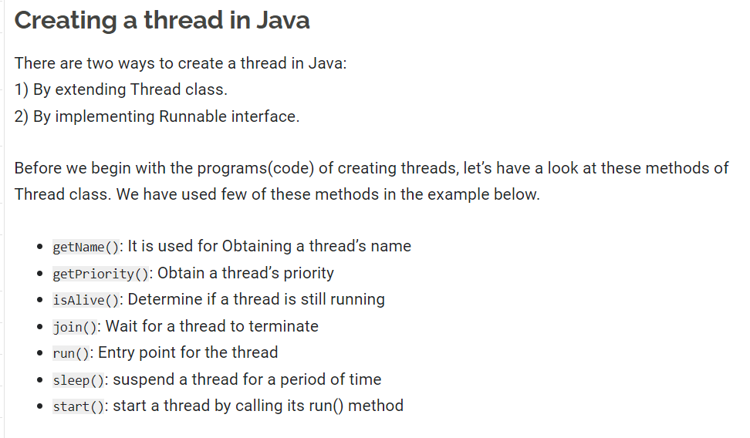

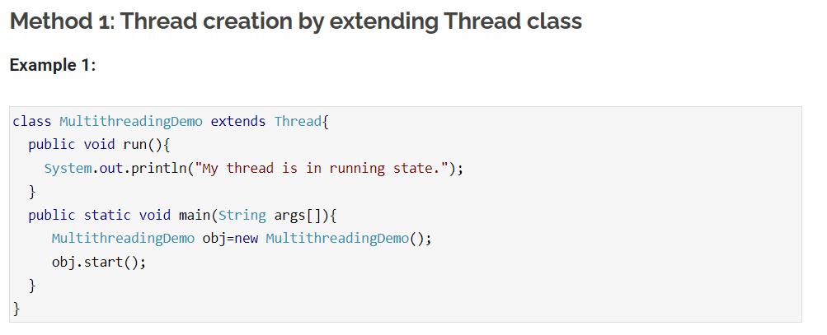

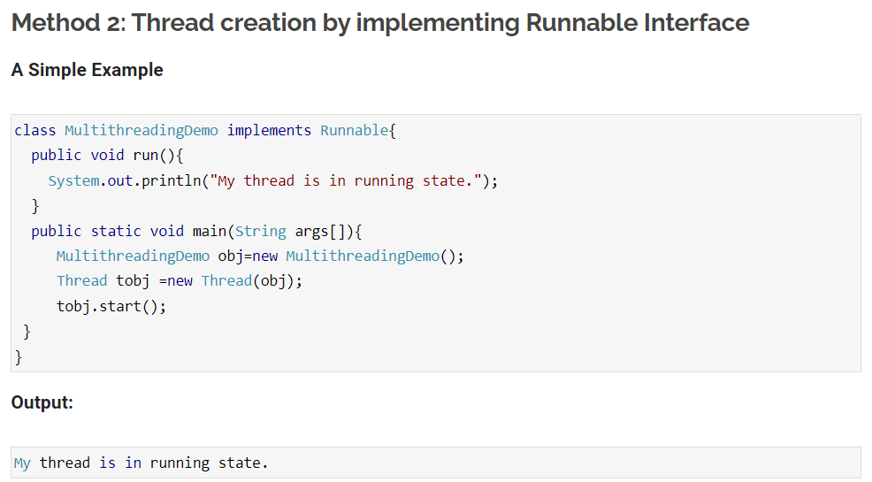

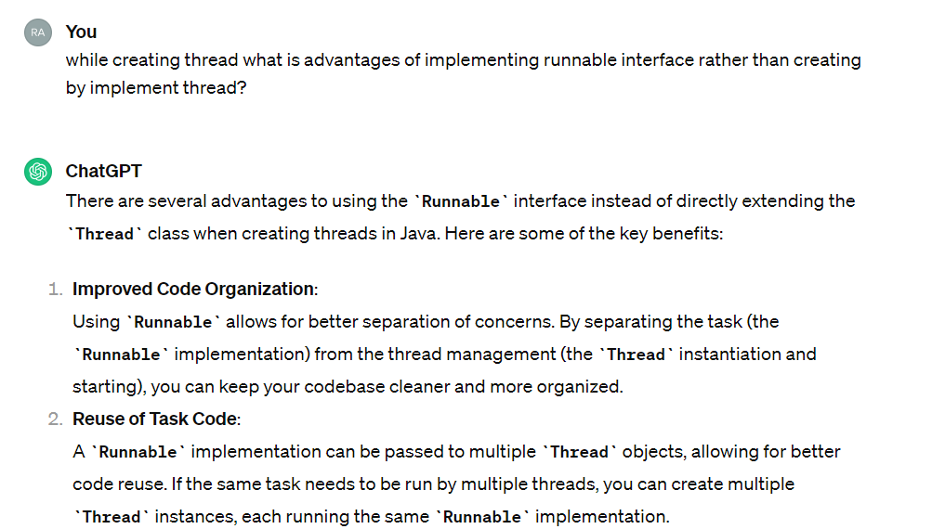

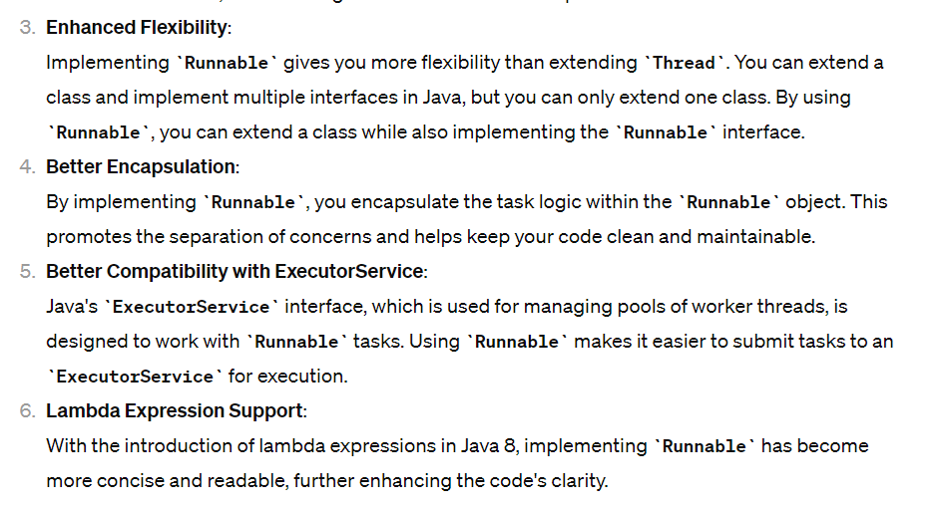

# Singleton

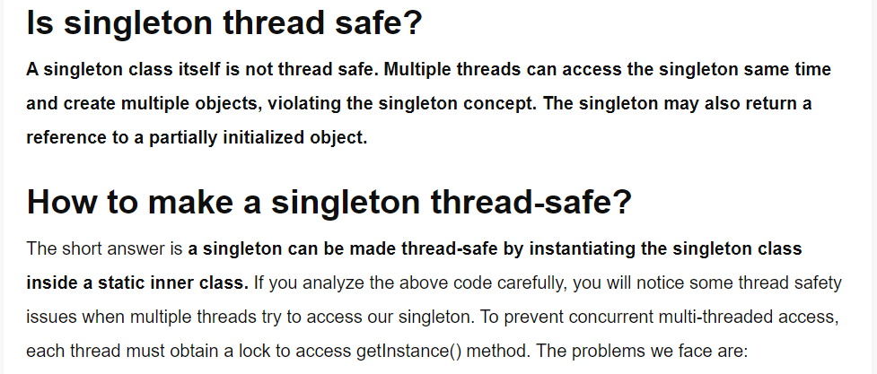

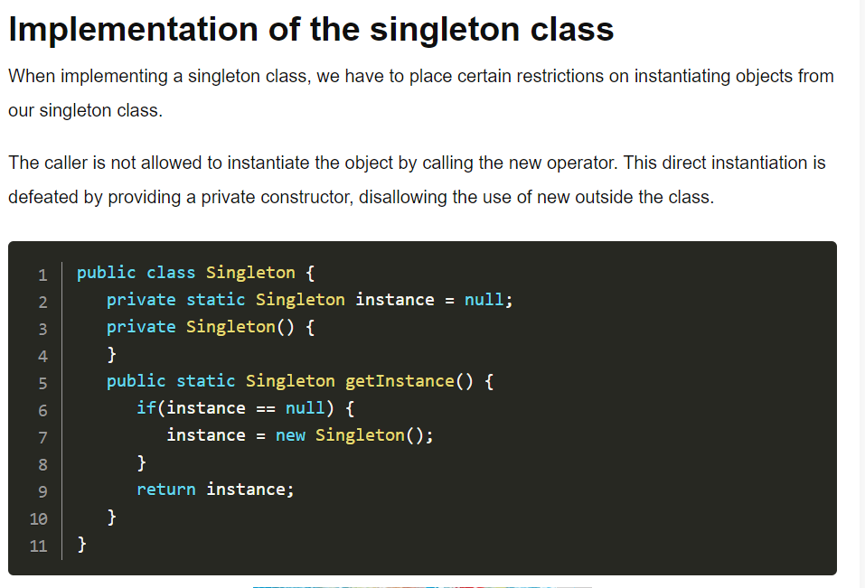

**Making Thread safe :**

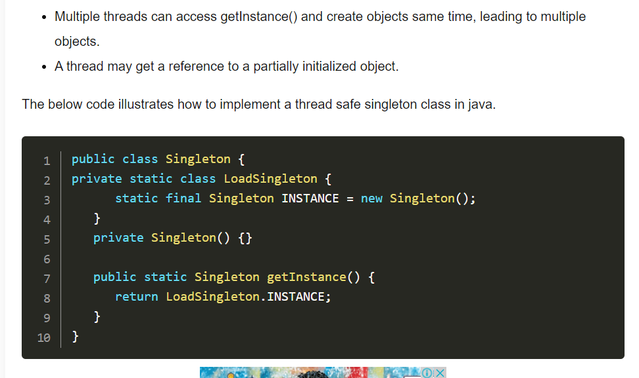

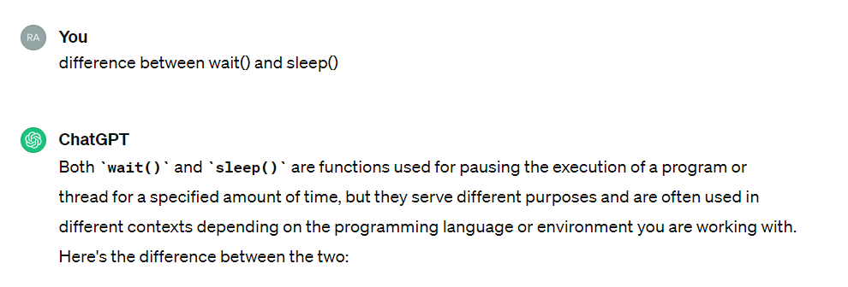

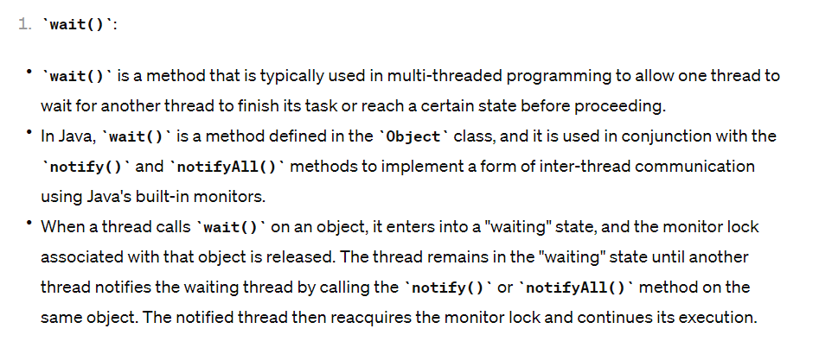

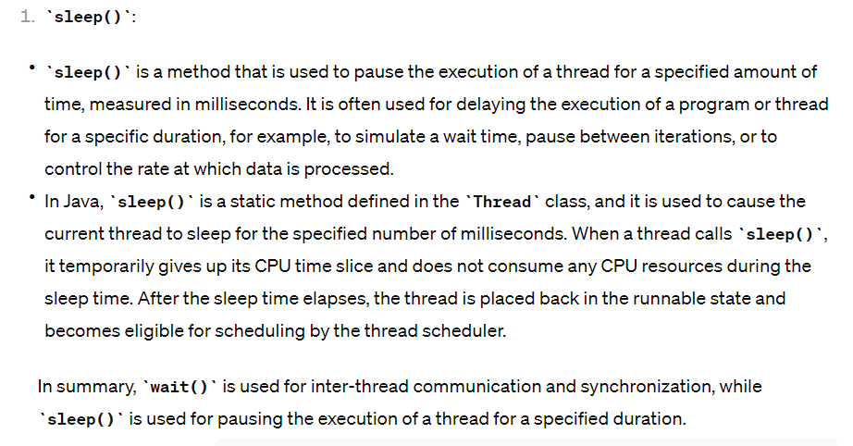

# Mock Testing JUNIT

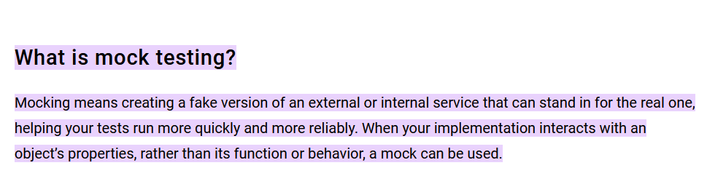

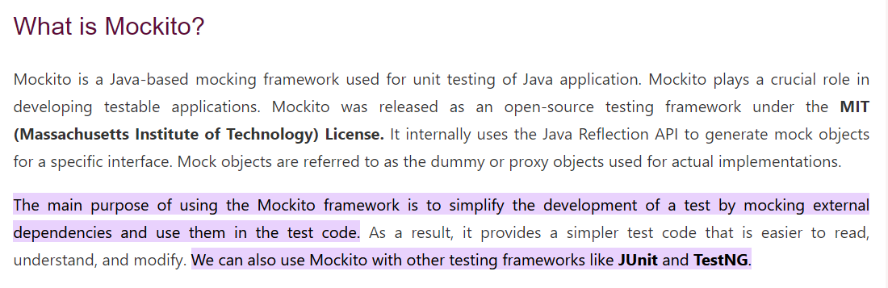

# Association mapping

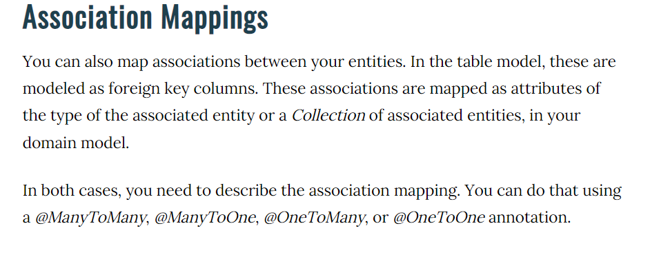

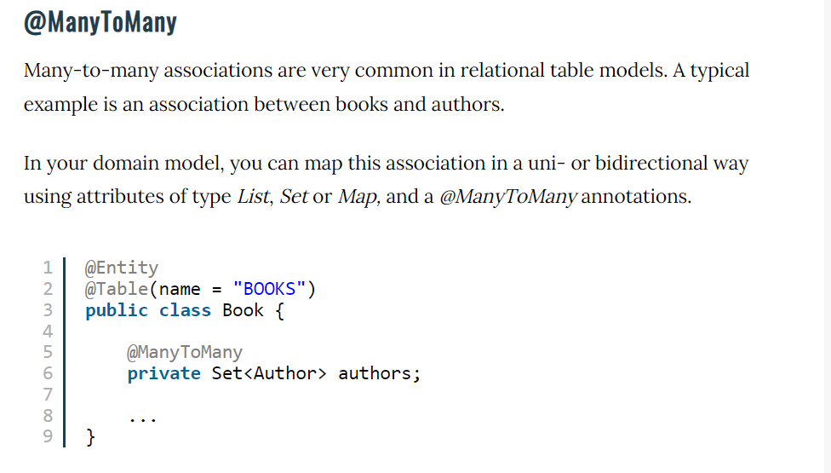

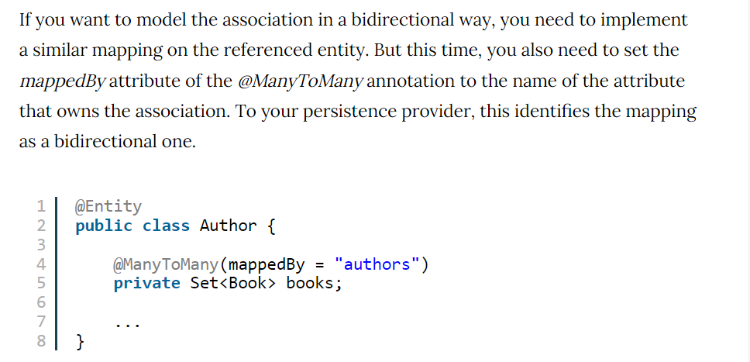

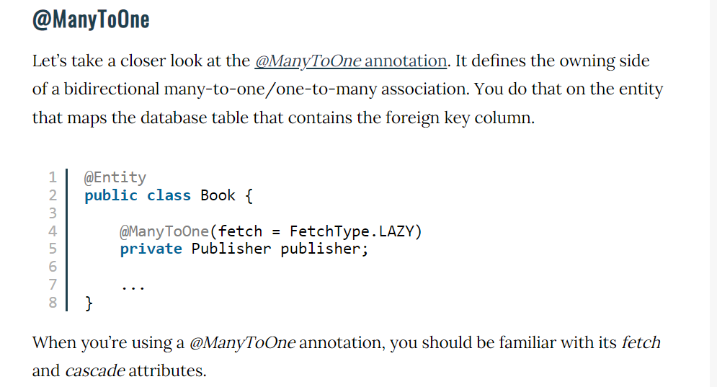

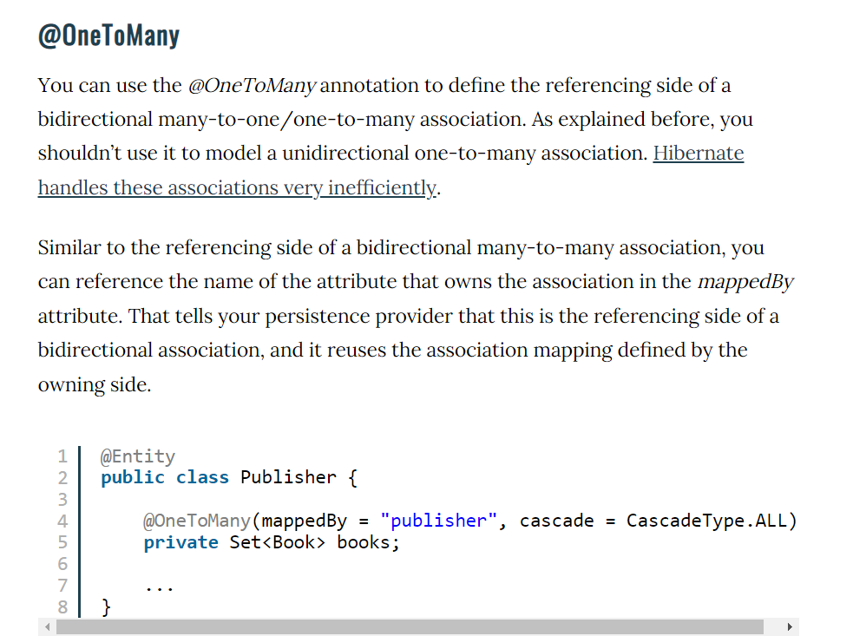

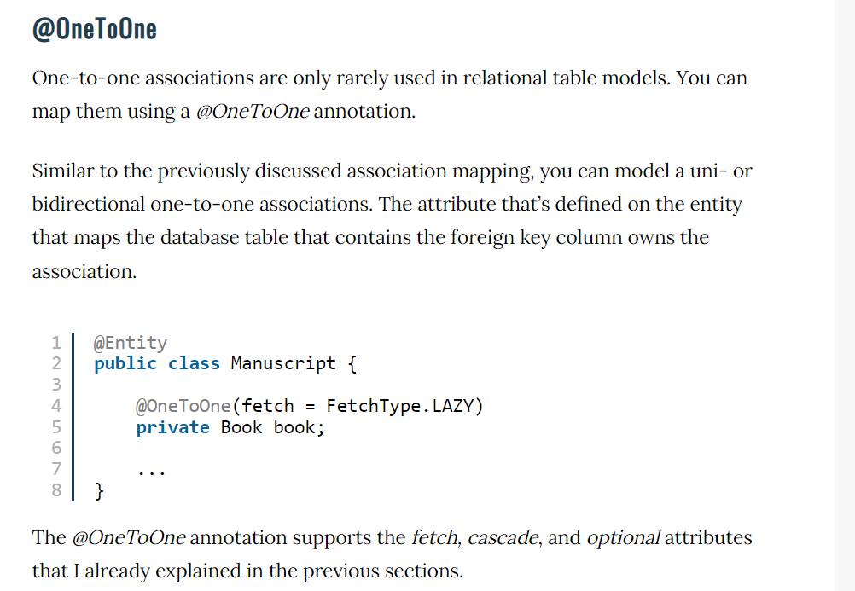

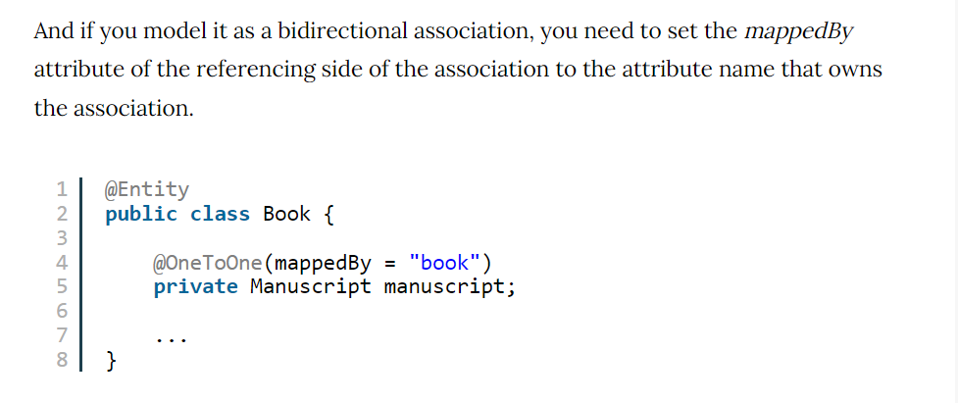

1. Association mapping annotation @JoinColumn

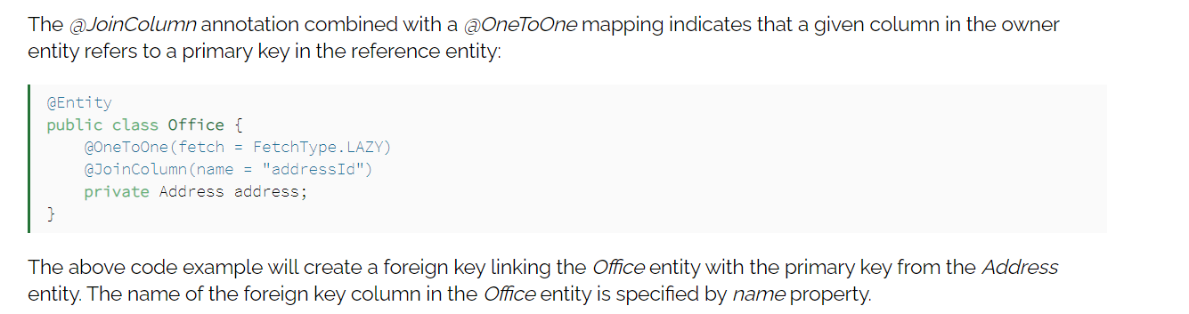

# Design Patterns

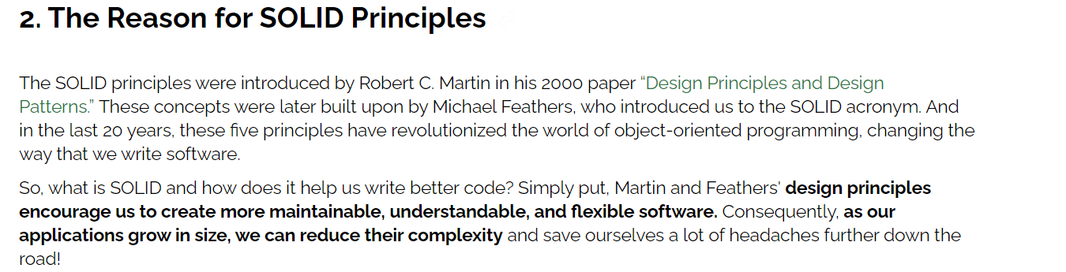

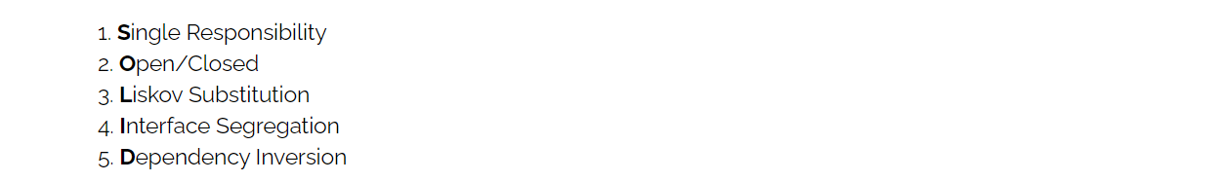

<https://www.baeldung.com/solid-principles>

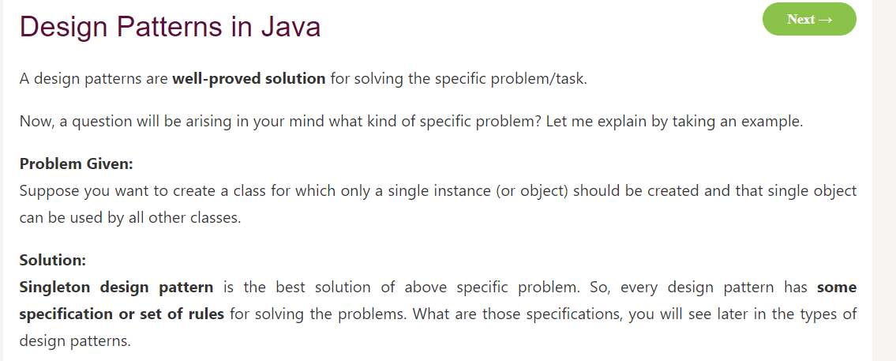

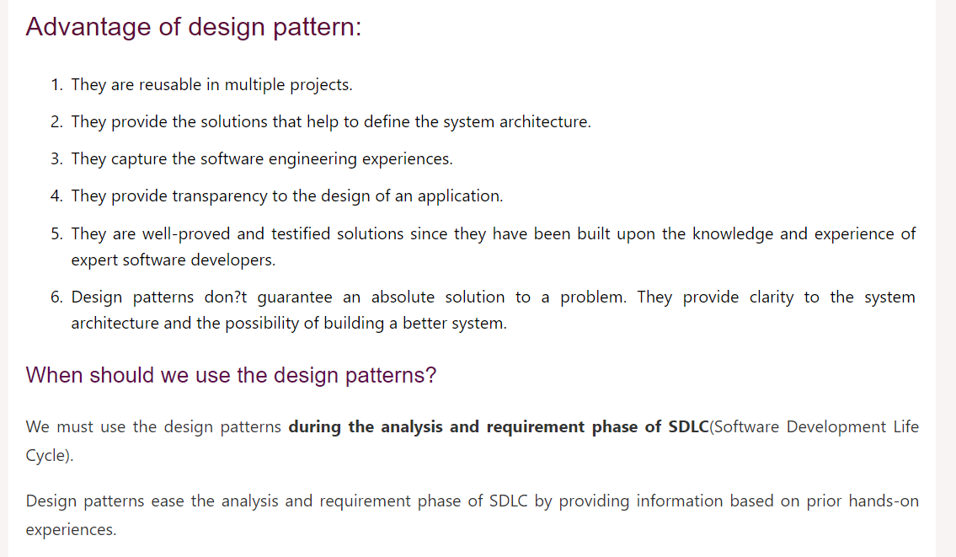

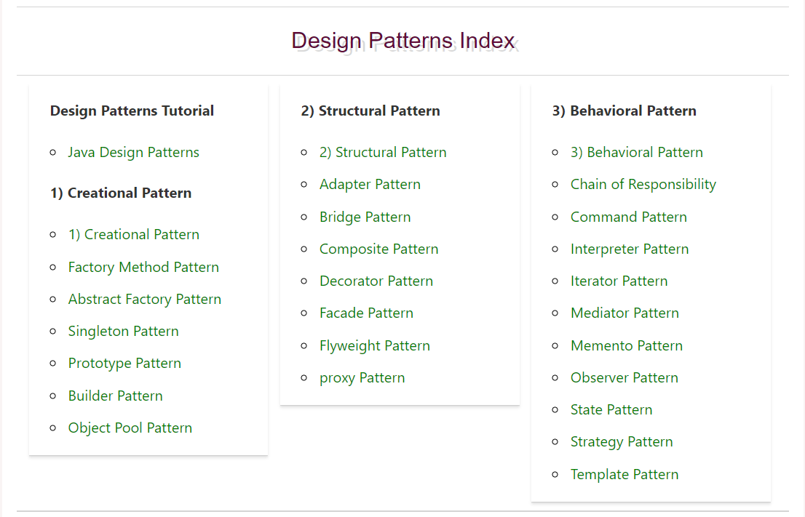

<https://www.javatpoint.com/creational-design-patterns>

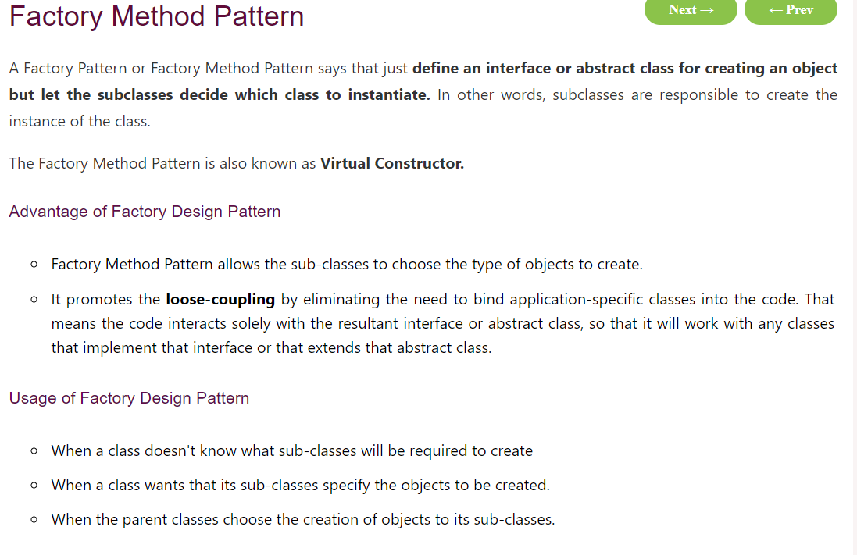

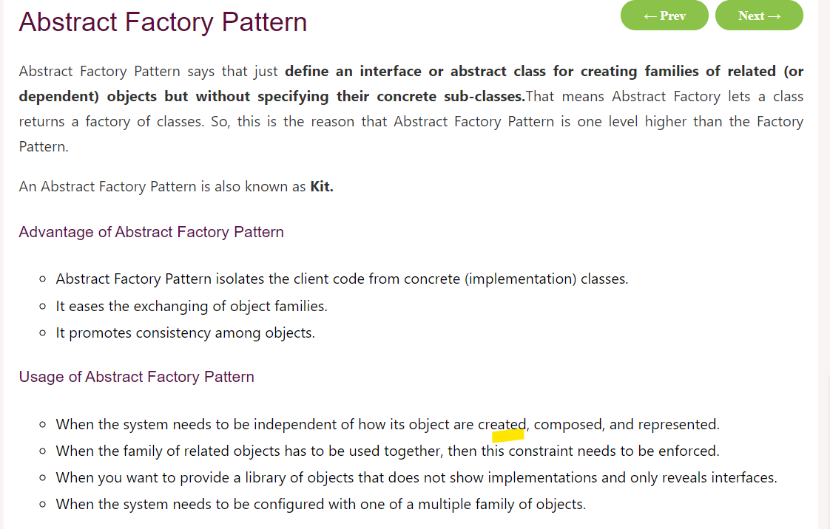

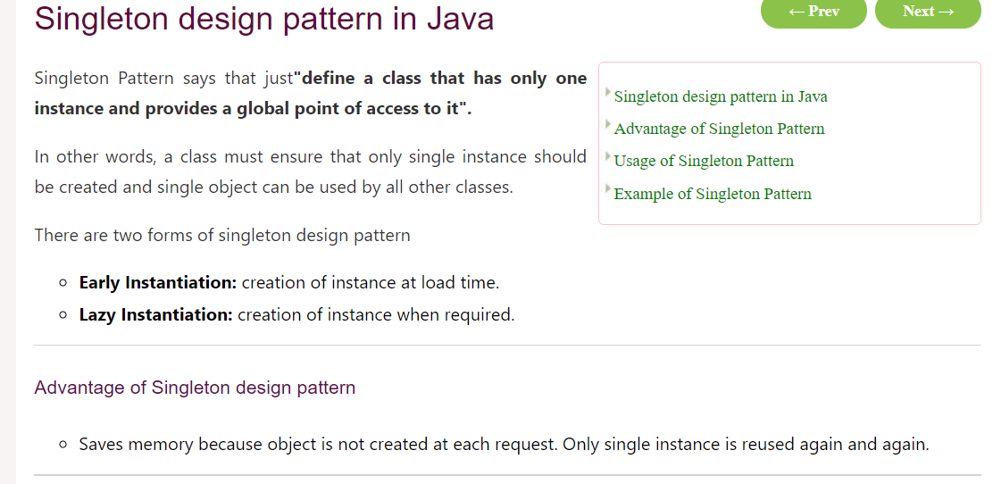

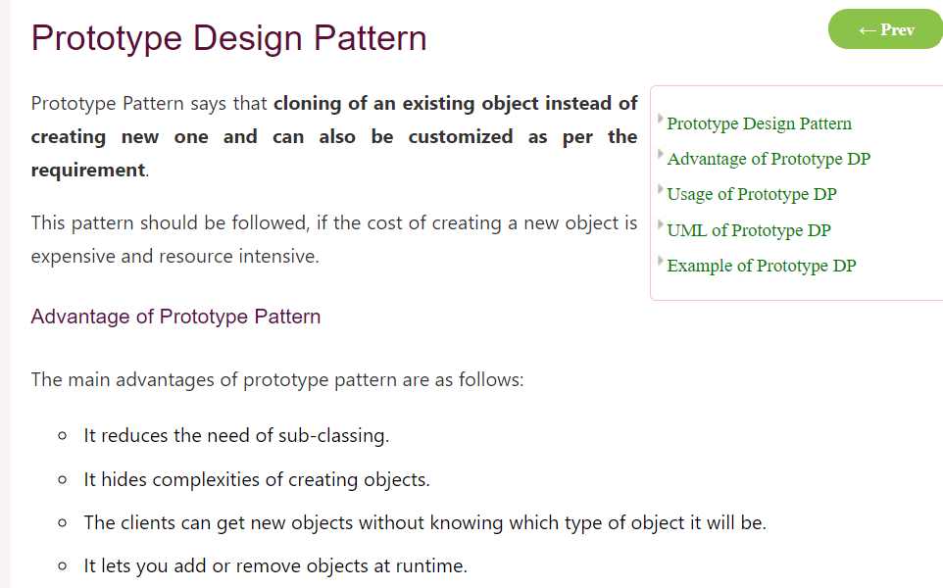

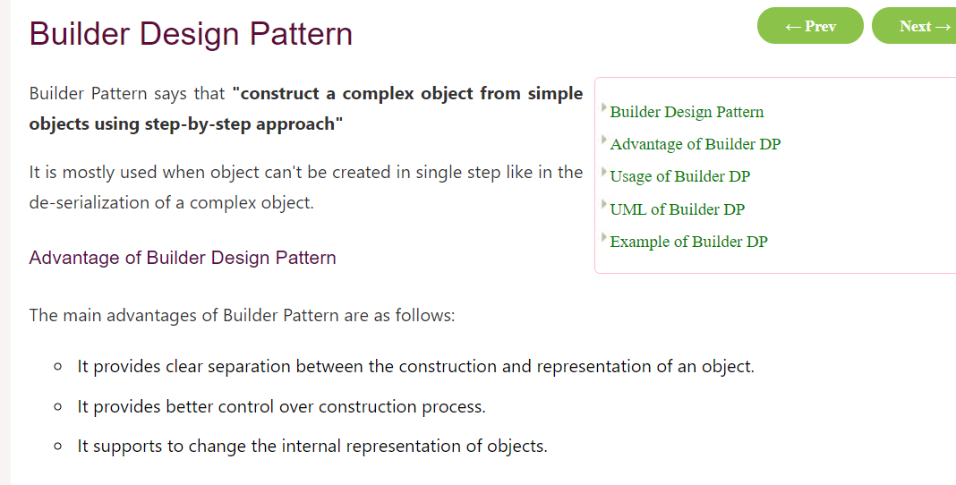

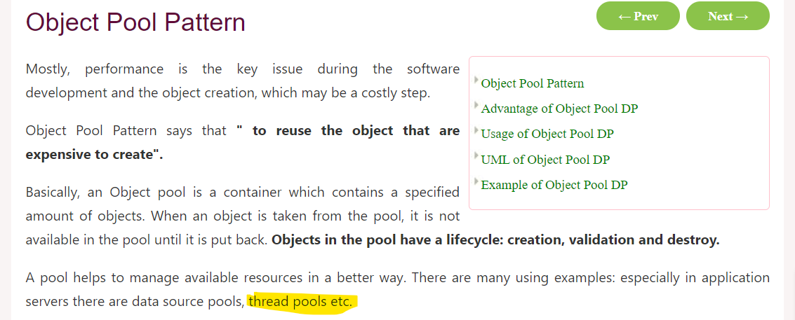

# Spring Boot

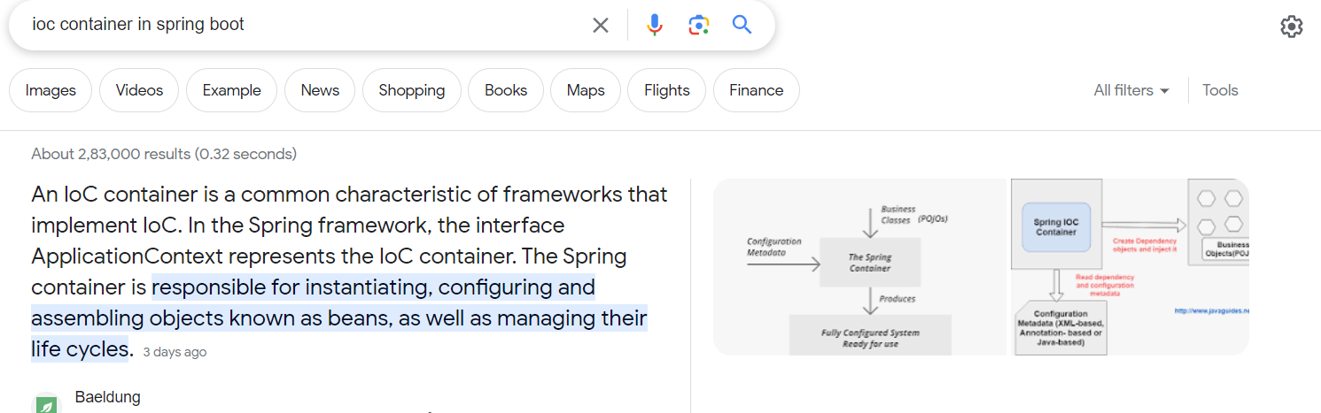

What you understand by auto-configuration by spring boot

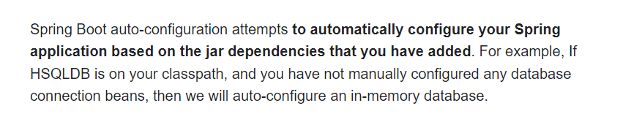

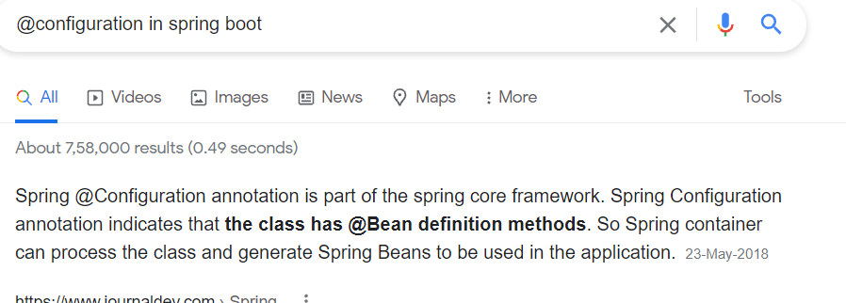

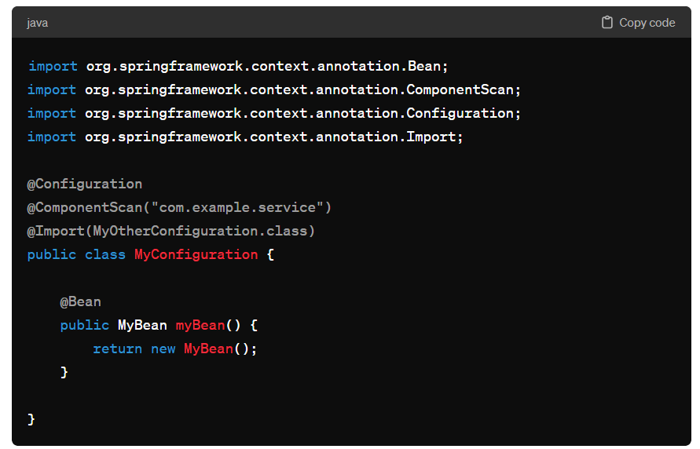

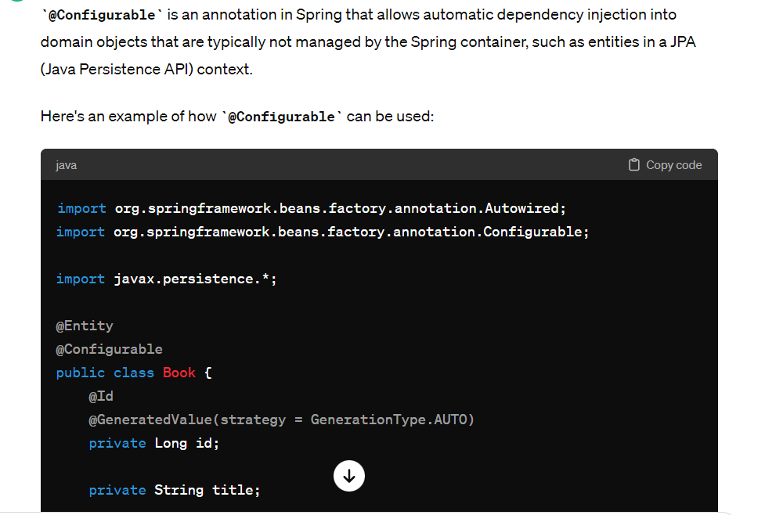

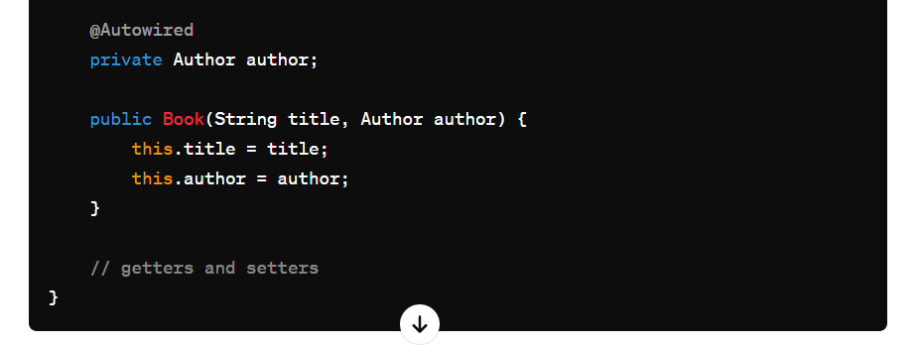

@Qualifier

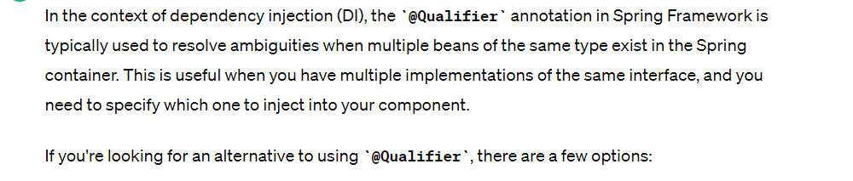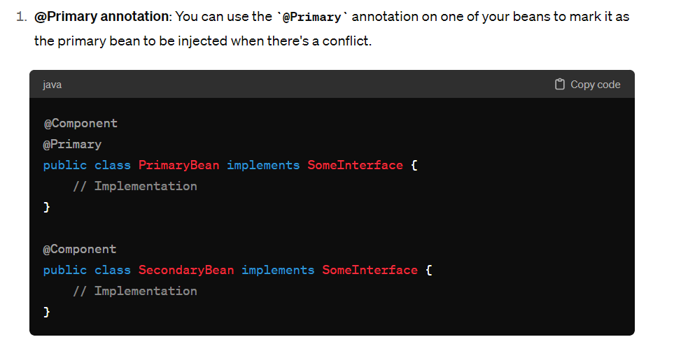

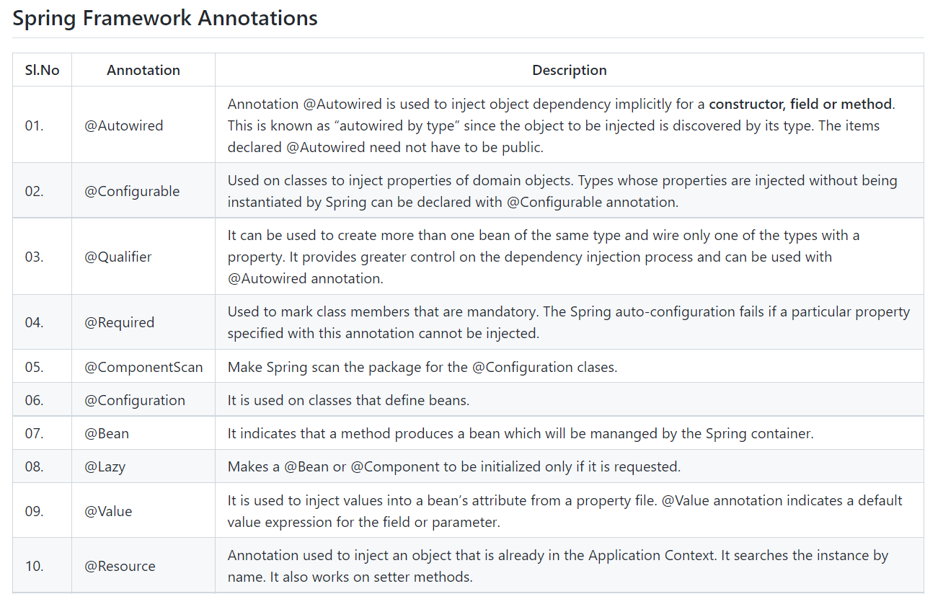

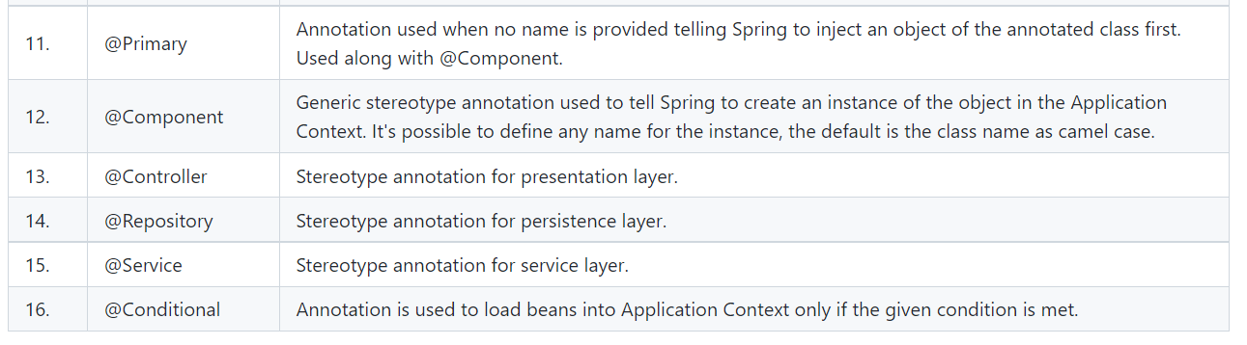

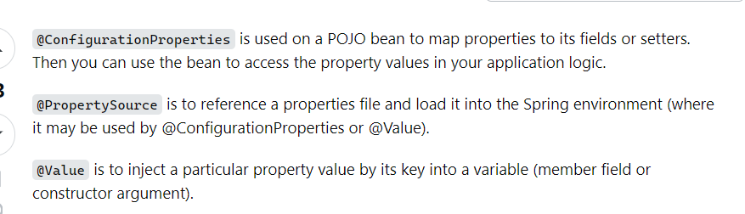

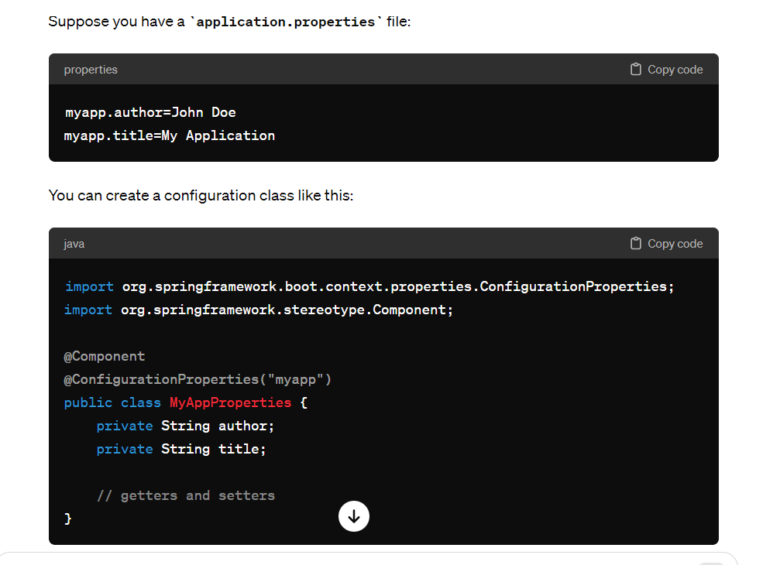

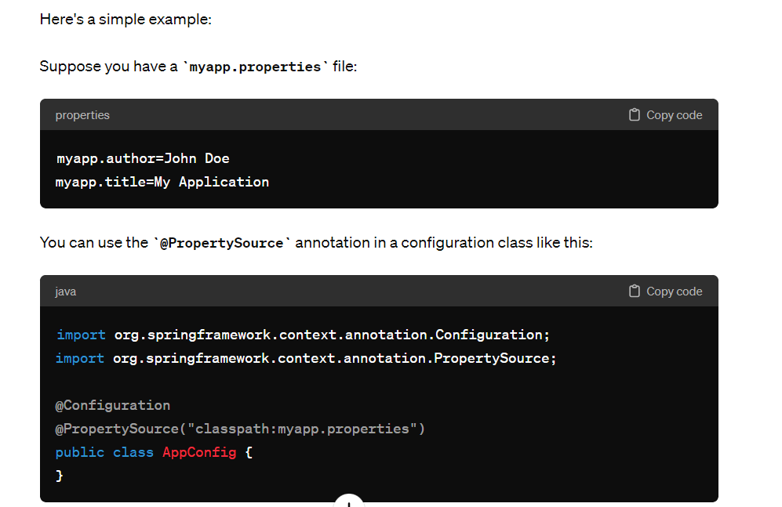

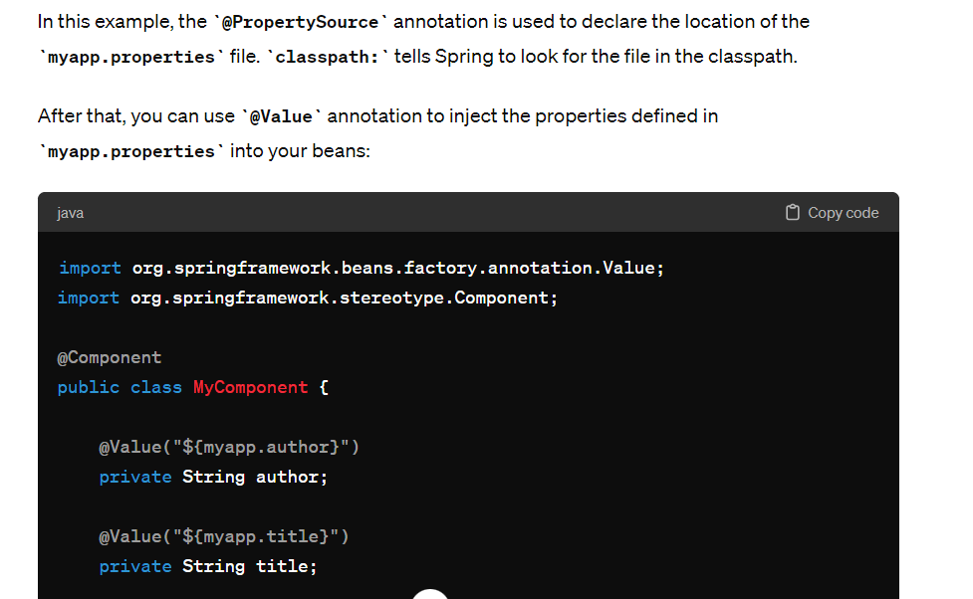

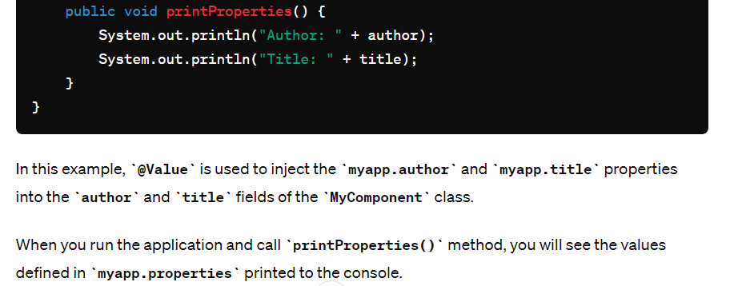

@Autowired. It allows Spring to resolve and inject collaborating beans into our bean.

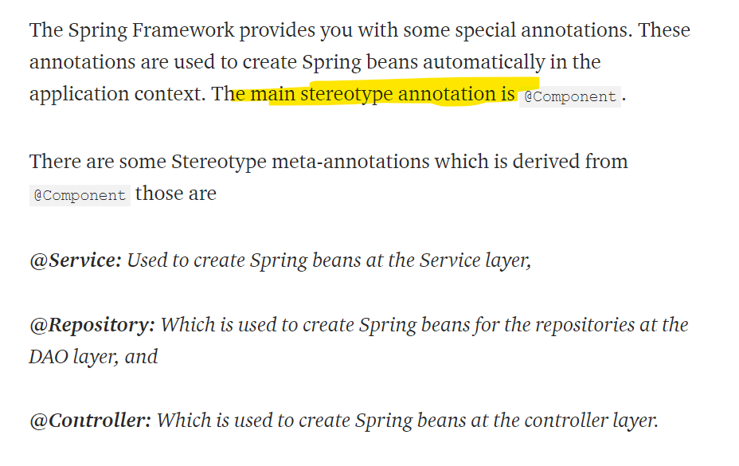

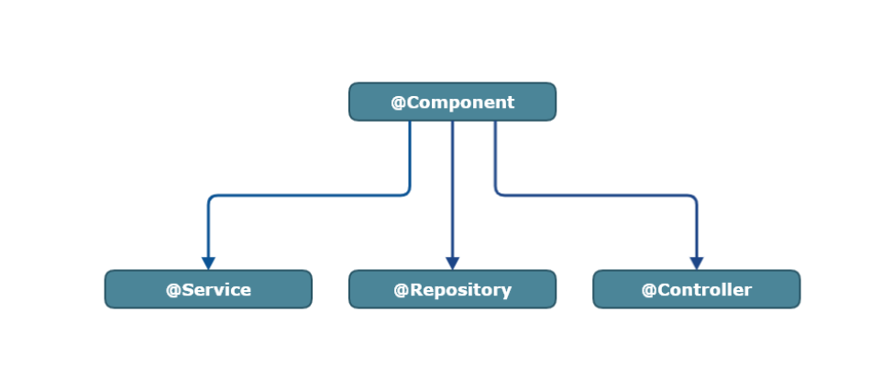

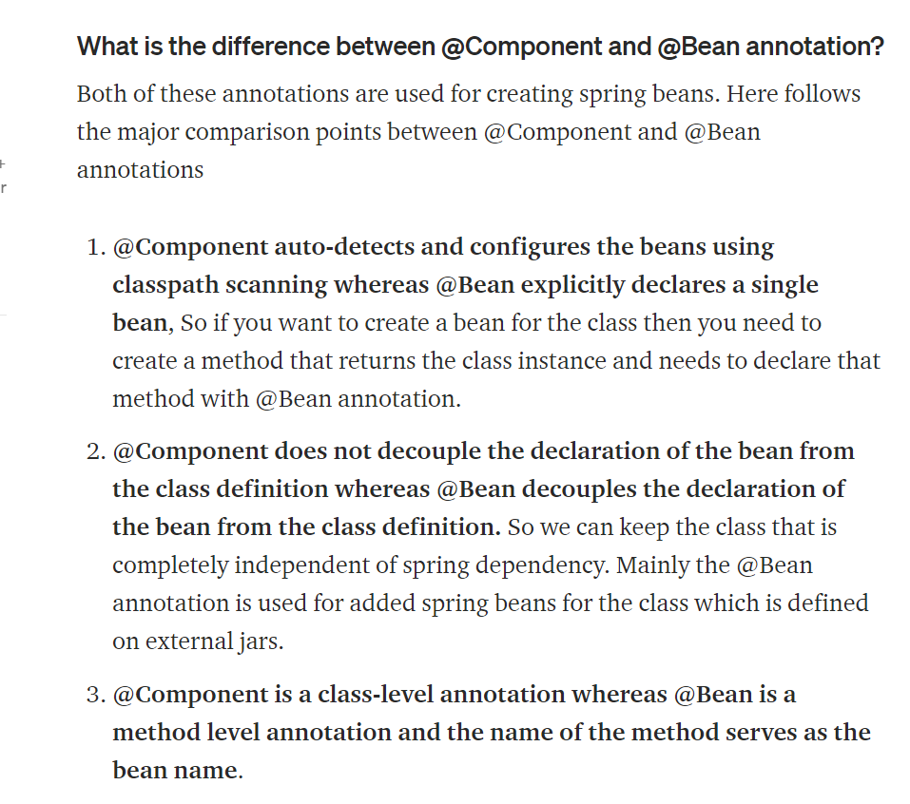

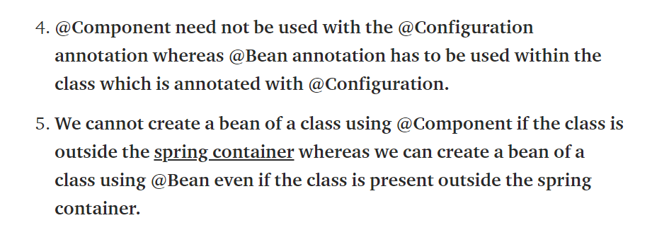

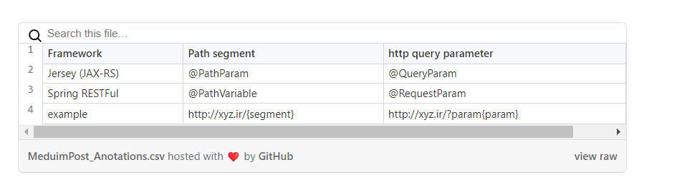

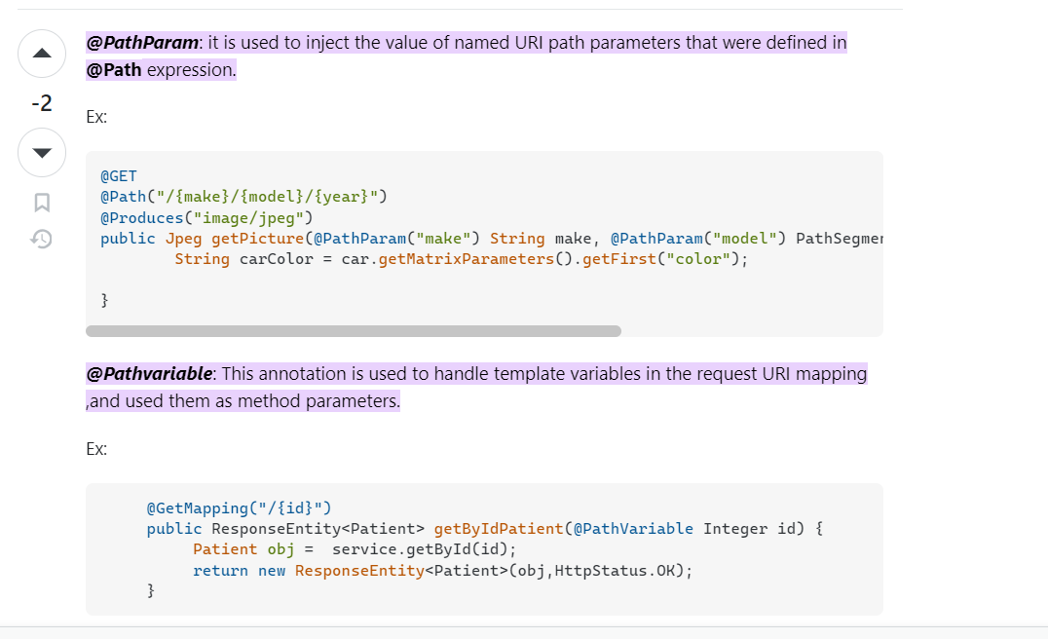

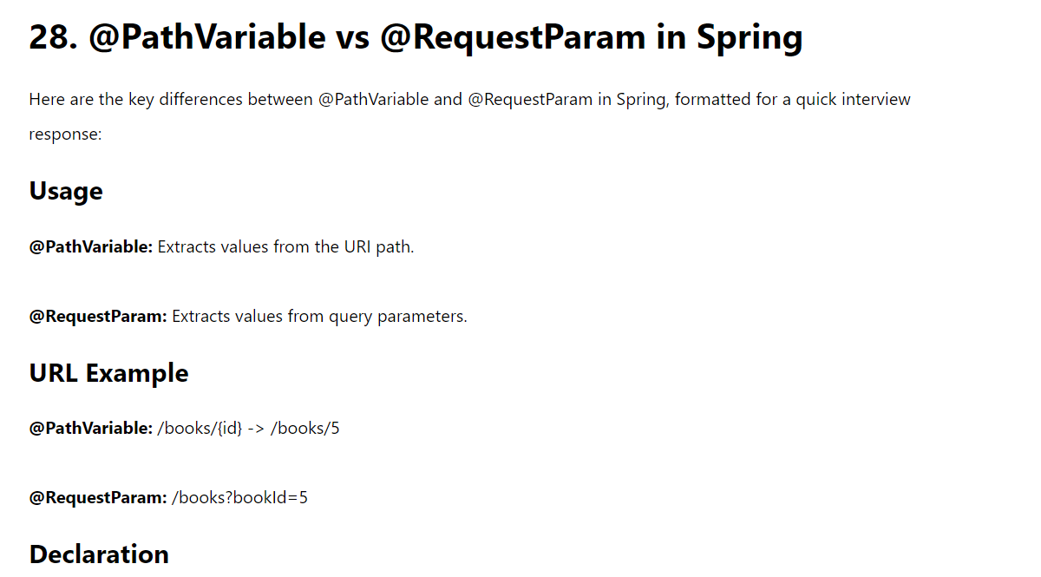

## @Bean scopes:

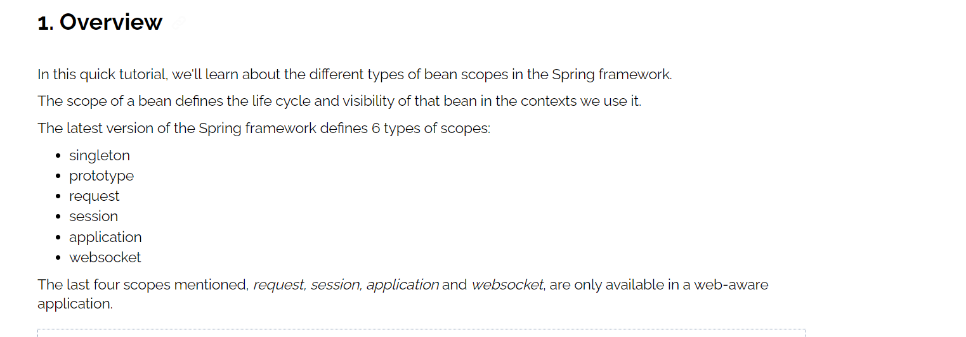

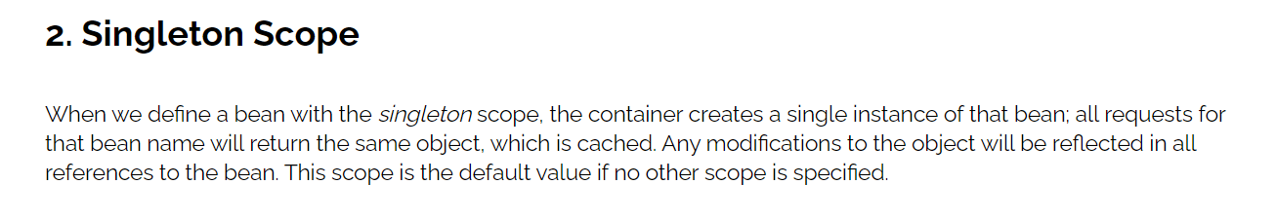

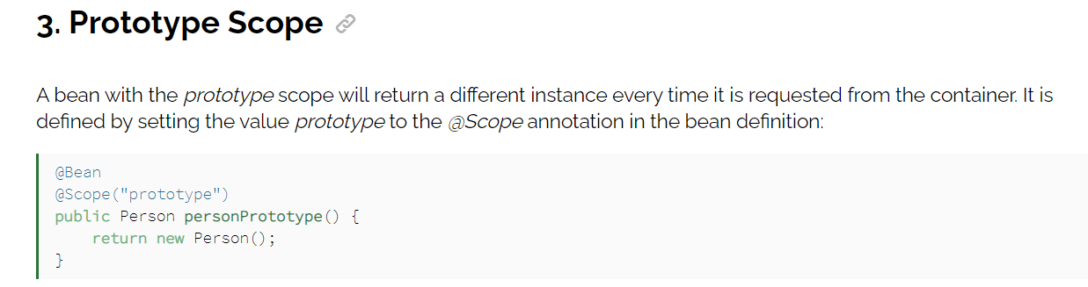

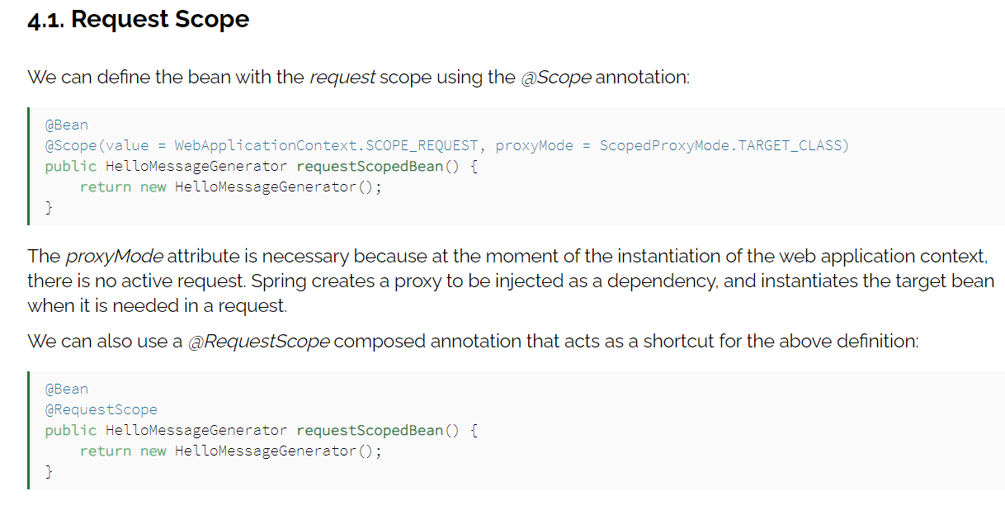

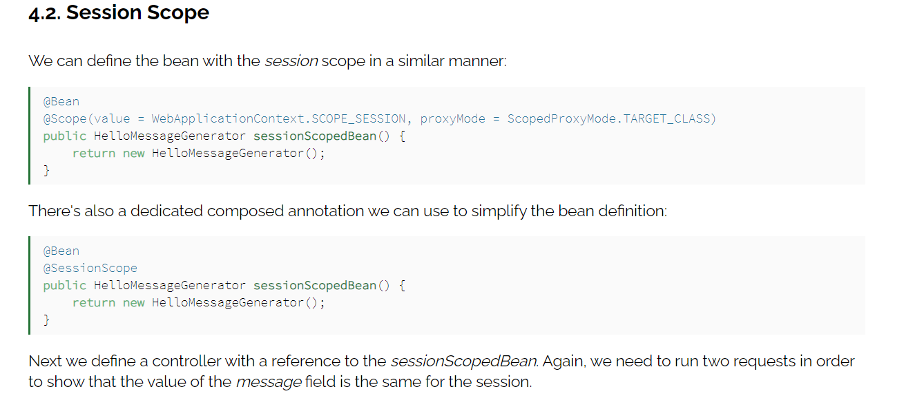

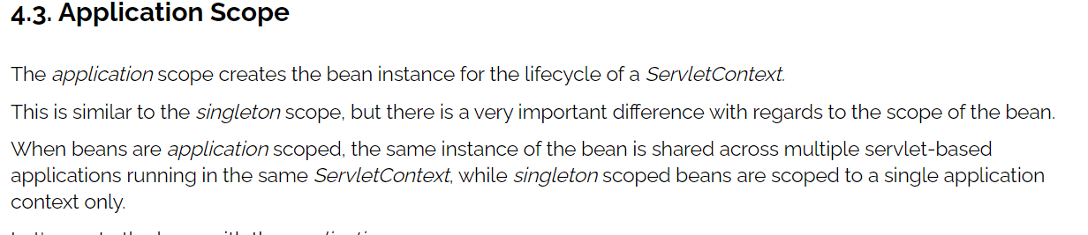

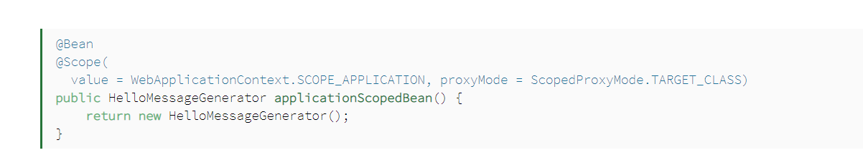

## Spring boot configuration

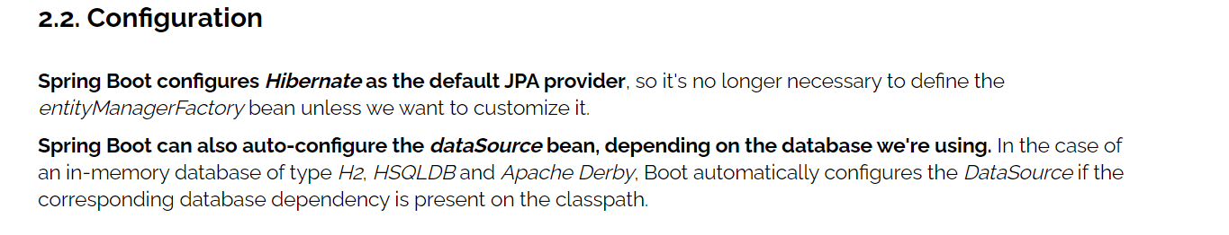 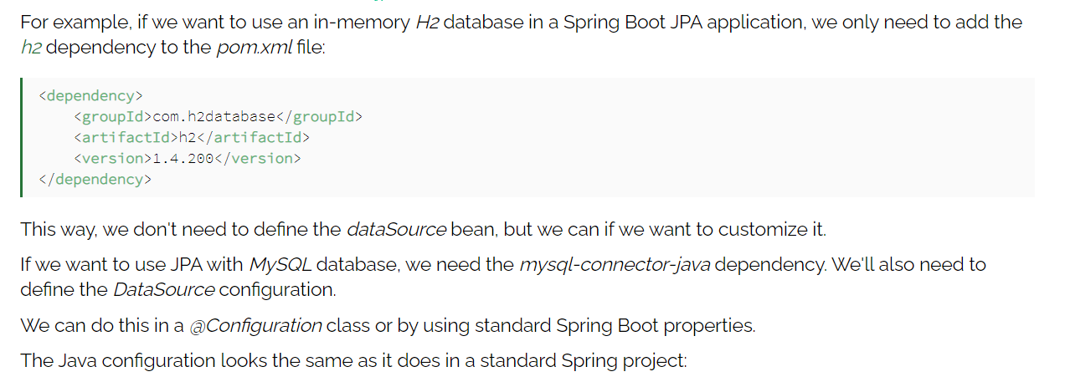

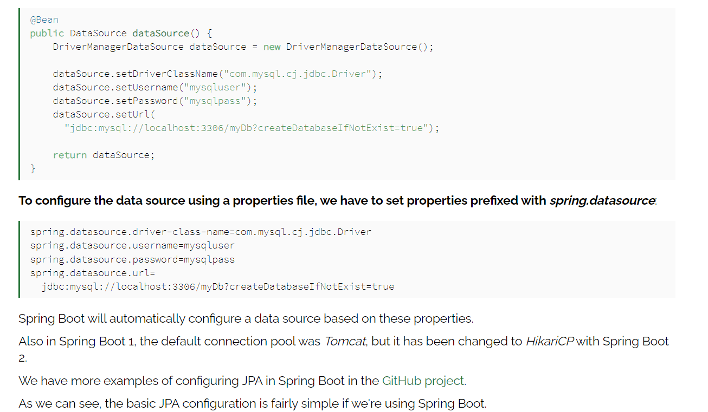

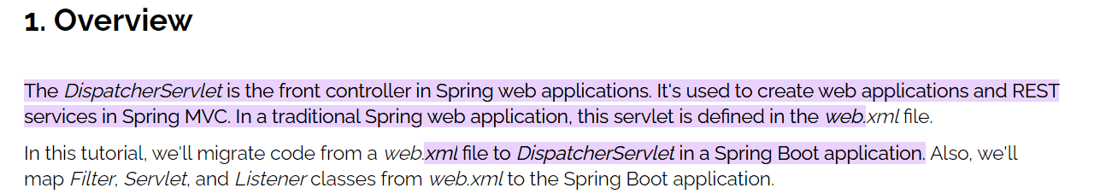

## Consumes and Produces

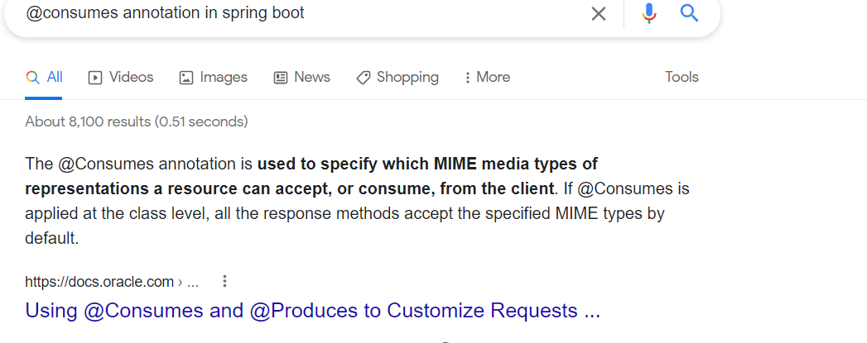

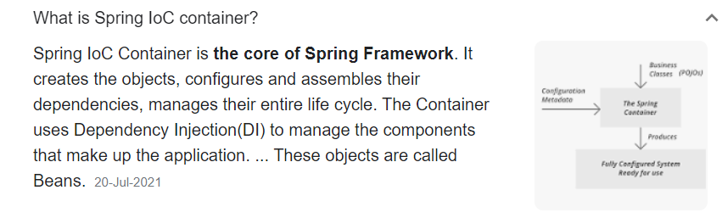

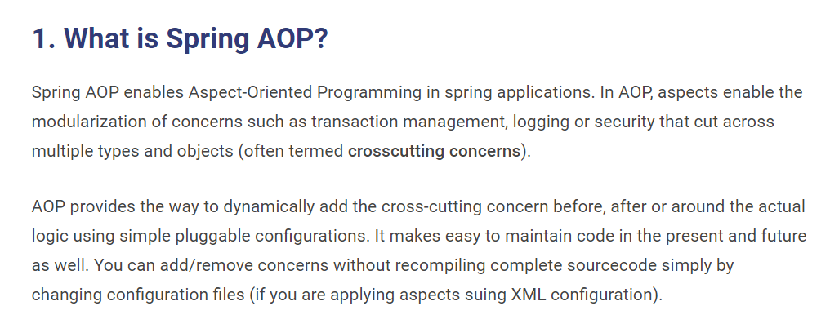

[**https://howtodoinjava.com/spring-aop-tutorial/**](https://howtodoinjava.com/spring-aop-tutorial/)

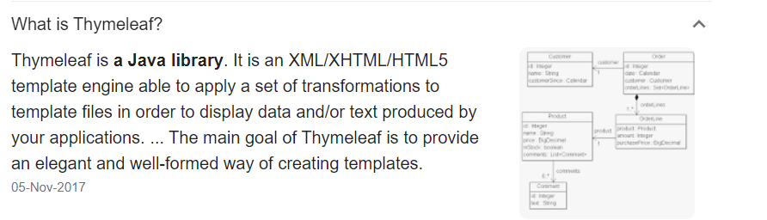

## Actuator

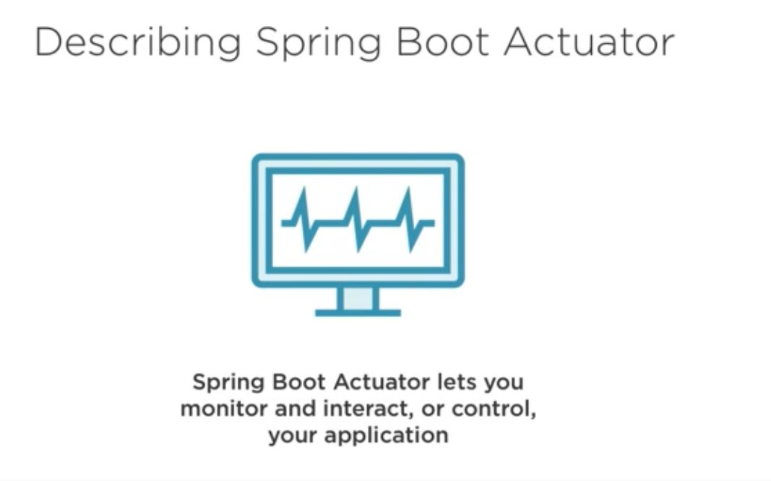

**Exposure all end points :**

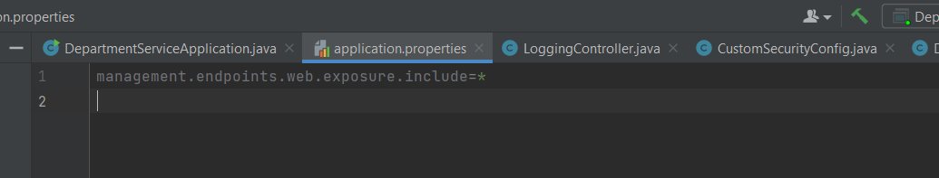

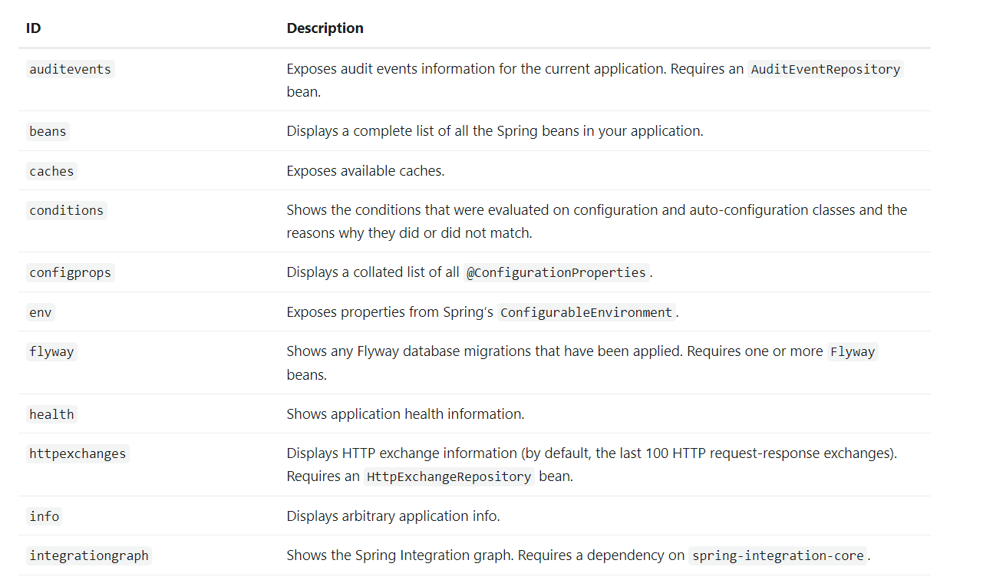

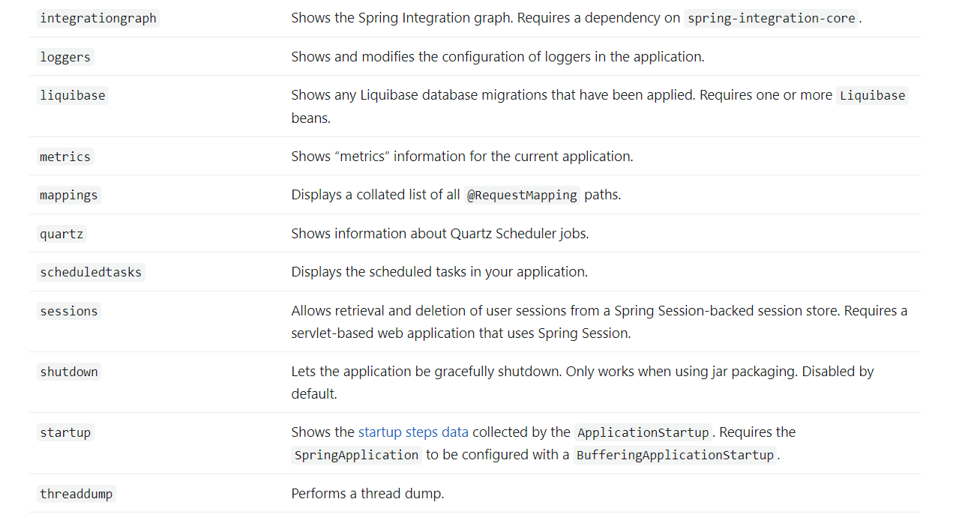

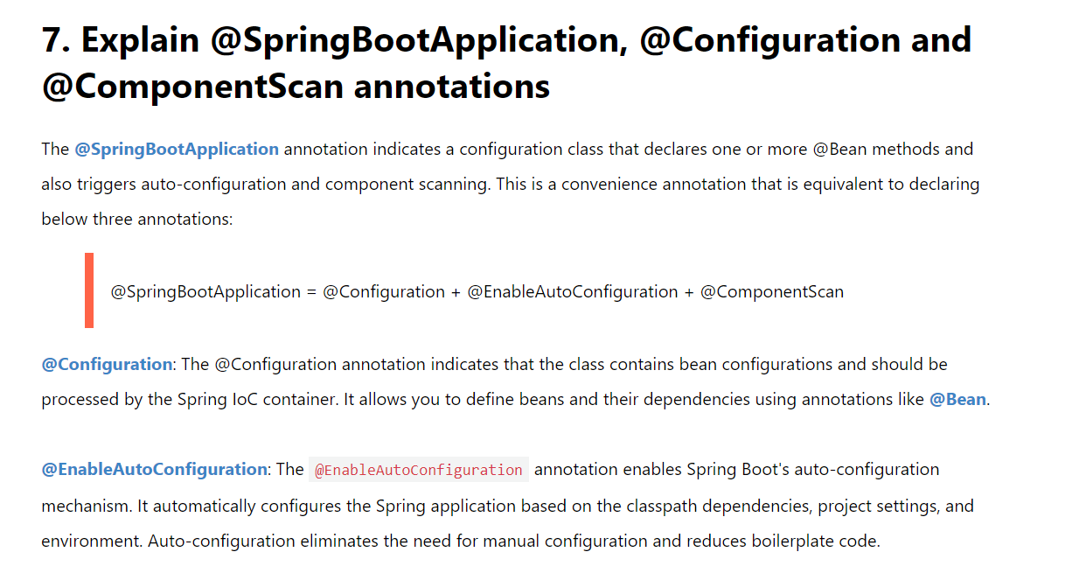

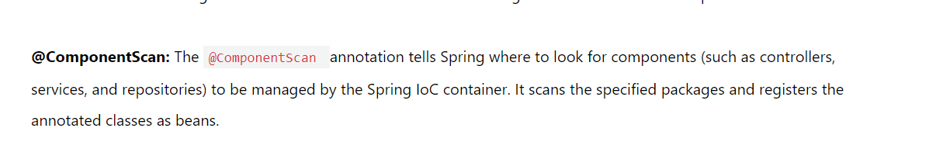

[**https://www.javaguides.net/2018/11/spring-boot-interview-questions-and-answers.html**](https://www.javaguides.net/2018/11/spring-boot-interview-questions-and-answers.html)

## Spring Boot profiles

Spring Boot profiles group parts of the application configuration and make it be available only in certain environments.

A profile is a set of configuration settings. Spring Boot allows to define profile specific property files in the form of application-{profile}.properties. It automatically loads the properties in an application.properties file for all profiles, and the ones in profile-specific property files only for the specified profile. The keys in the profile-specific property override the ones in the master property file.

Note: Spring Boot properties are loaded in a particular order. If several profiles are specified, the last-wins strategy applies.

The @Profile annotation indicates that a component is eligible for registration when the specified profile or profiles are active. The default profile is called default; all the beans that do not have a profile set belong to this profile.

There are plenty of ways of defining active profiles in Spring Boot, including command line arguments, Maven/Gradle settings, JVM system parameters, environment variables, spring.profiles.active property, and SpringApplication methods.

https://zetcode.com/springboot/profile/#:~:text=Spring%20Boot%20profiles%20group%20parts,form%20of%20application%2D%7Bprofile%7D.

# Overview of Spring Boot Dev Tools

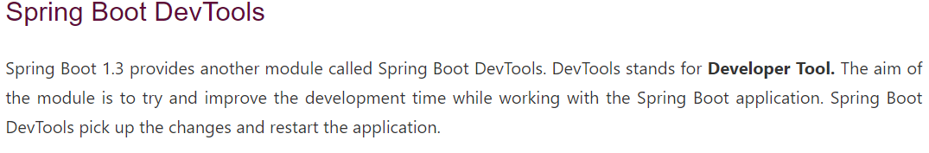

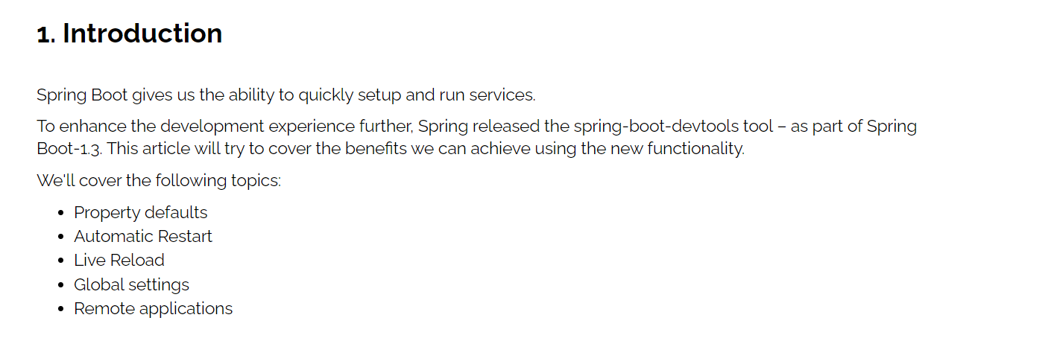

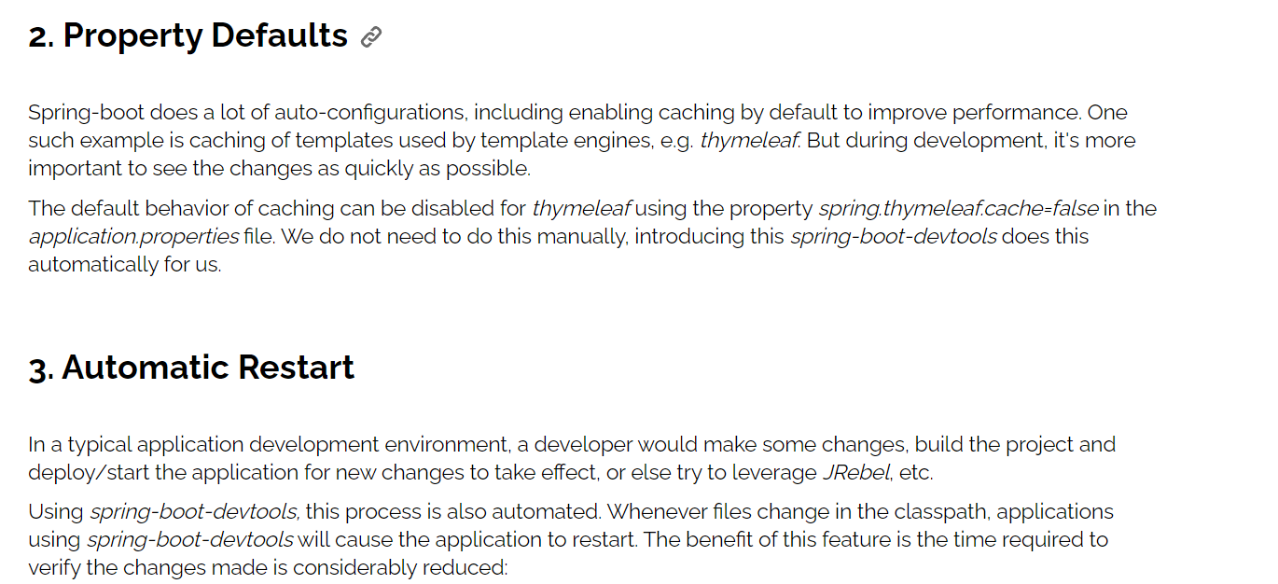

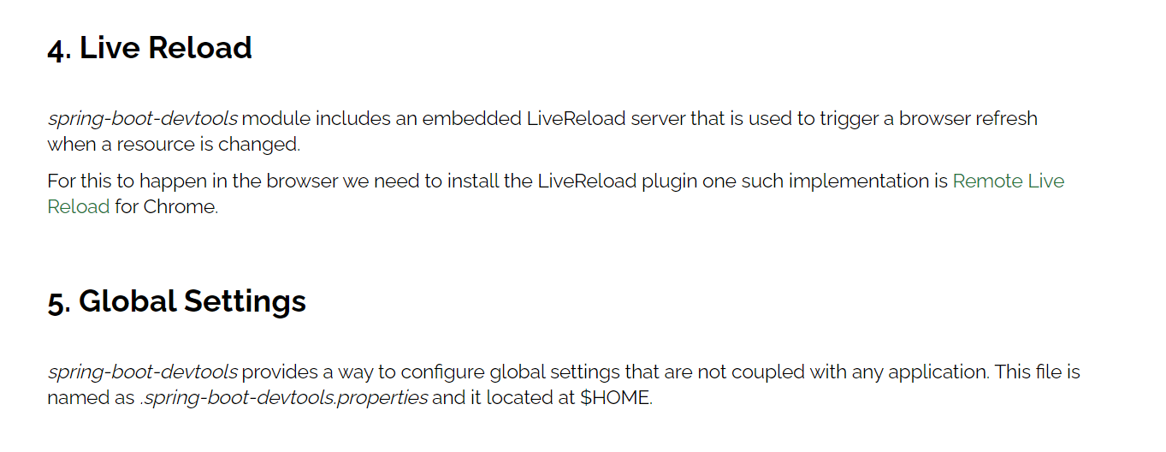

# Spring Data :

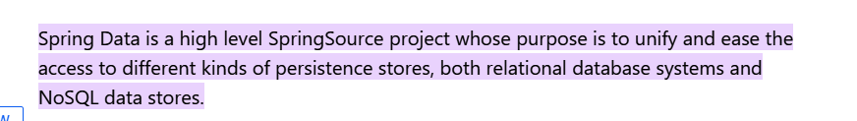

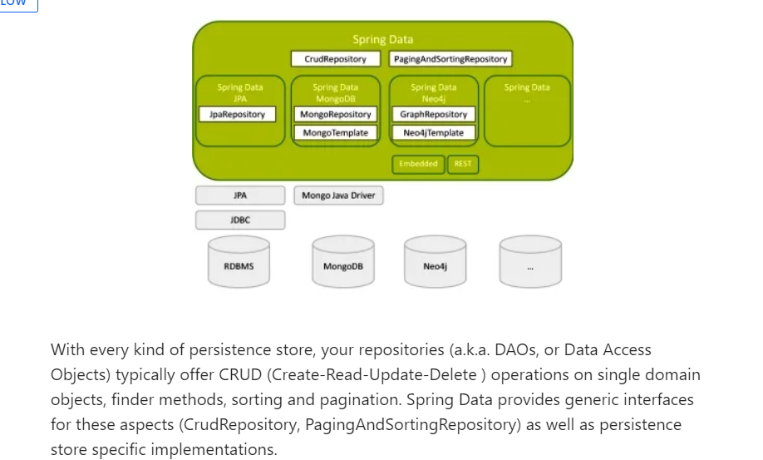

# SQL

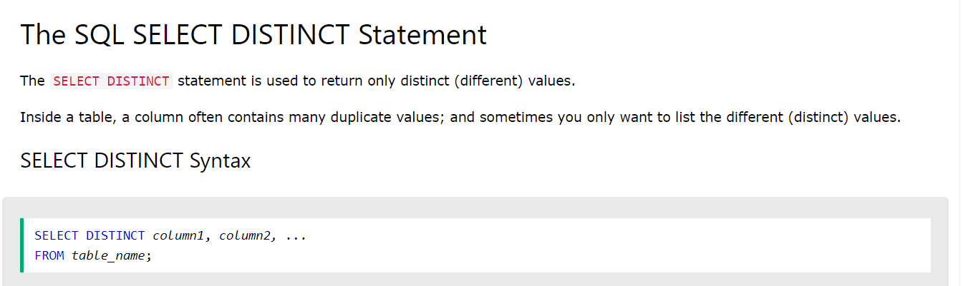

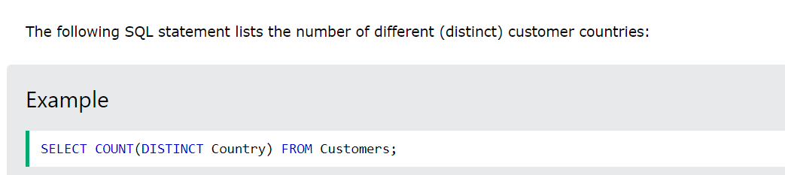

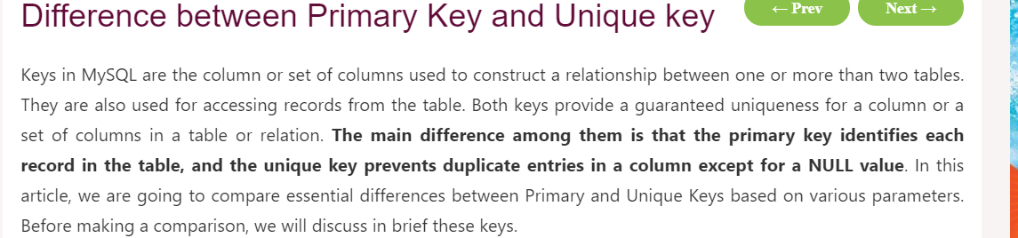

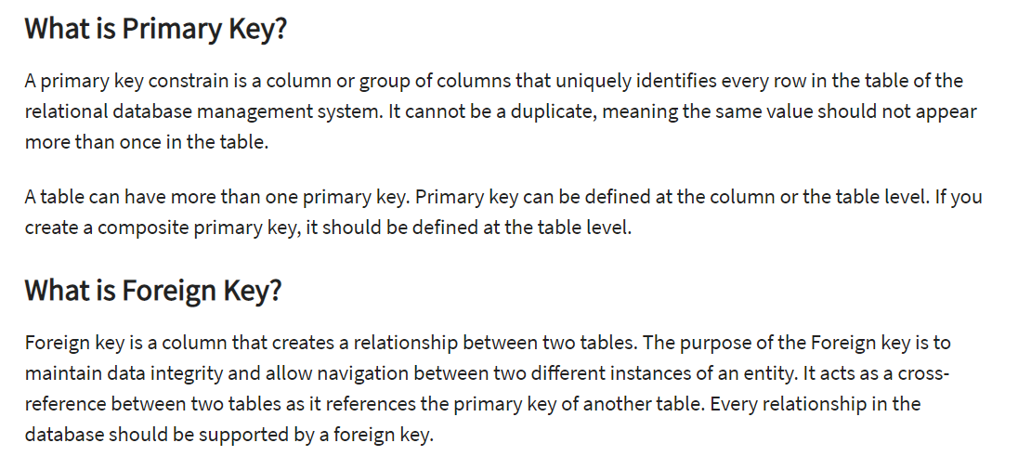

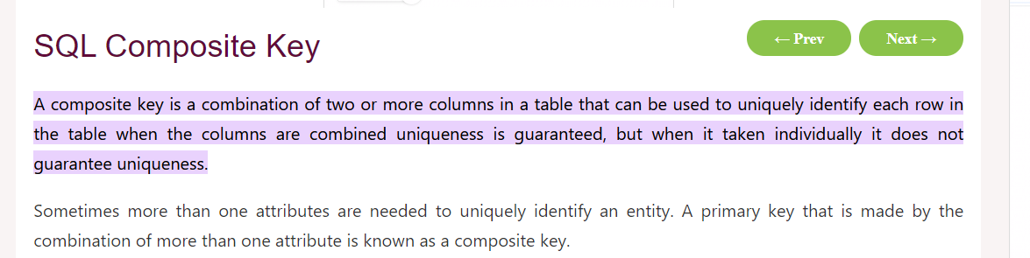

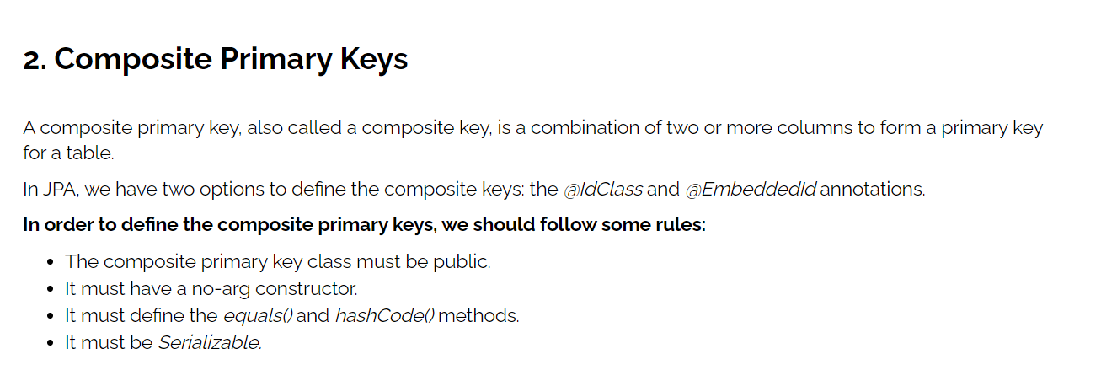

[**https://www.baeldung.com/jpa-composite-primary-keys**](https://www.baeldung.com/jpa-composite-primary-keys)

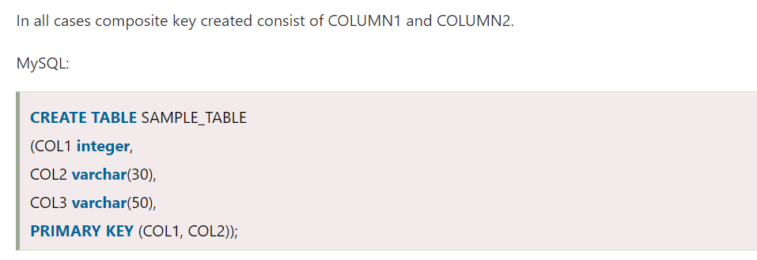

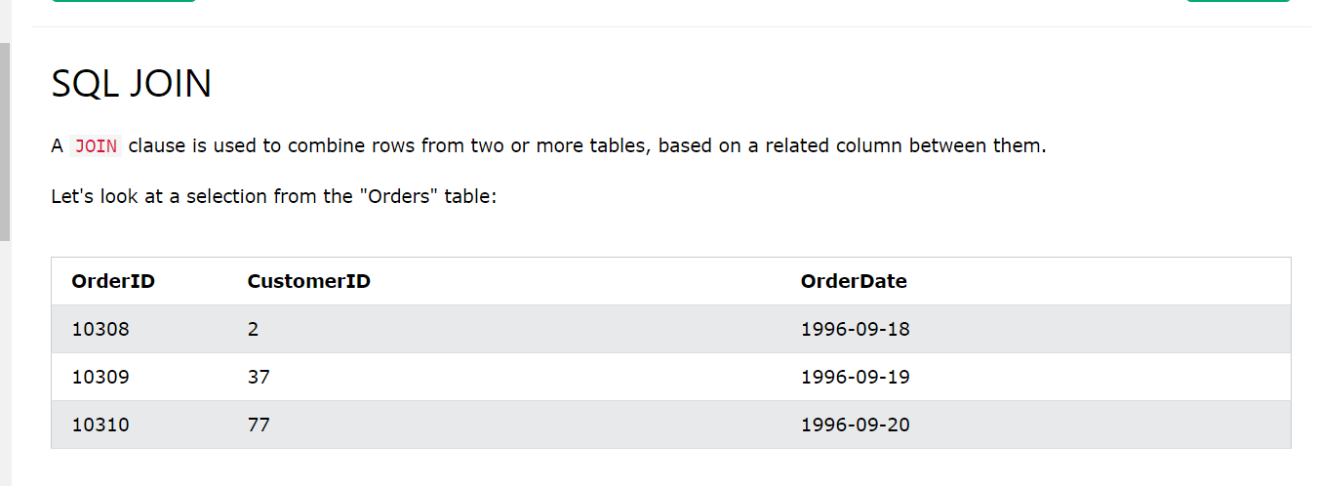

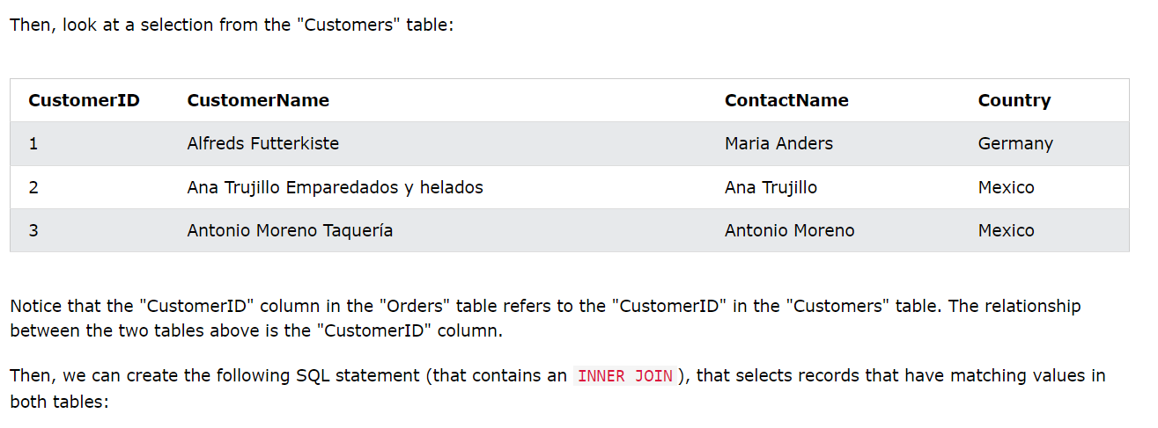

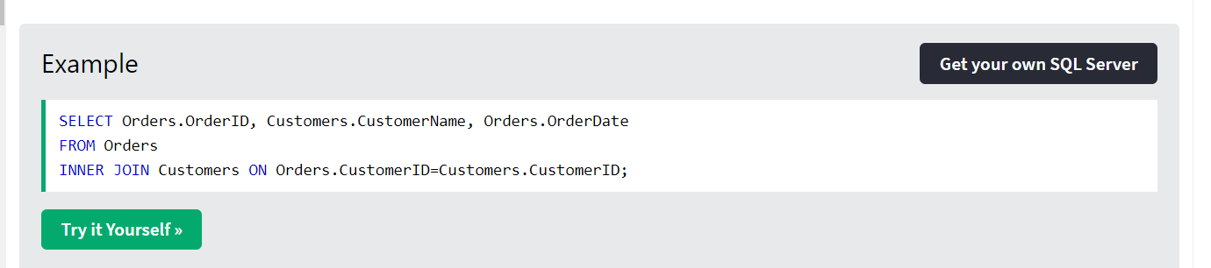

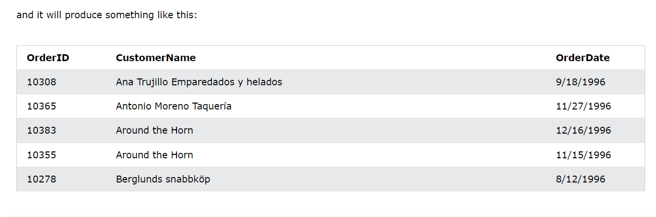

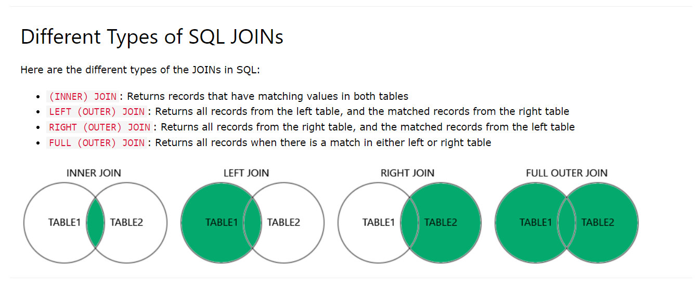

# DBMS

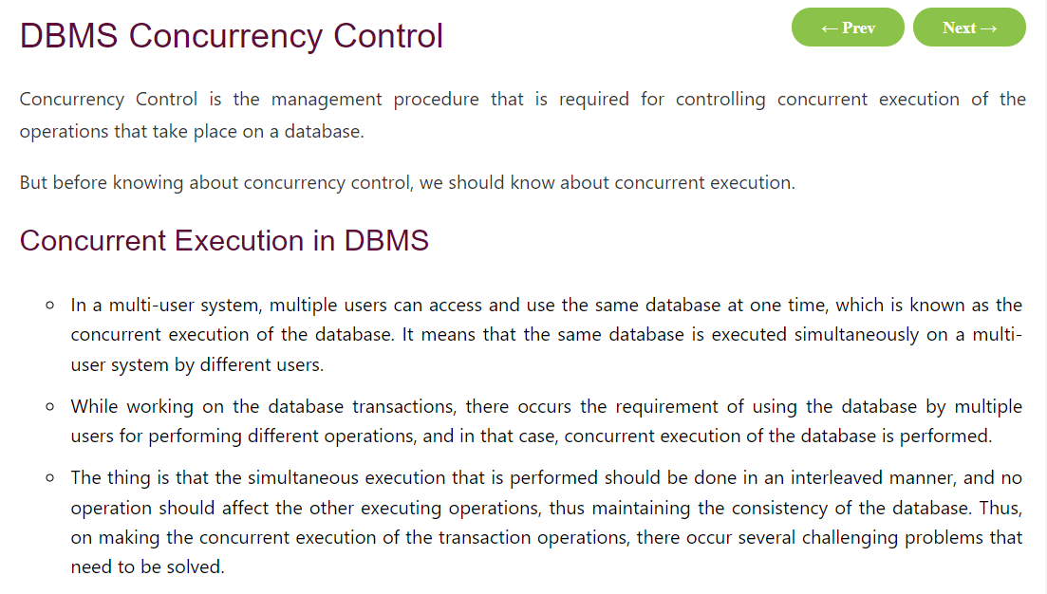

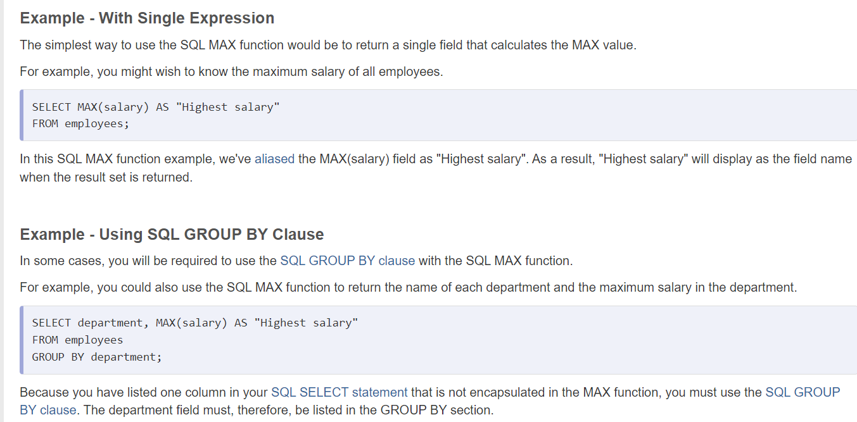



query to fetch 500 records and print only last 10 records

To lock certain records in a database, you typically use transactions and locks provided by the database management system (DBMS). Different databases might have different mechanisms for achieving record locking, but here's a general approach:

1. **Start a Transaction**: Begin a transaction to encapsulate the operations that involve the records you want to lock.
2. **Select the Records to Lock**: Execute a SELECT query with appropriate conditions to retrieve the records you want to lock.
3. **Apply Locks**: Use the appropriate locking mechanism provided by your DBMS. Common types of locks include:
   * **Row-level locks**: Lock individual rows to prevent other transactions from modifying them.
   * **Table-level locks**: Lock the entire table to prevent any operations (e.g., INSERT, UPDATE, DELETE) on it.
   * **Exclusive locks**: Locks that prevent other transactions from accessing the locked resource.
   * **Shared locks**: Locks that allow other transactions to read the locked resource but prevent them from modifying it.
4. **Perform Operations**: Perform any necessary operations (e.g., updates, deletions) on the locked records within the transaction.
5. **Commit the Transaction**: If the operations are successful and you no longer need the locks, commit the transaction to make the changes permanent and release the locks.

Here's a simplified example in pseudocode using SQL:

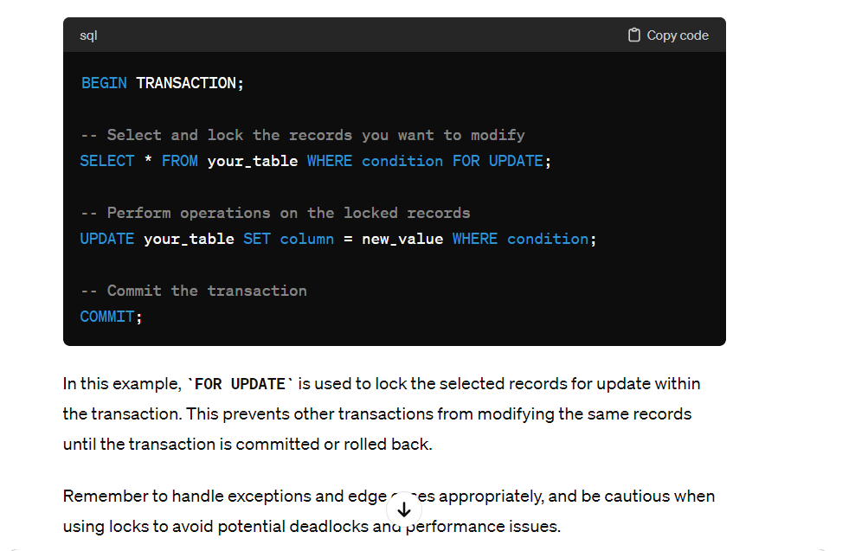

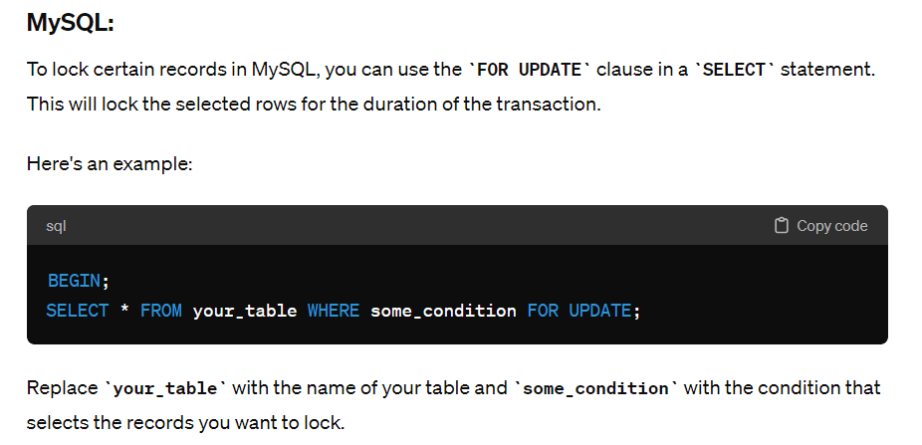

# REST VS SOAP

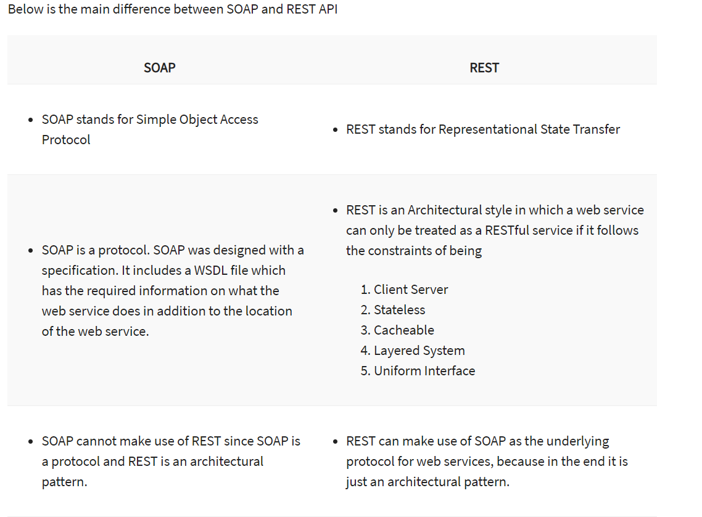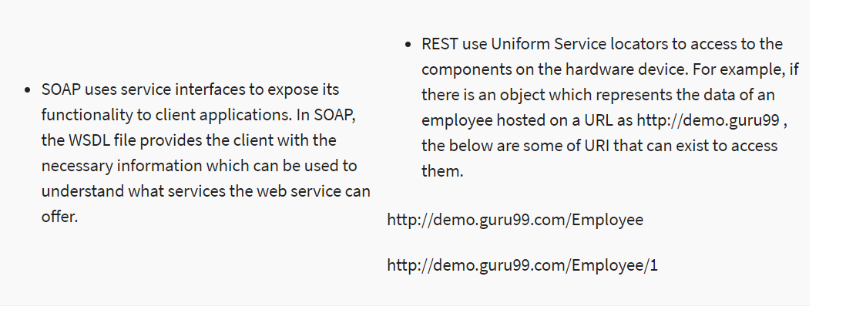

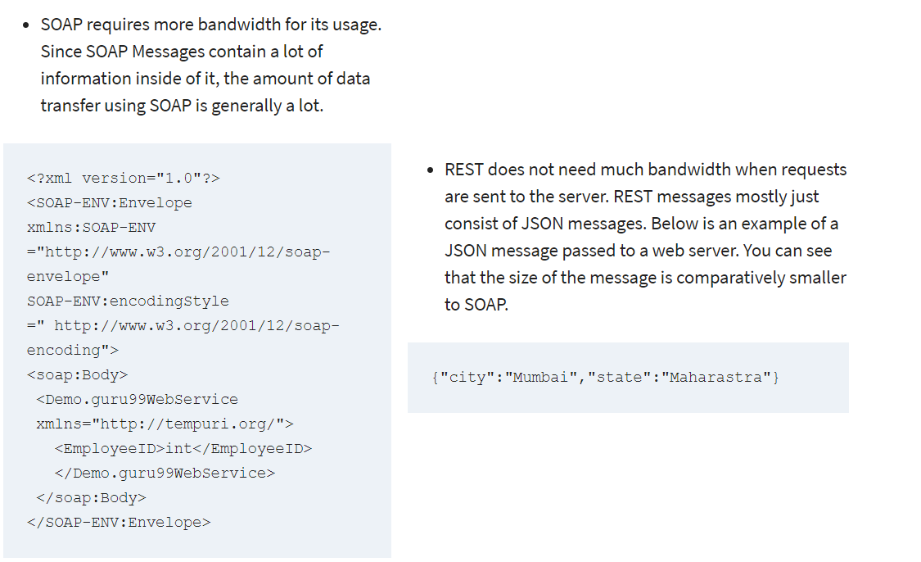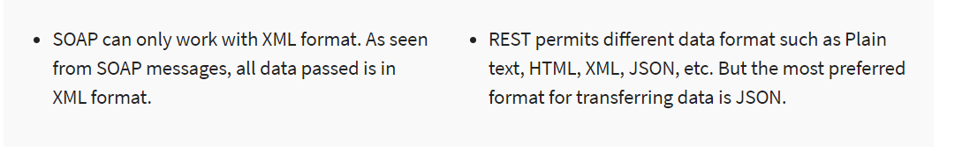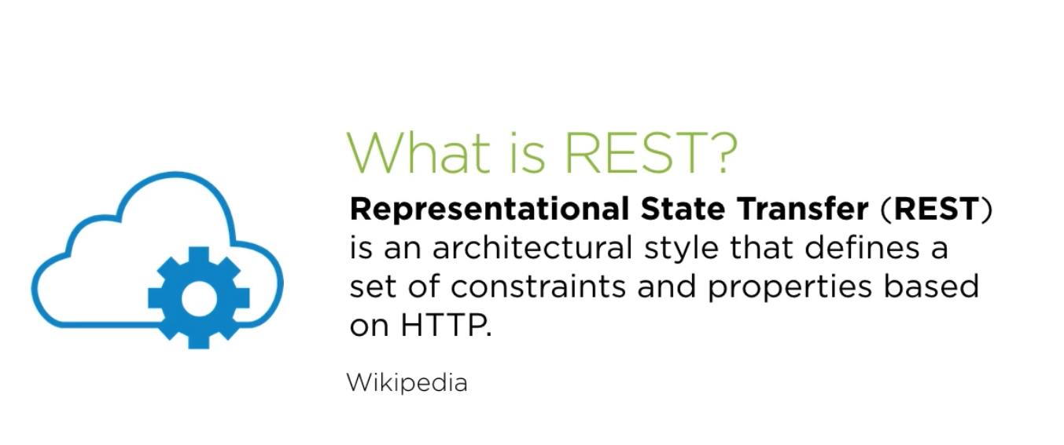

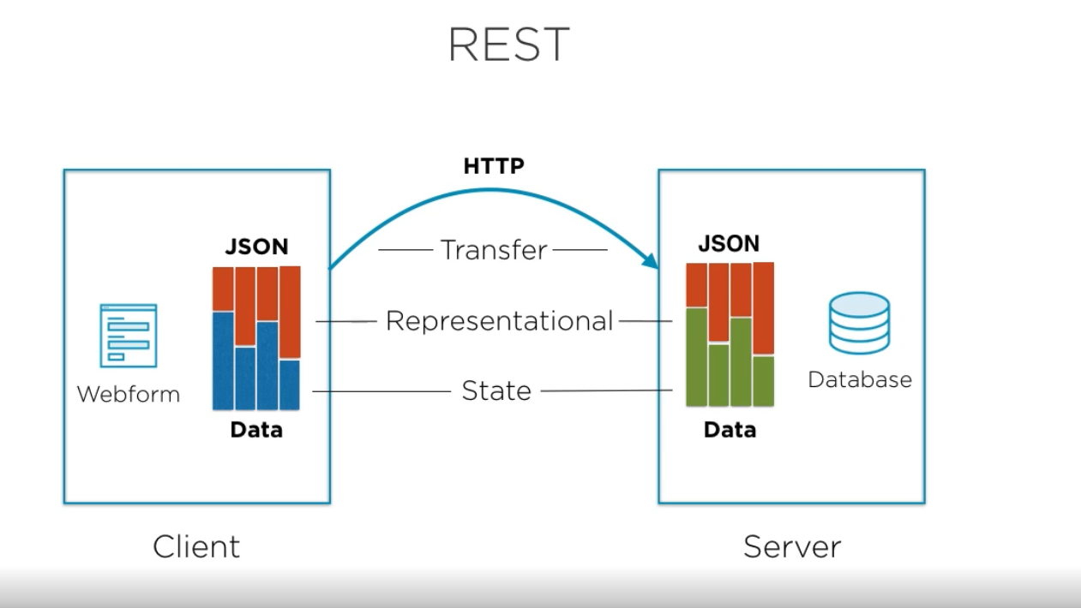

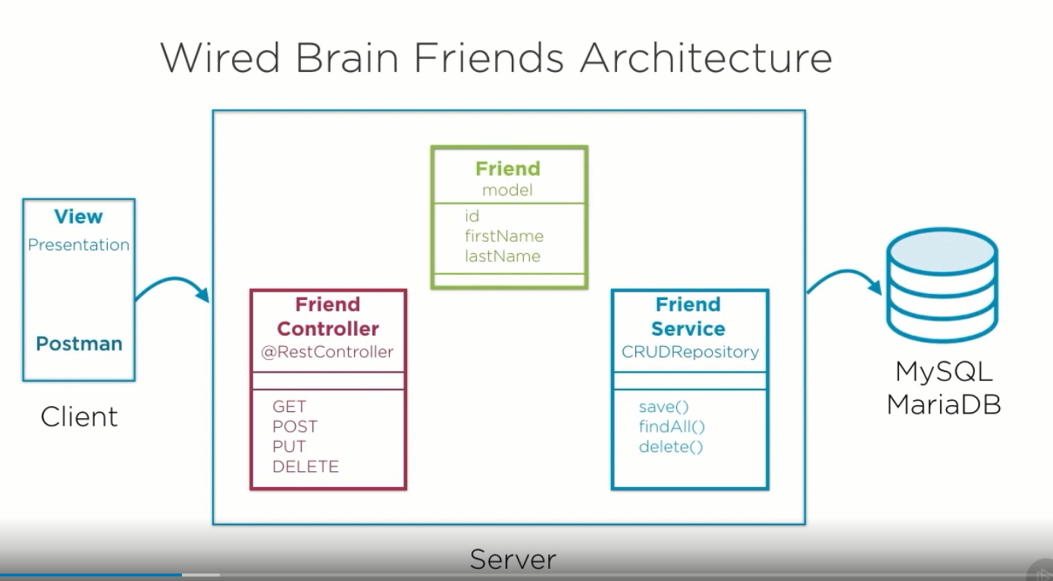

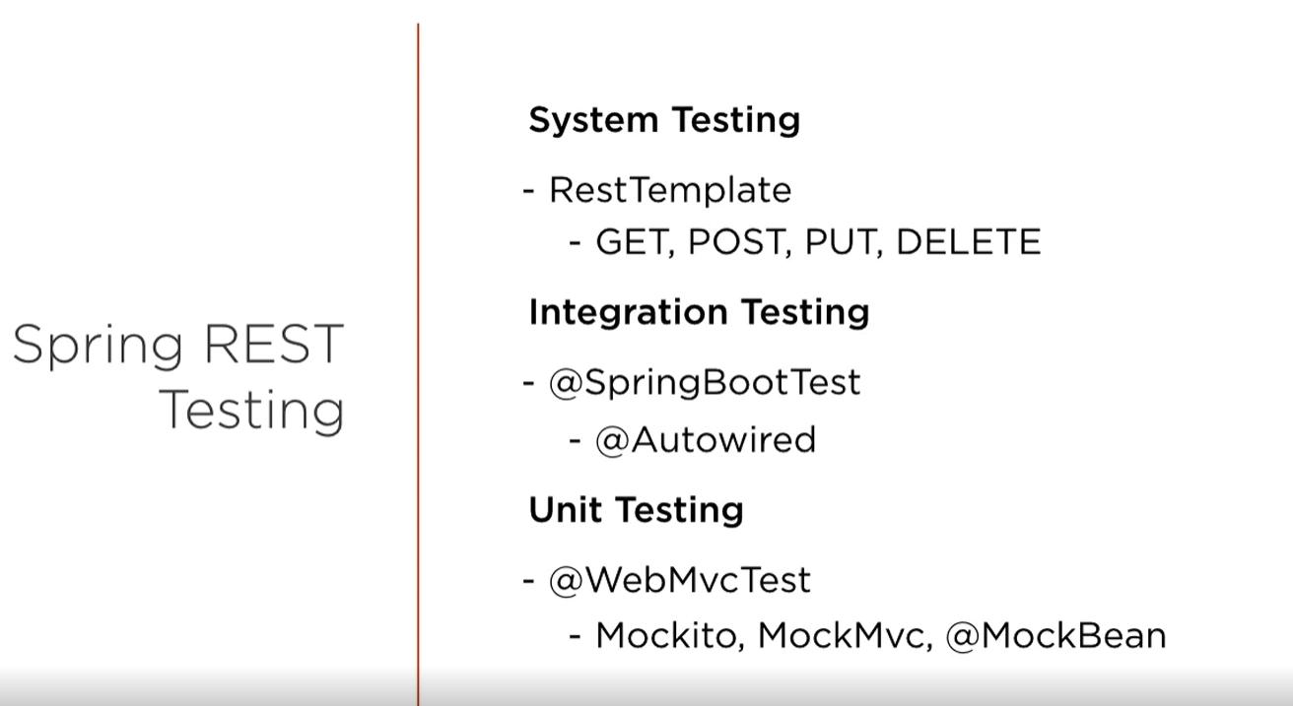

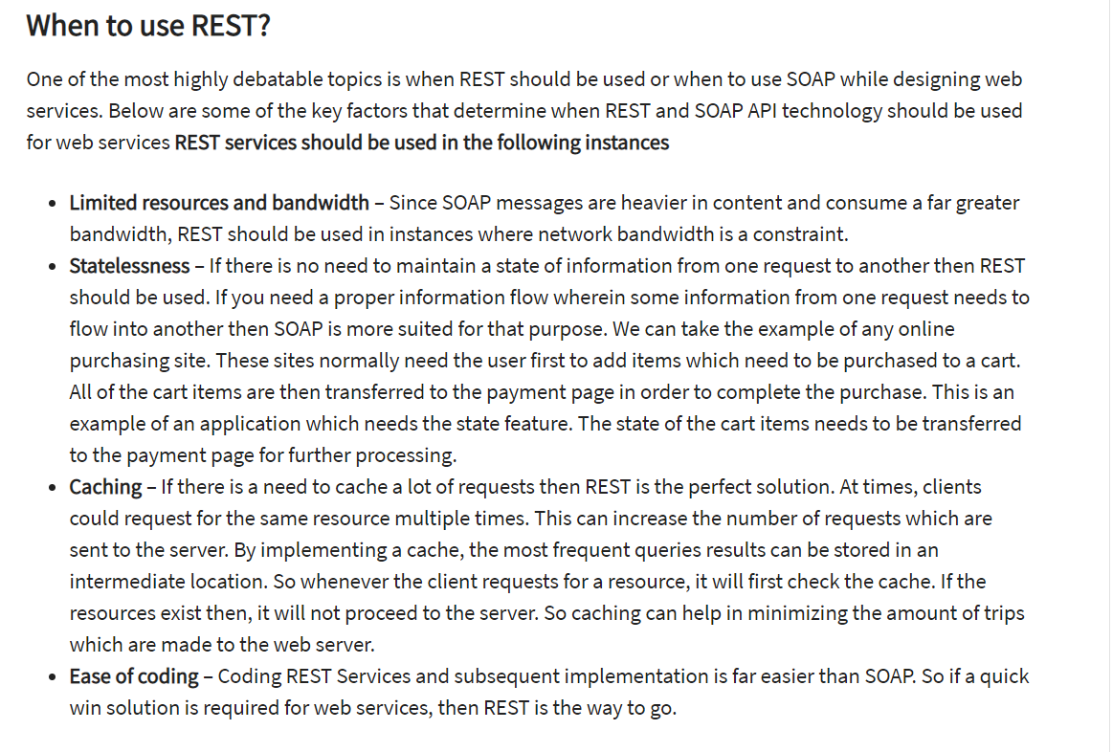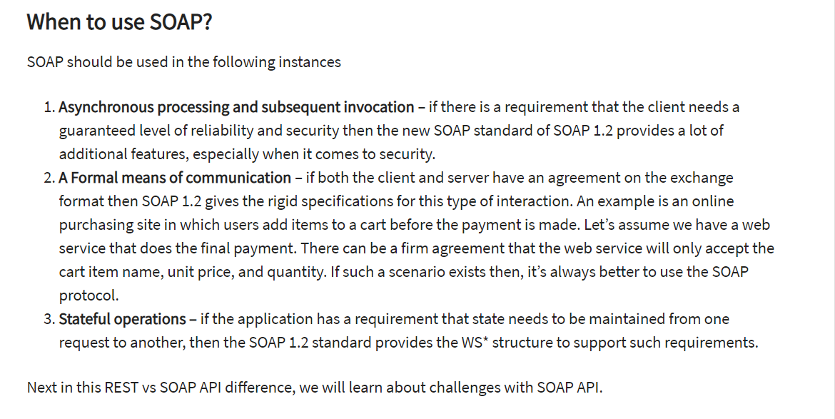

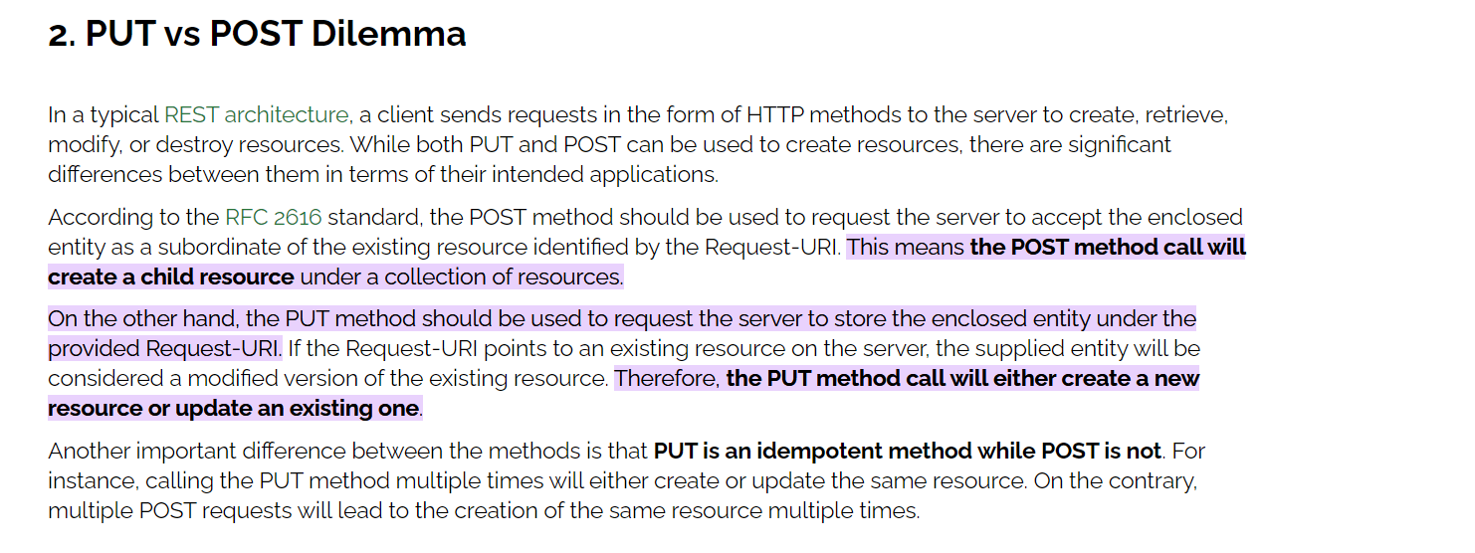

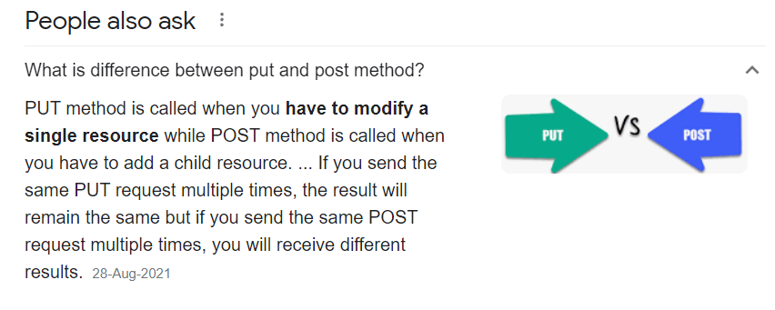

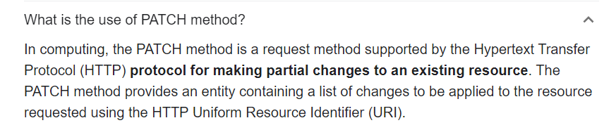

**Authorization for REST API:**

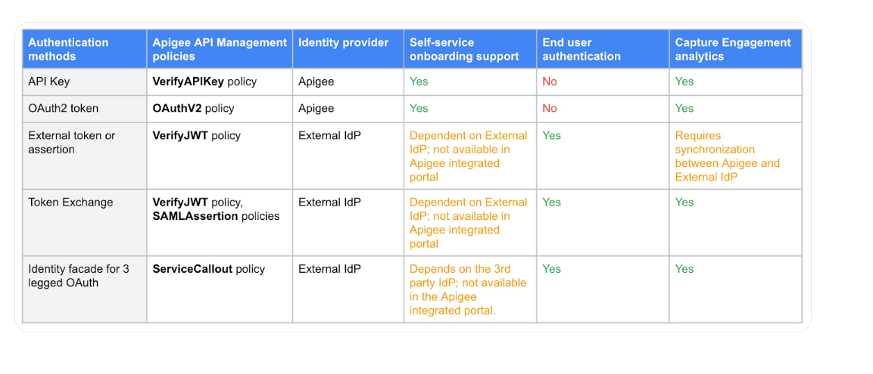

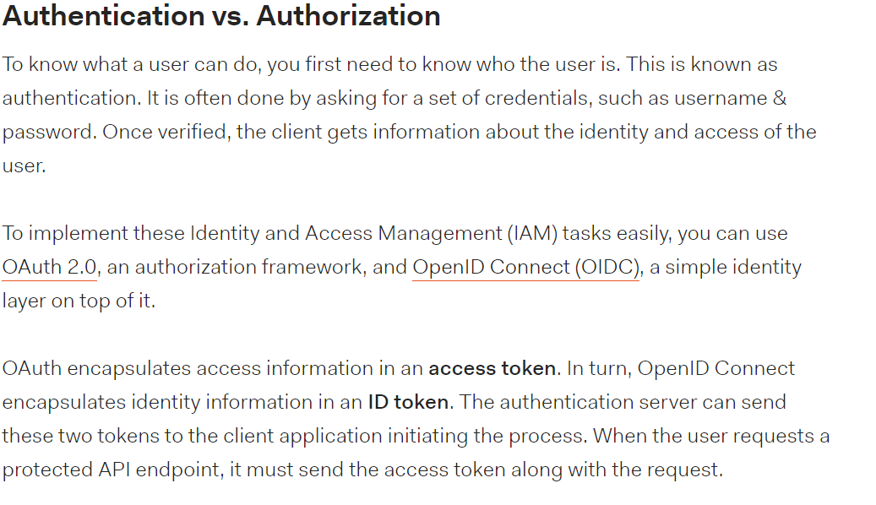

# Microservices:

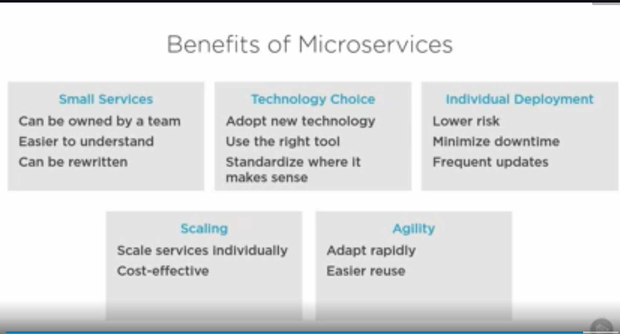

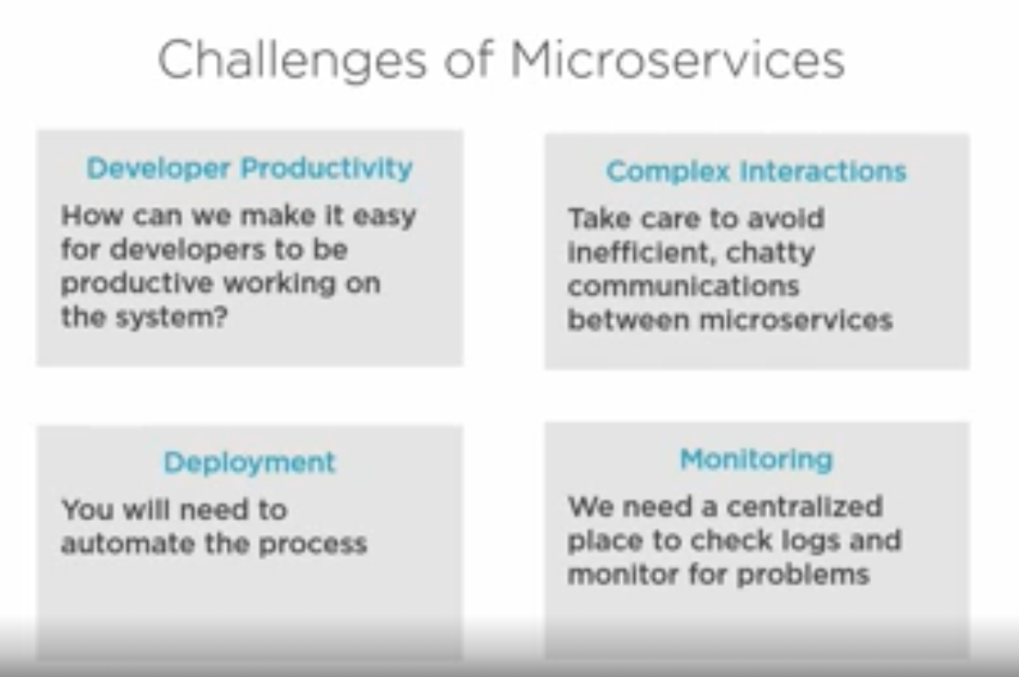

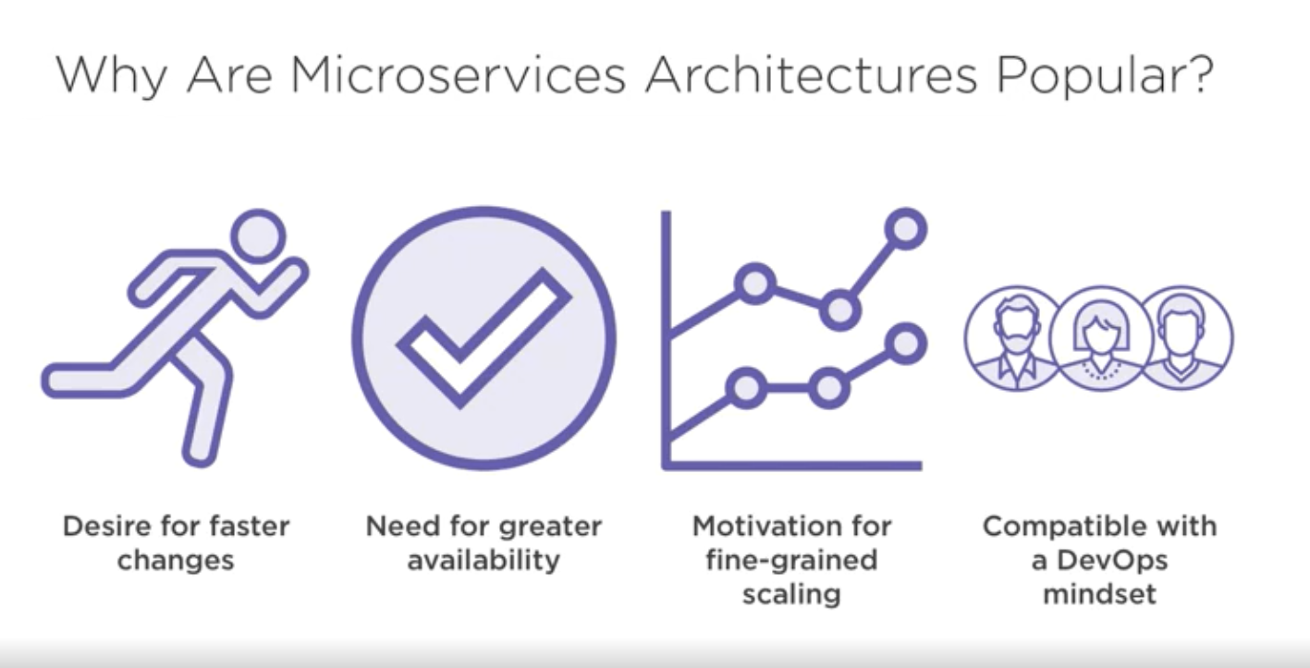

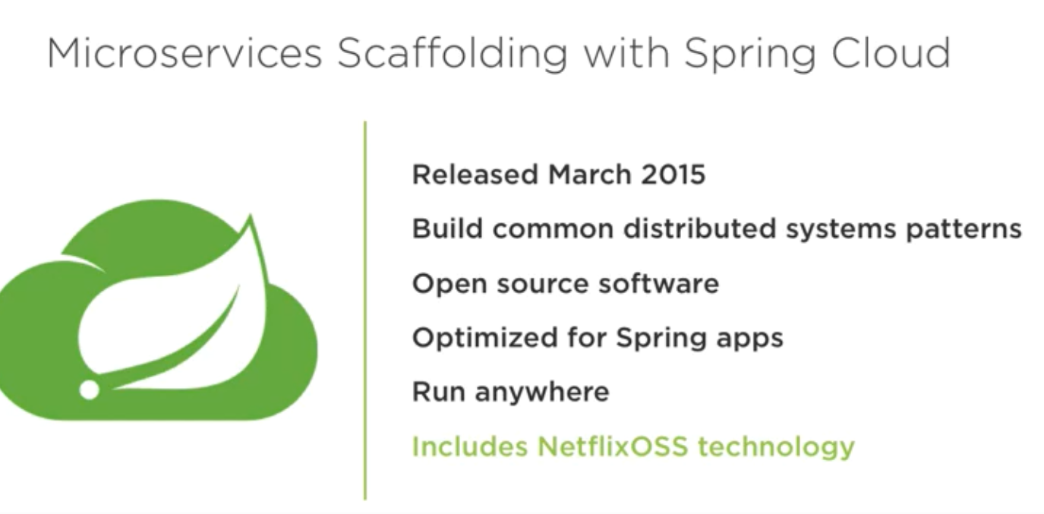

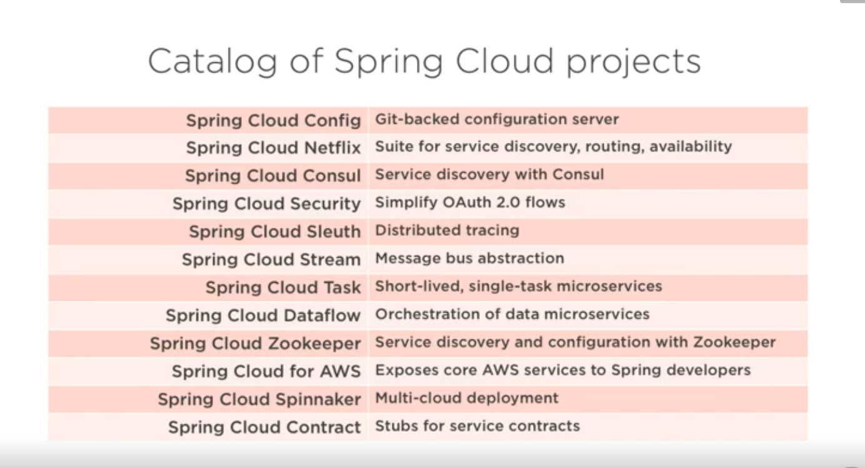

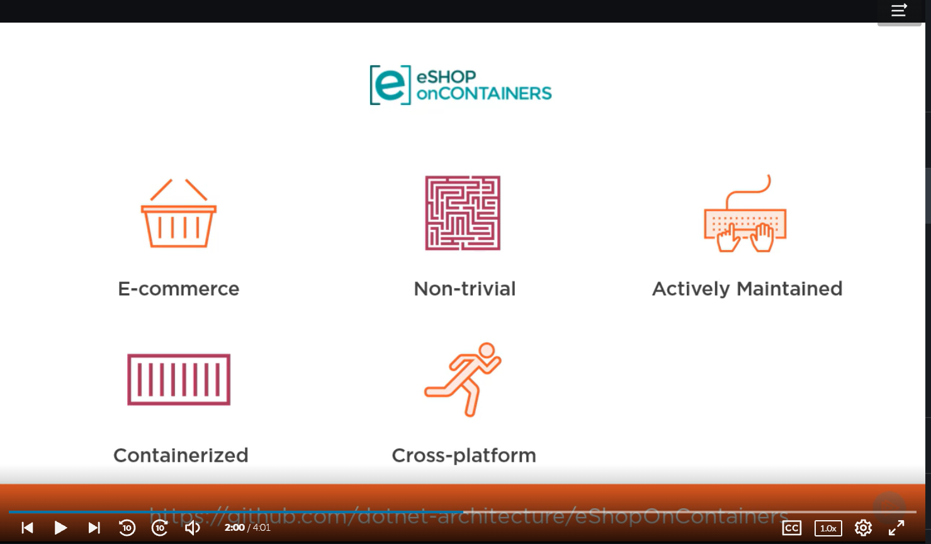

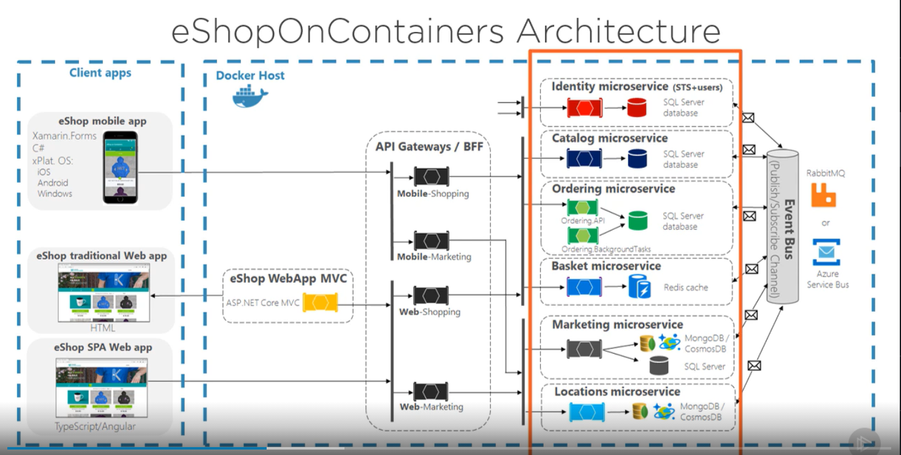

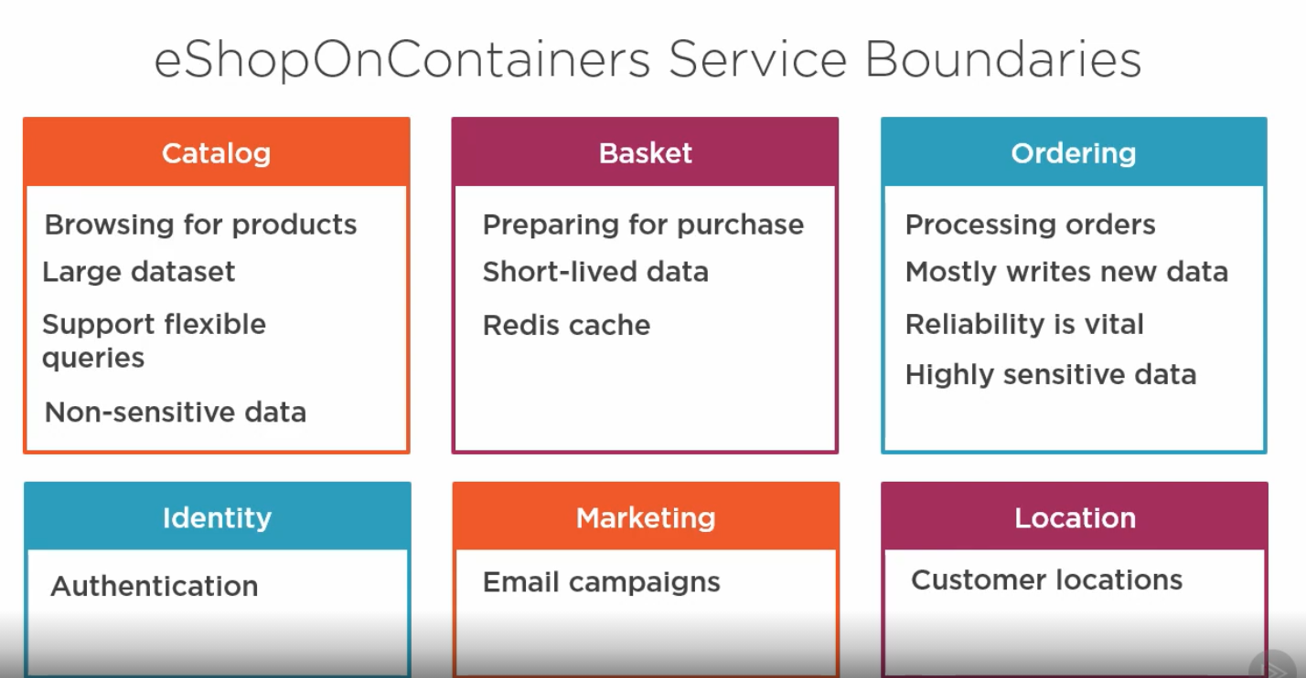

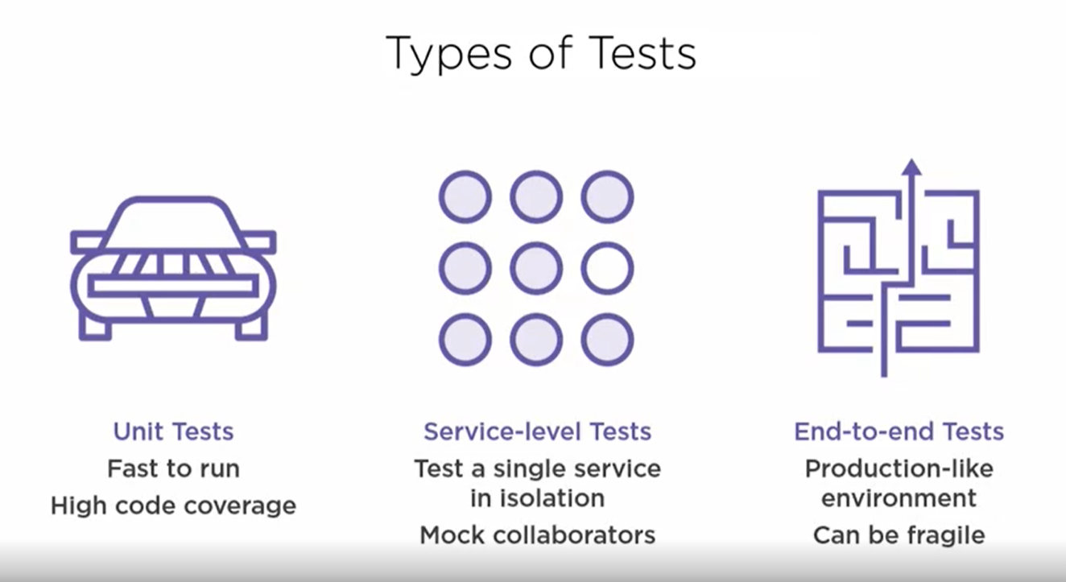

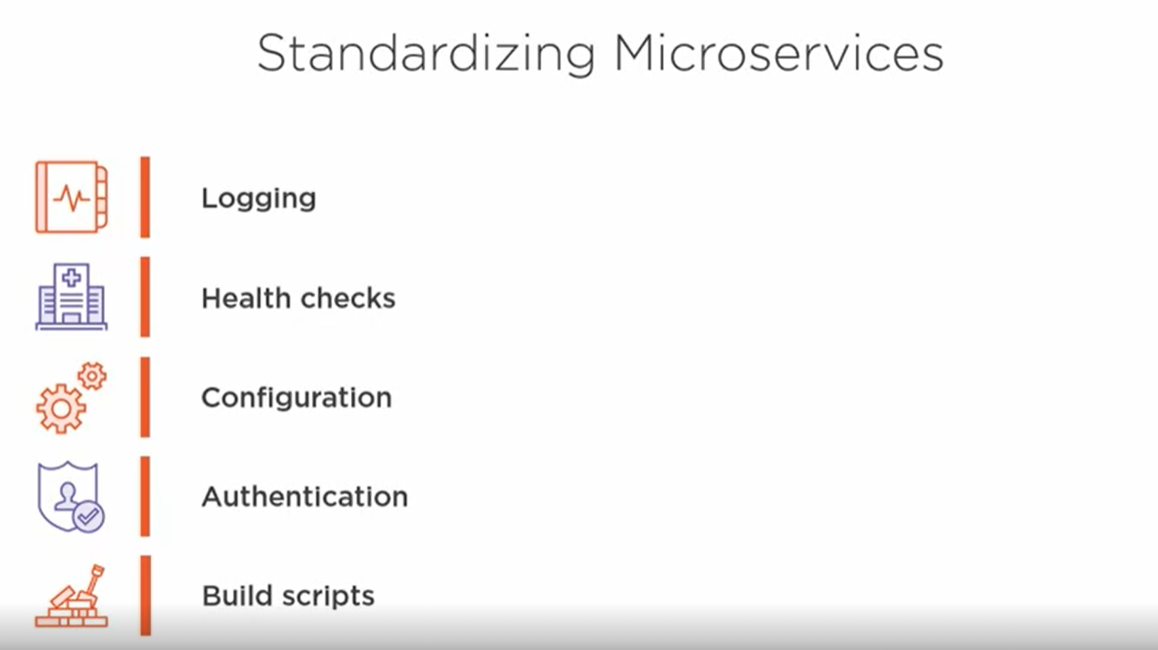

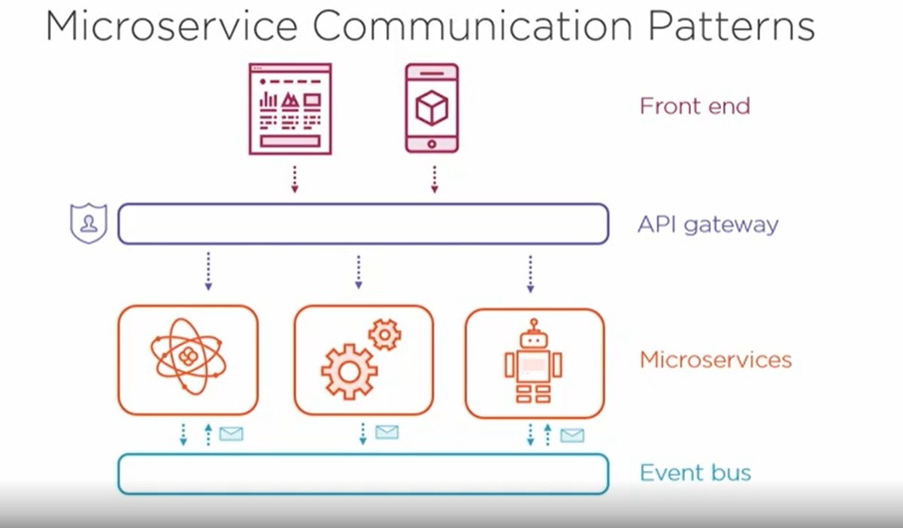

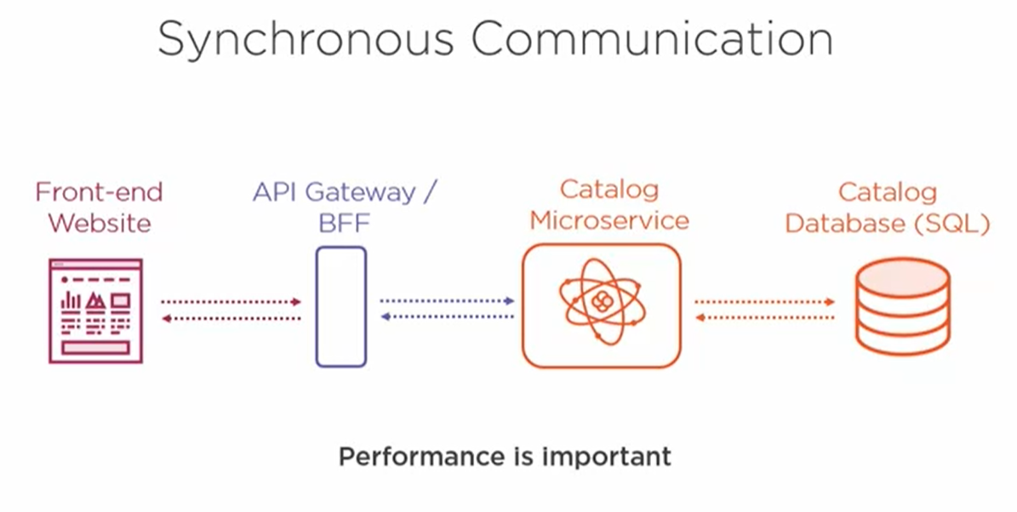

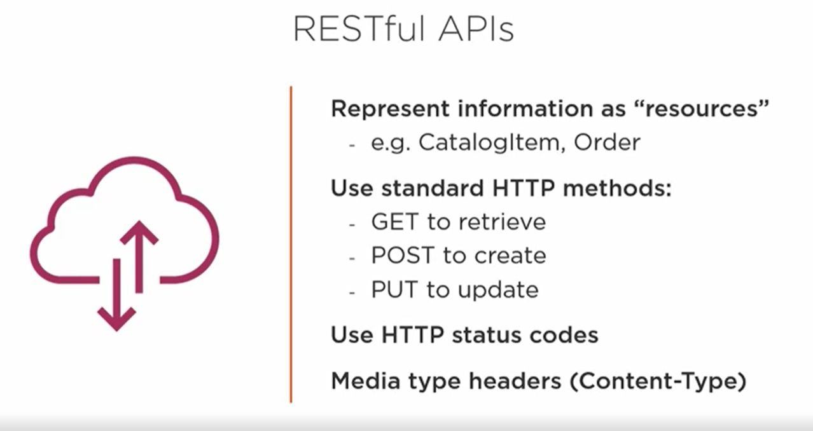

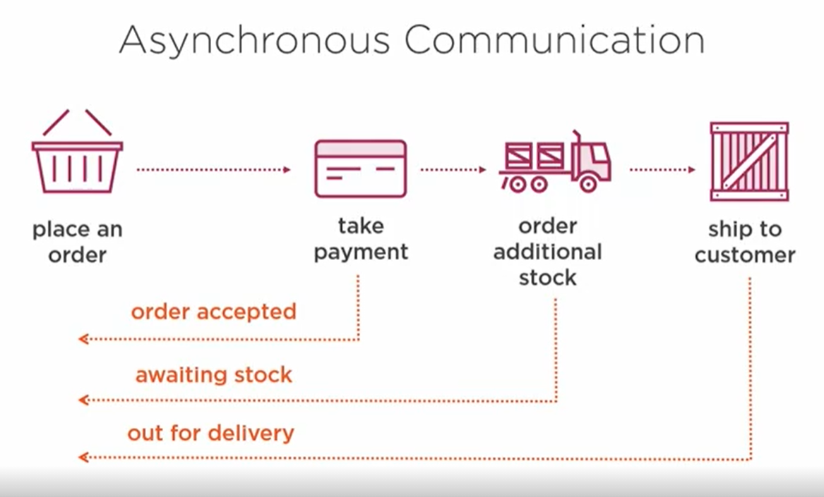

**How two microservices communicate with each other**

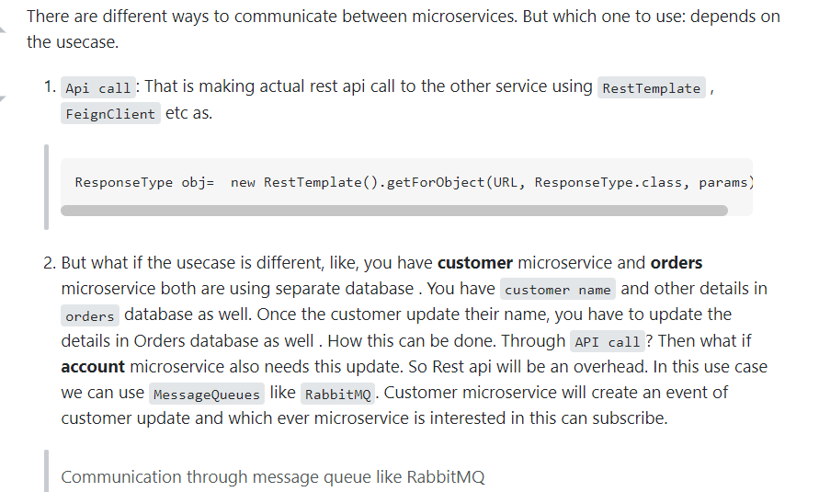

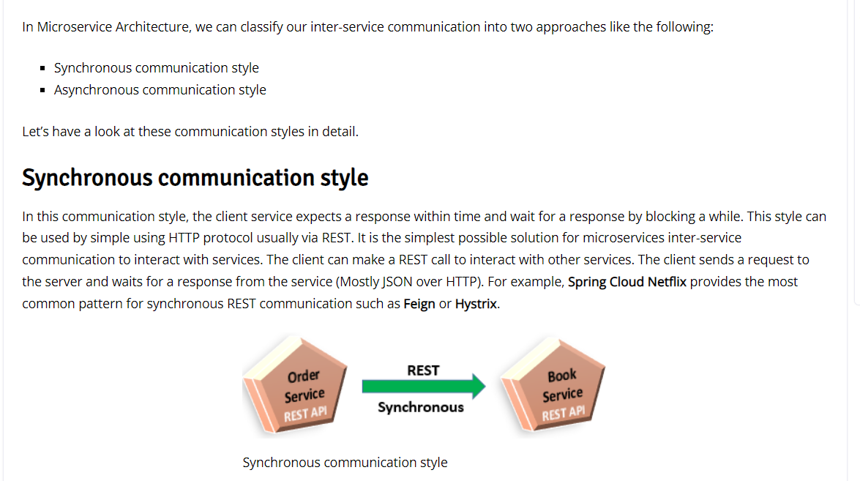

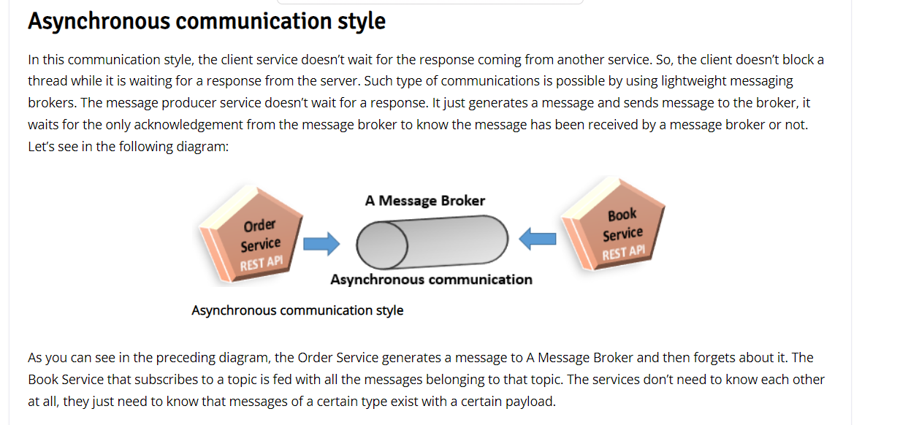

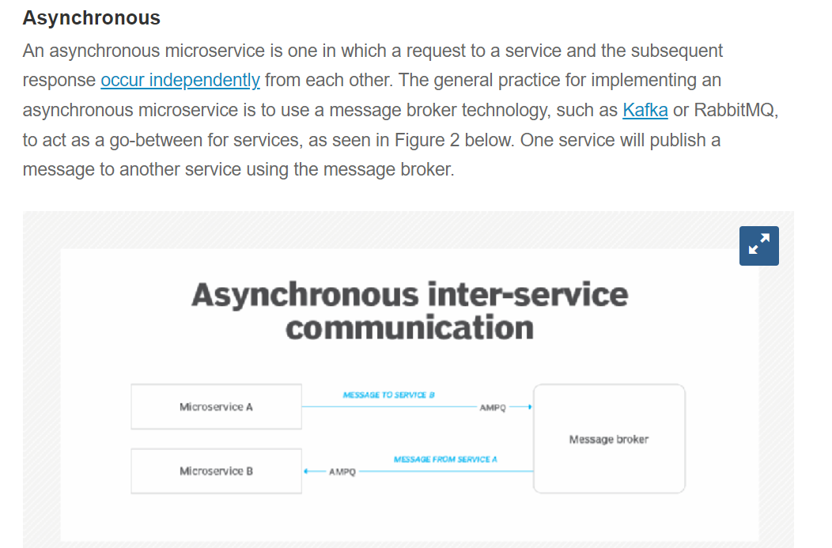

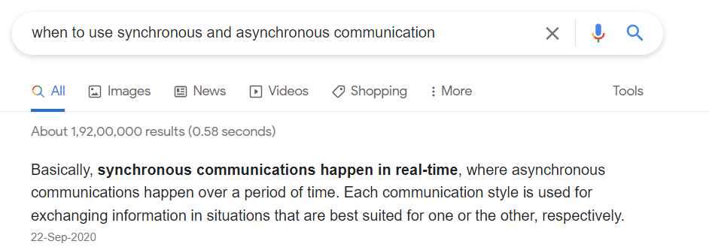

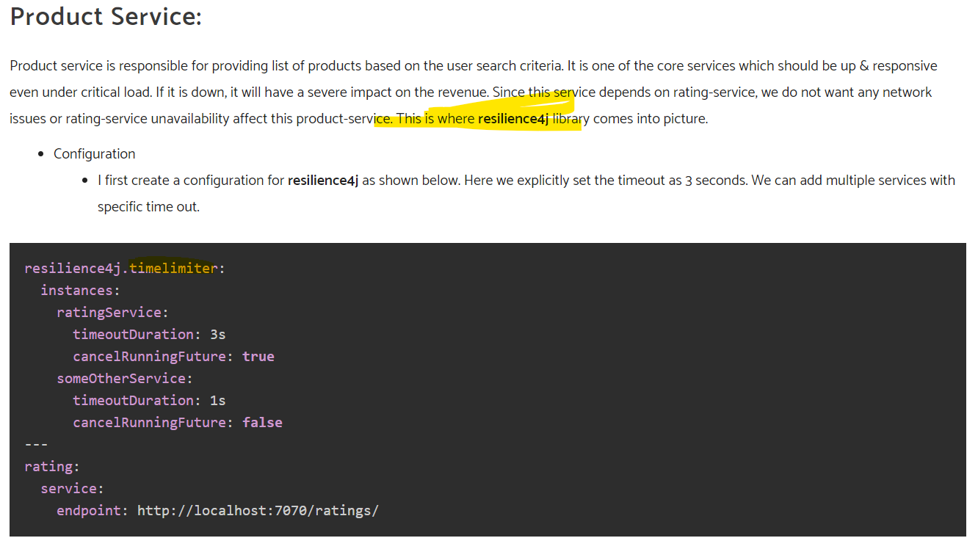

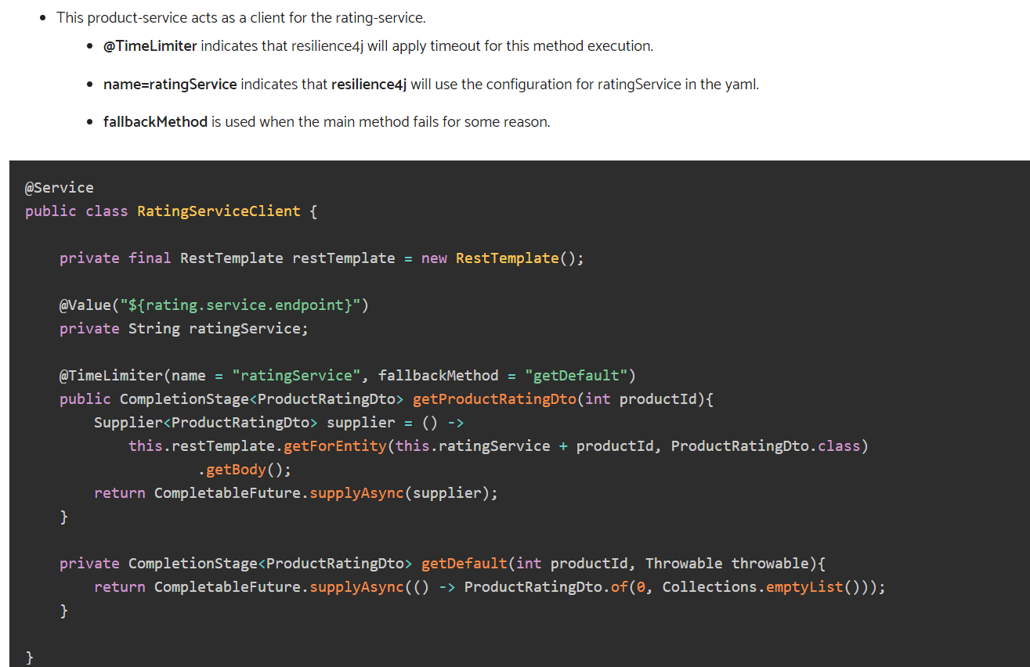

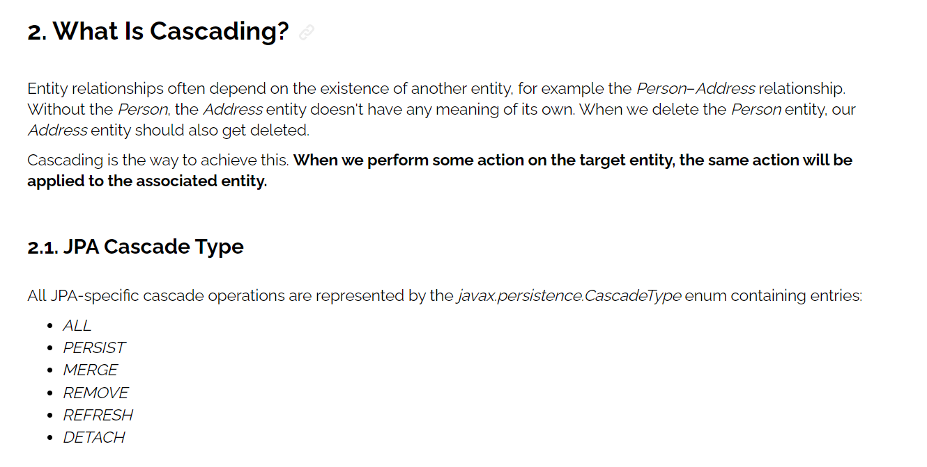

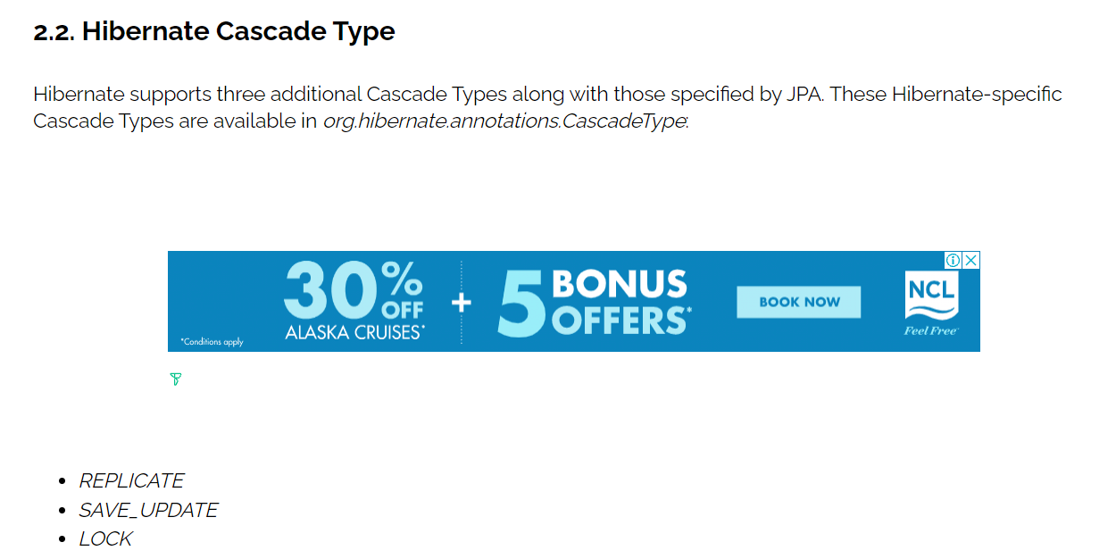

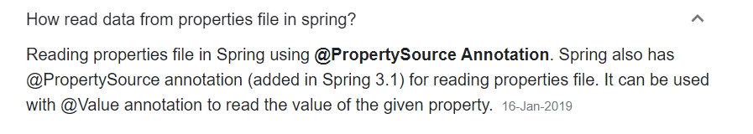

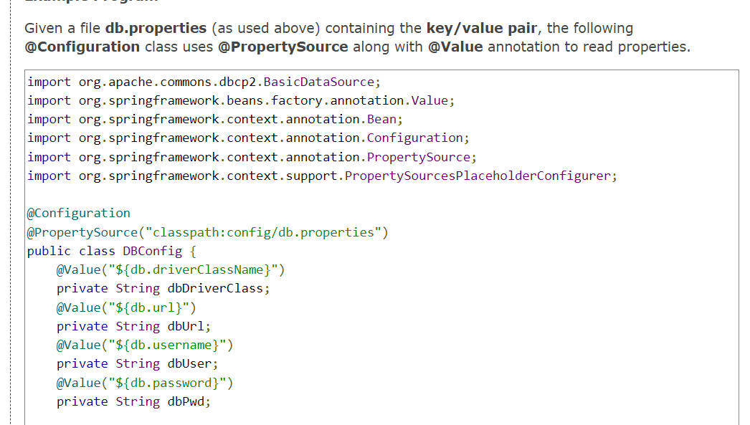

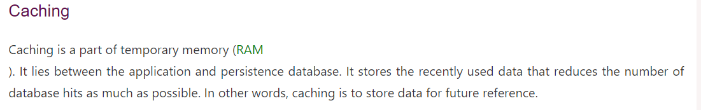

[**https://www.javatpoint.com/spring-boot-caching**](https://www.javatpoint.com/spring-boot-caching)

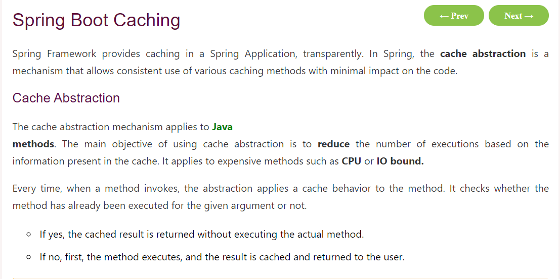

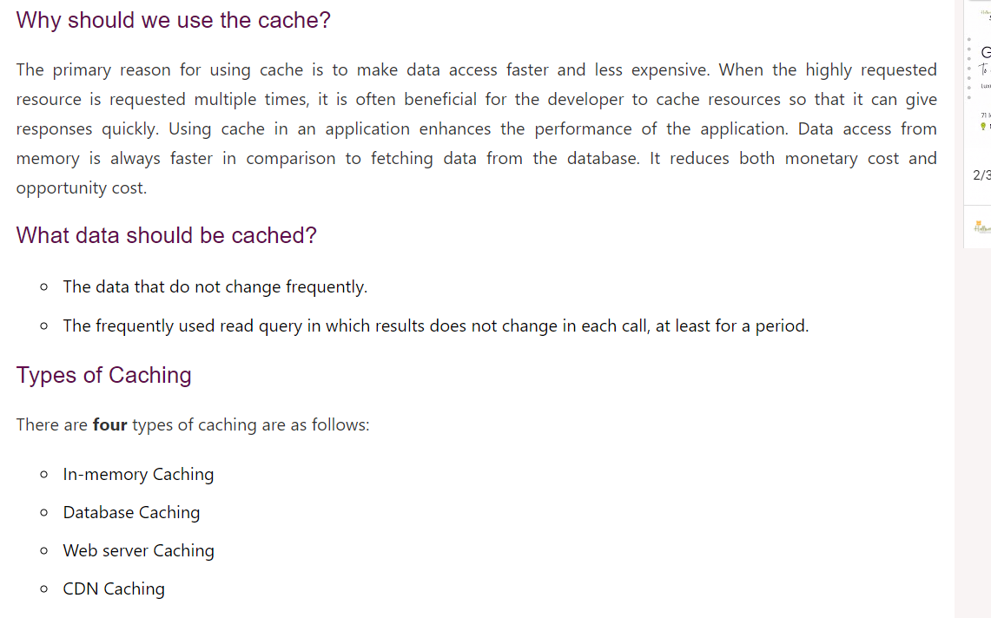

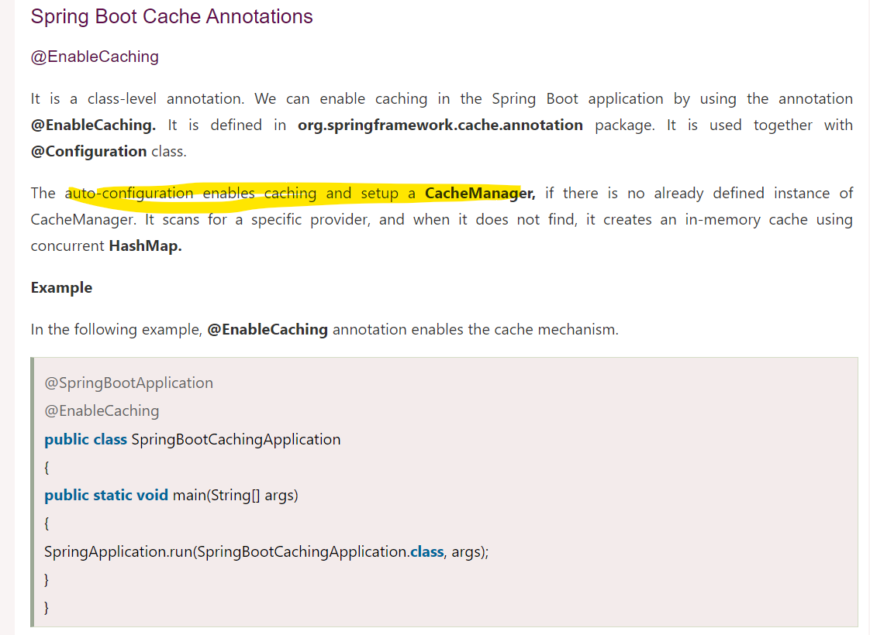

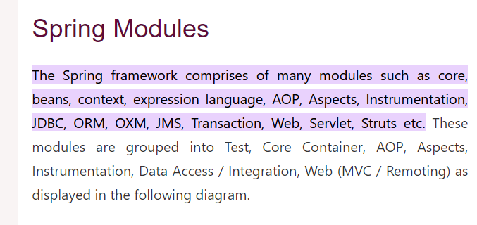

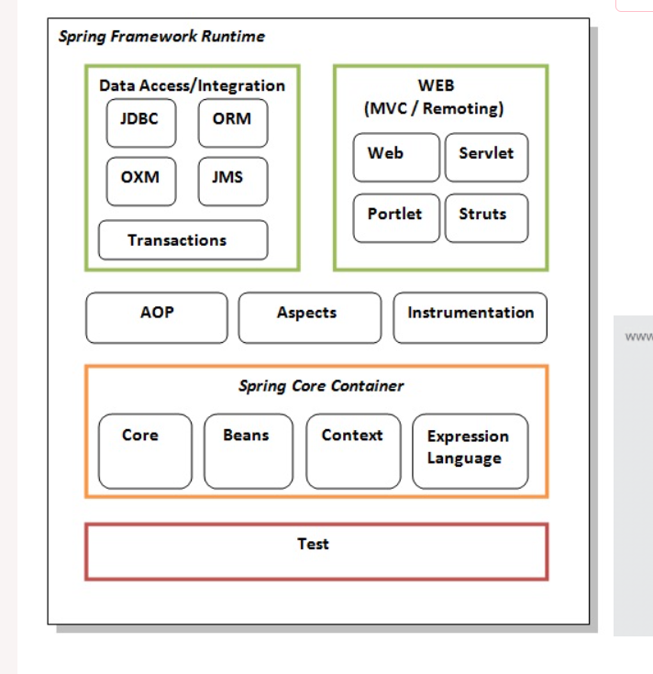

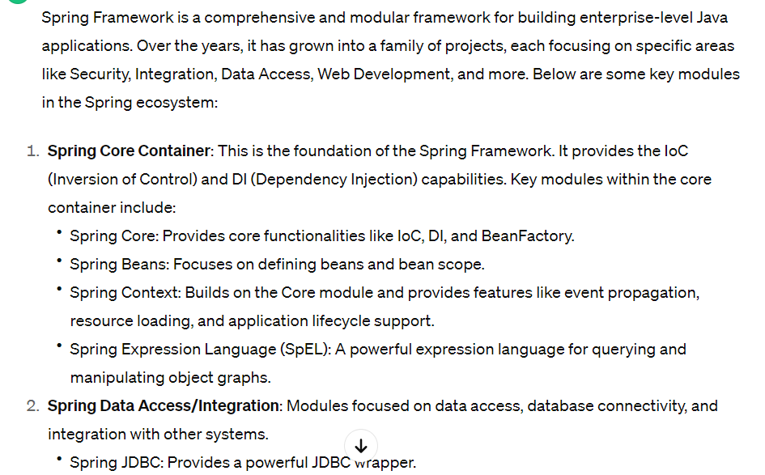

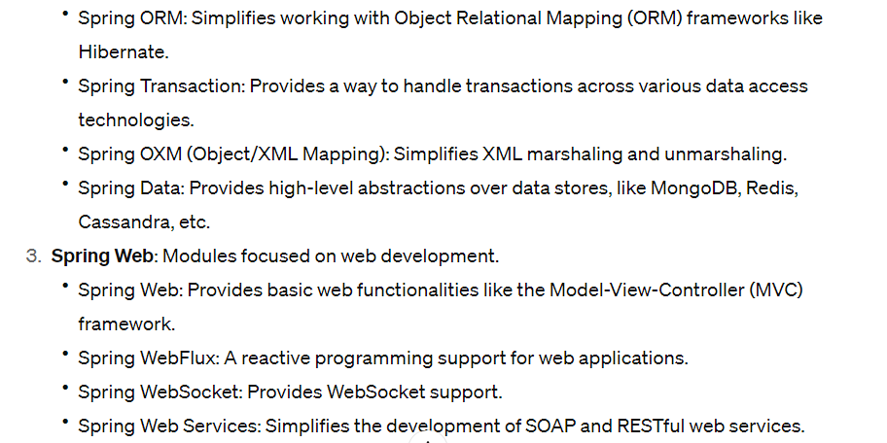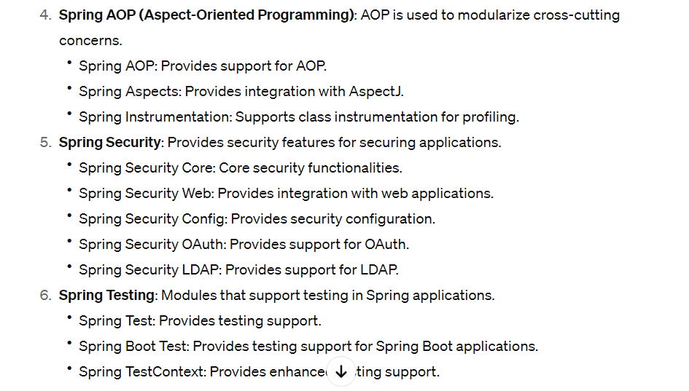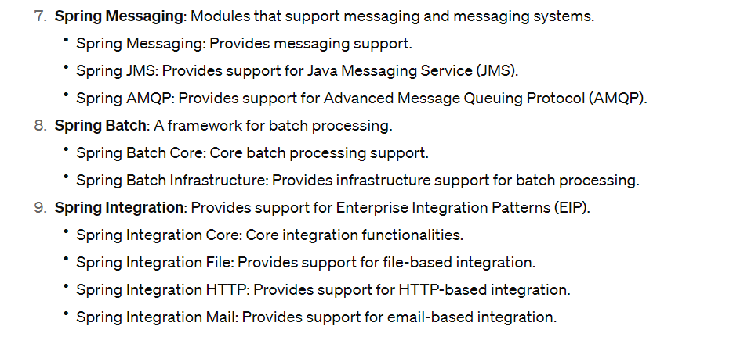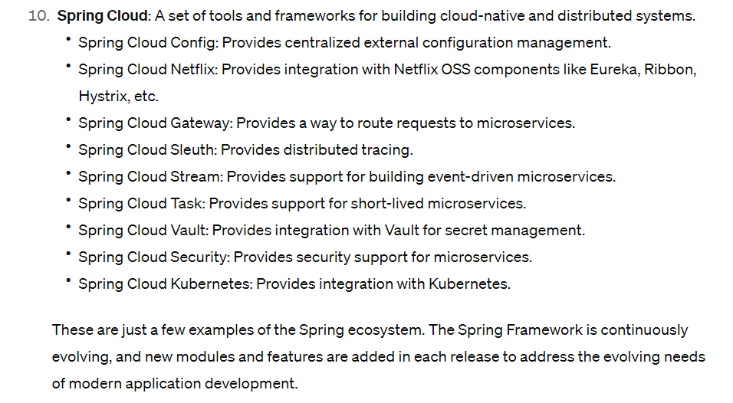

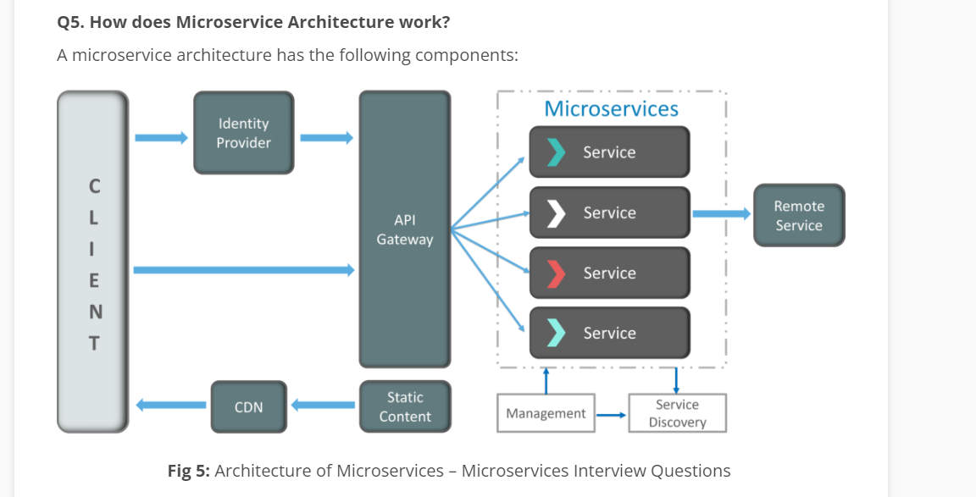 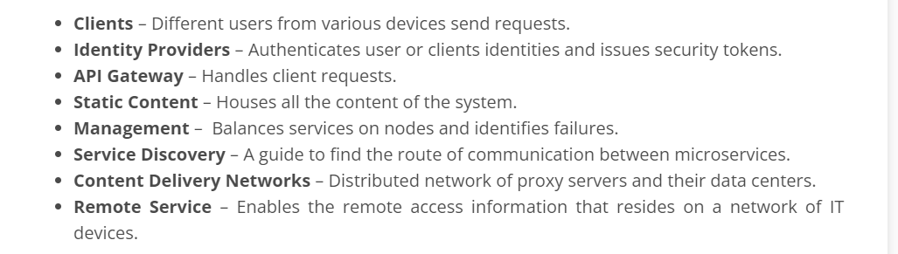

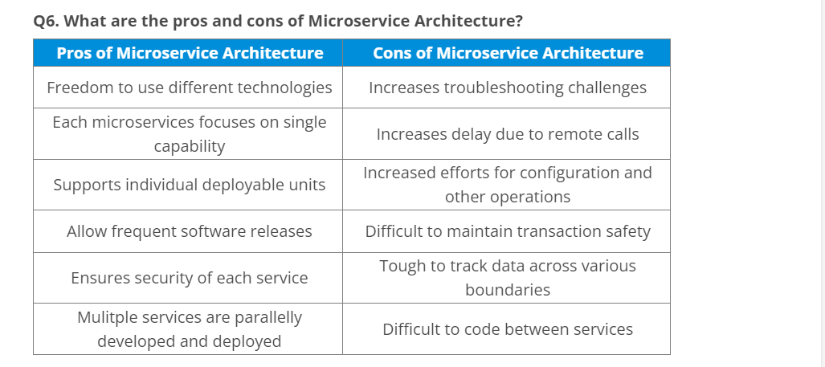

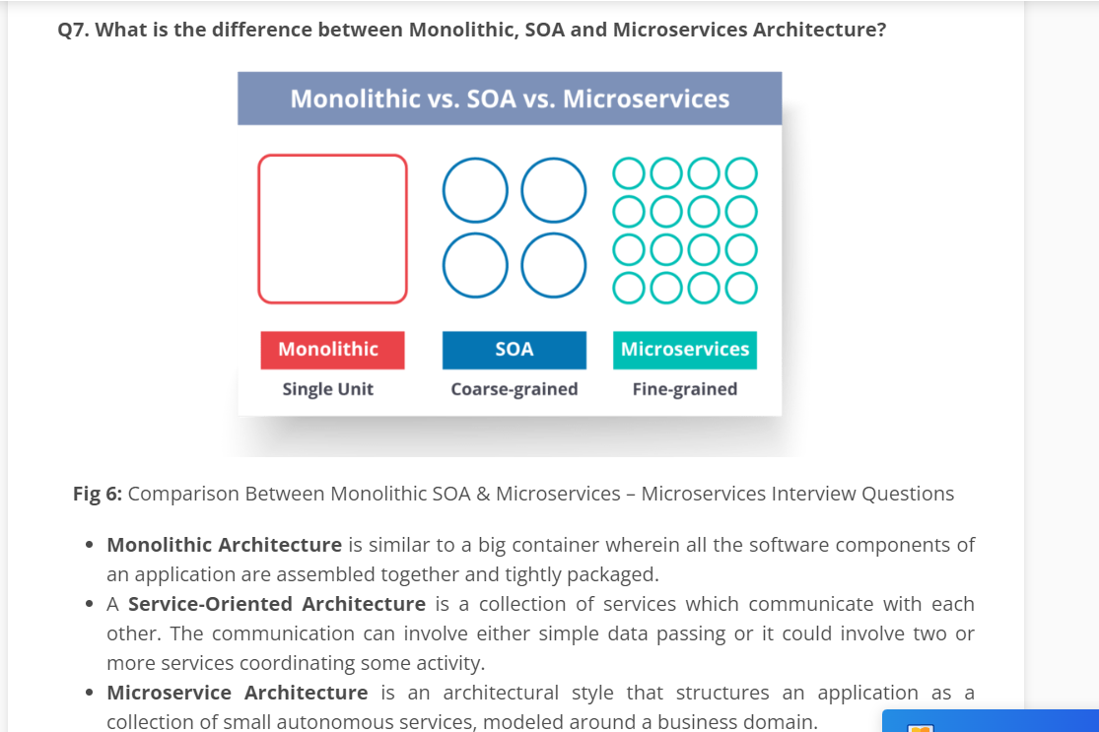

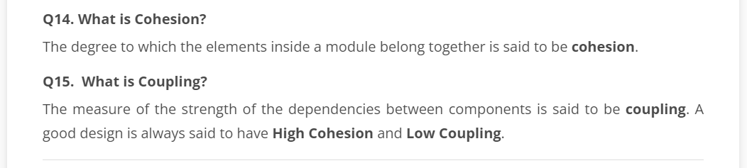

**Spring Boot** is the solution to this problem. Using spring boot you can avoid all the boilerplate code and configurations. So basically consider yourself as if you’re baking a cake spring is like the ingredients that are required to make the cake and spring boot is the complete cake in your hand.

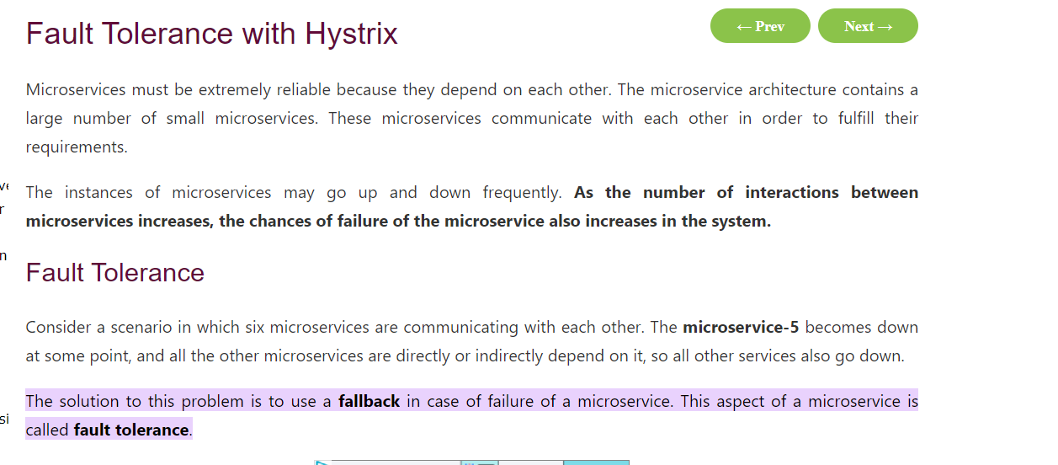

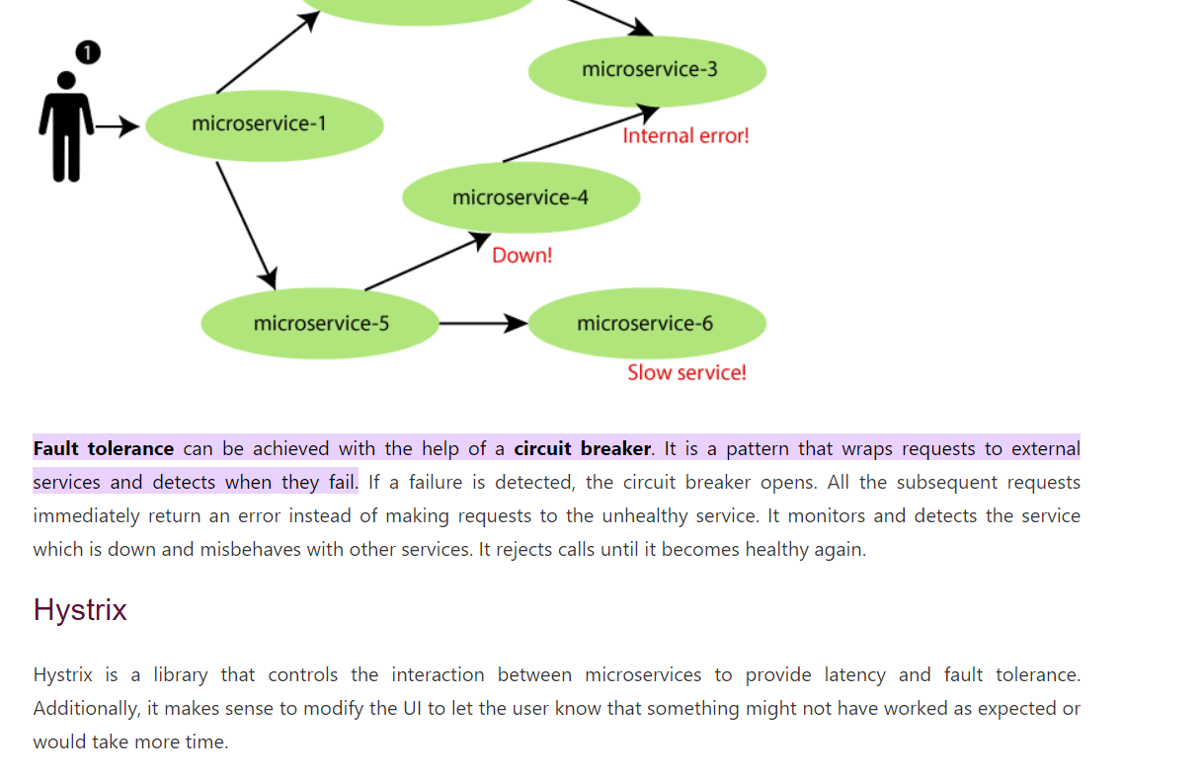

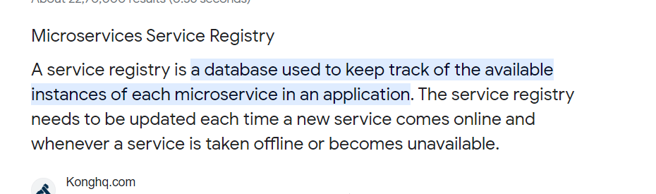

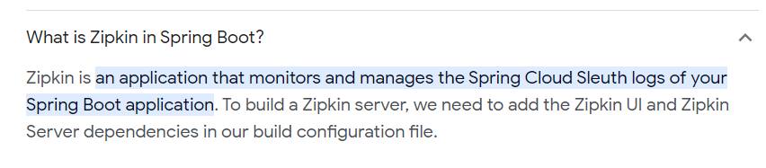

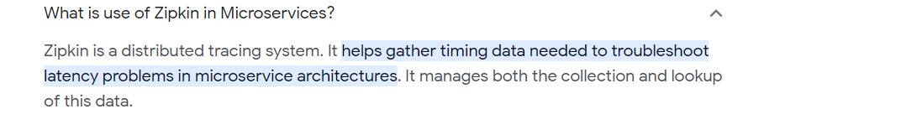

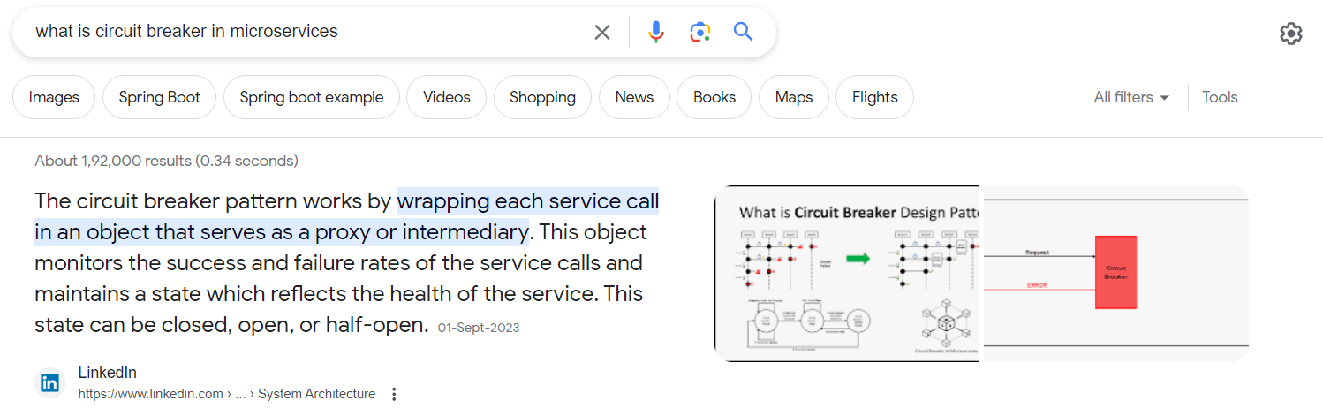

## Scaling Spring Boot Applications:

[**https://medium.com/javarevisited/scaling-spring-boot-applications-from-zero-to-hero-best-practices-and-techniques-to-29d950e15d3e**](https://medium.com/javarevisited/scaling-spring-boot-applications-from-zero-to-hero-best-practices-and-techniques-to-29d950e15d3e)

[**https://medium.com/javarevisited/difference-between-api-gateway-and-load-balancer-in-microservices-8c8b552a024**](https://medium.com/javarevisited/difference-between-api-gateway-and-load-balancer-in-microservices-8c8b552a024)

# Transaction management

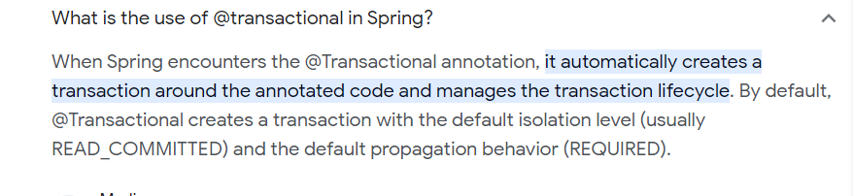

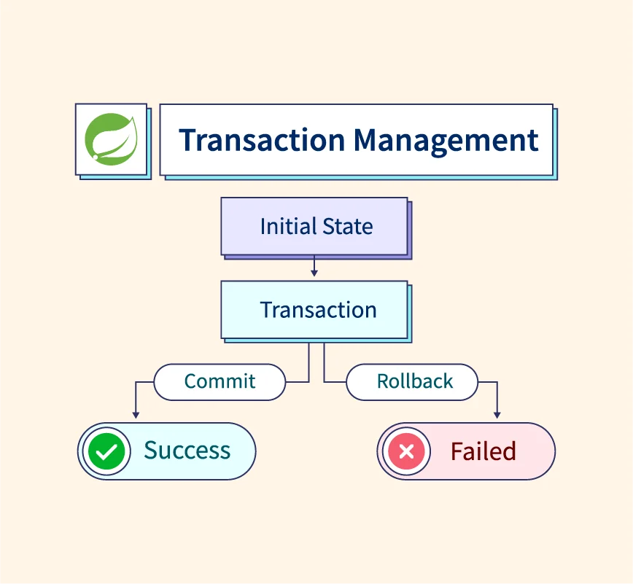

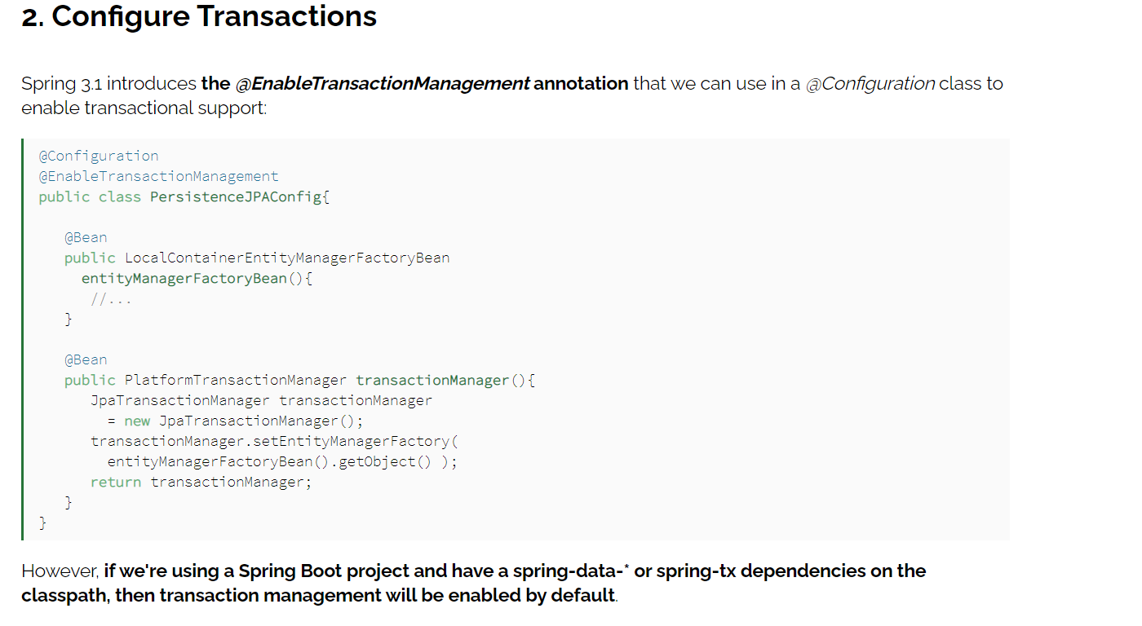

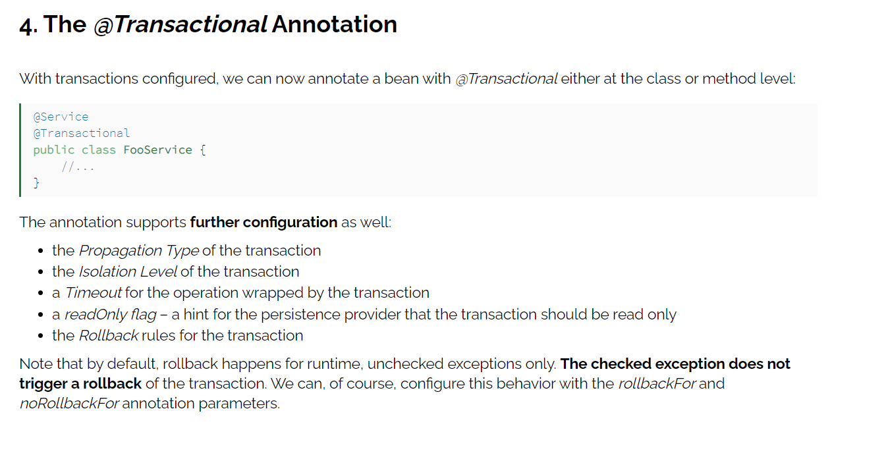

[**https://www.baeldung.com/transaction-configuration-with-jpa-and-spring**](https://www.baeldung.com/transaction-configuration-with-jpa-and-spring)

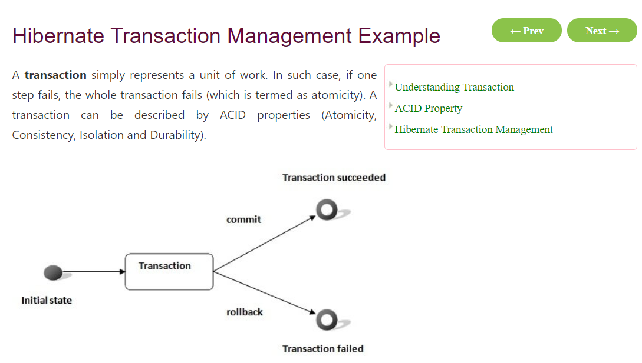

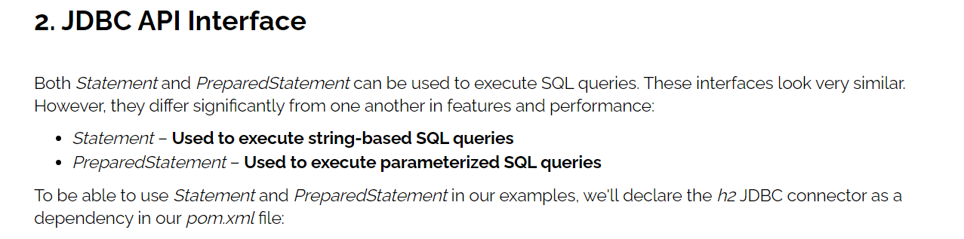

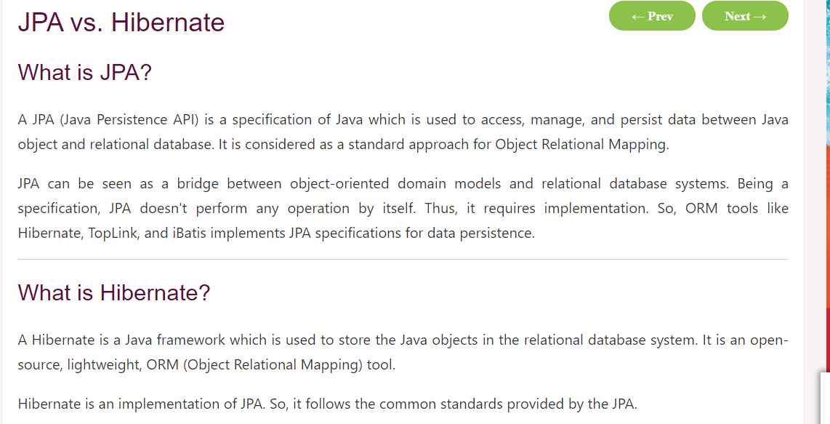

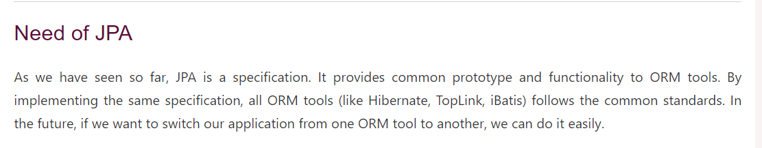

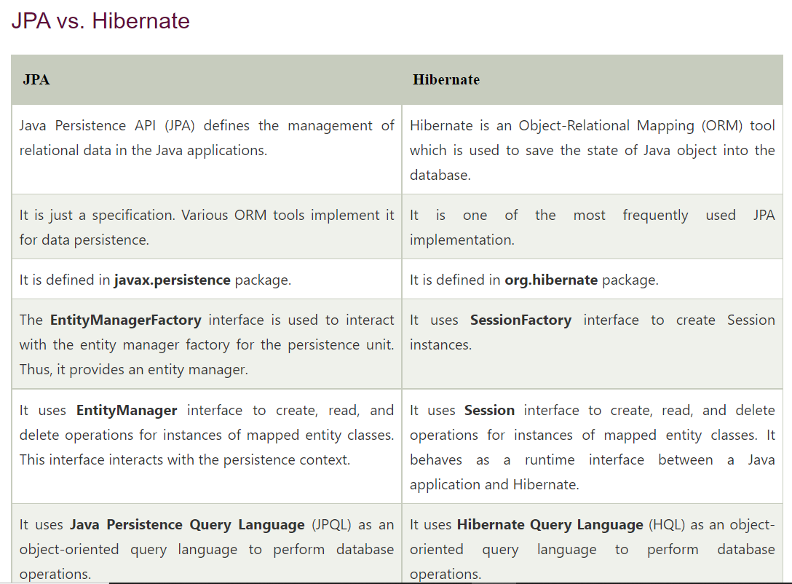

# Hibernate

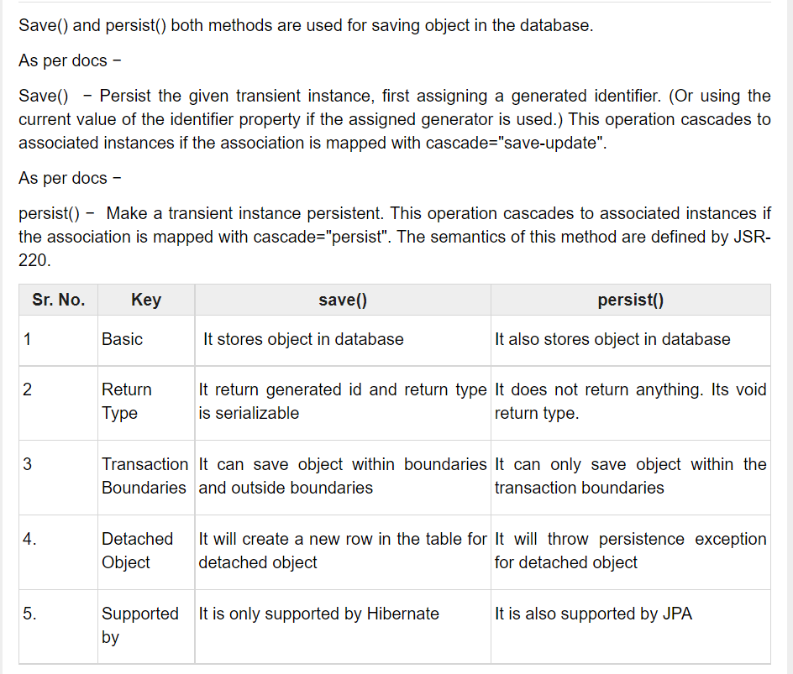

# GIT commands

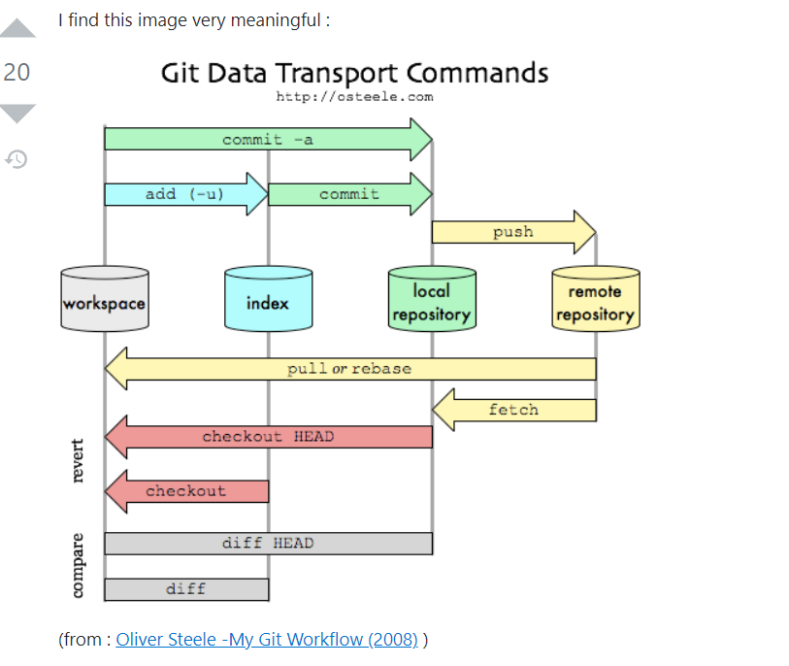

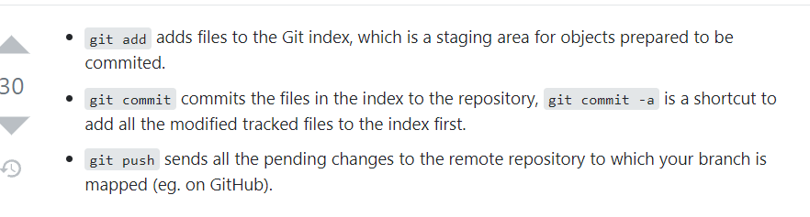

# Generics :

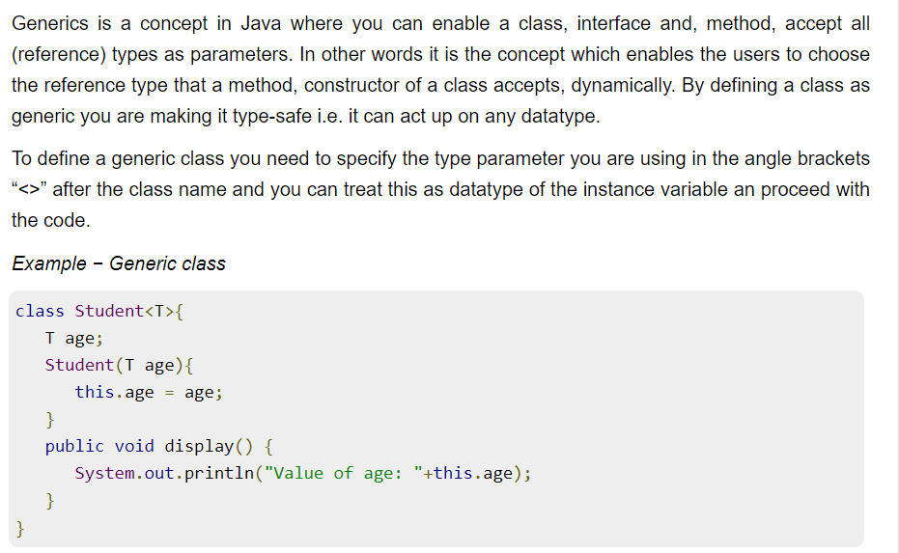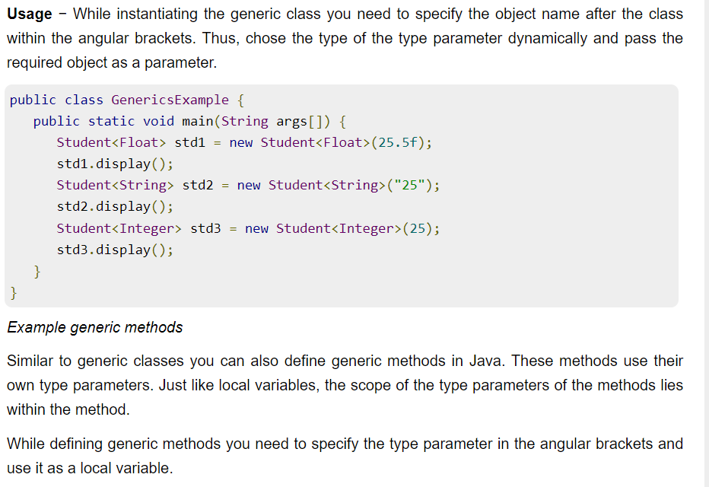

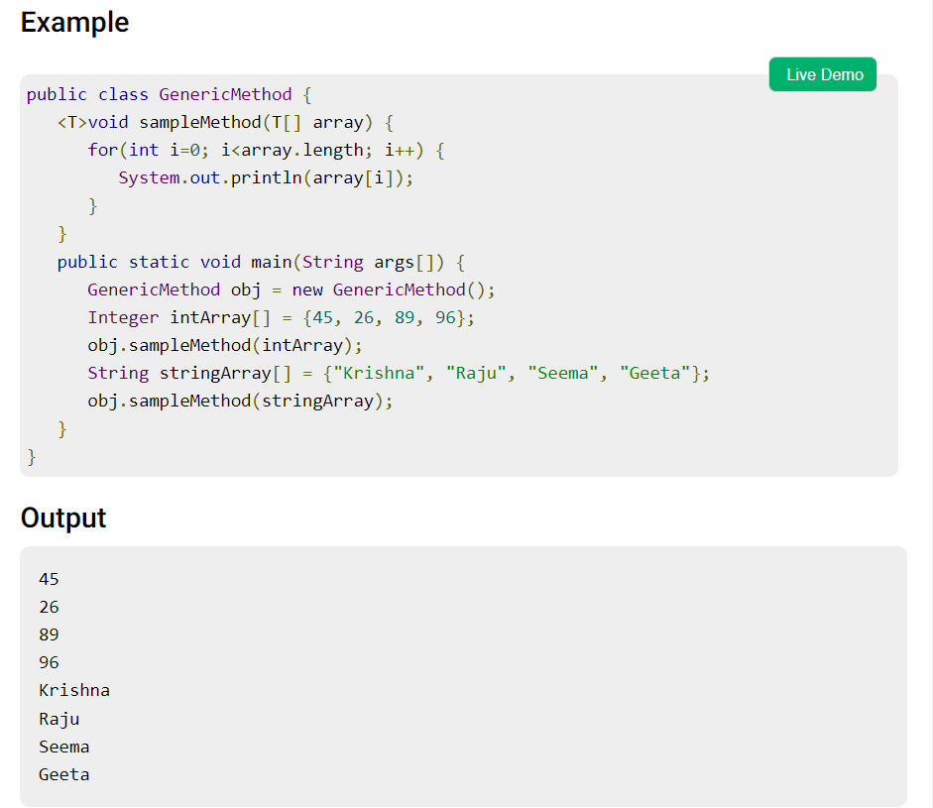

# Liferay

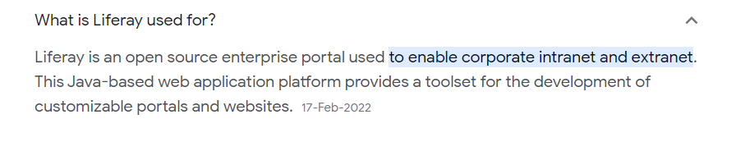

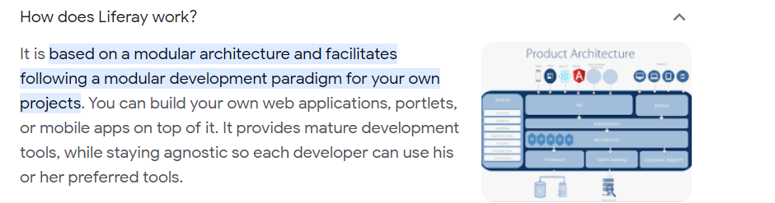

# React JS

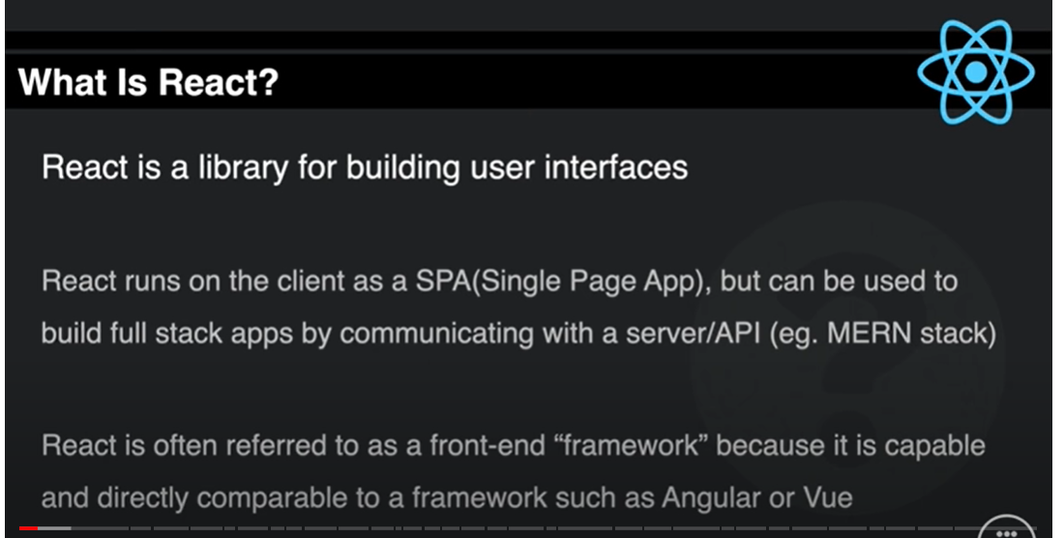

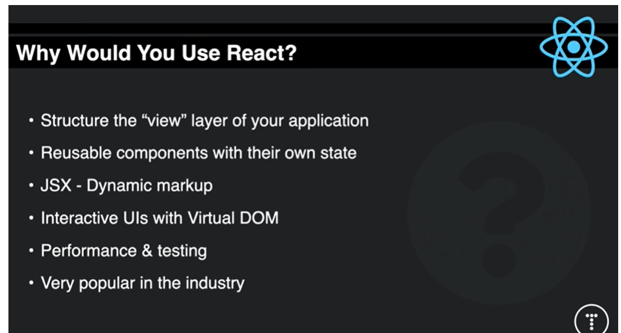

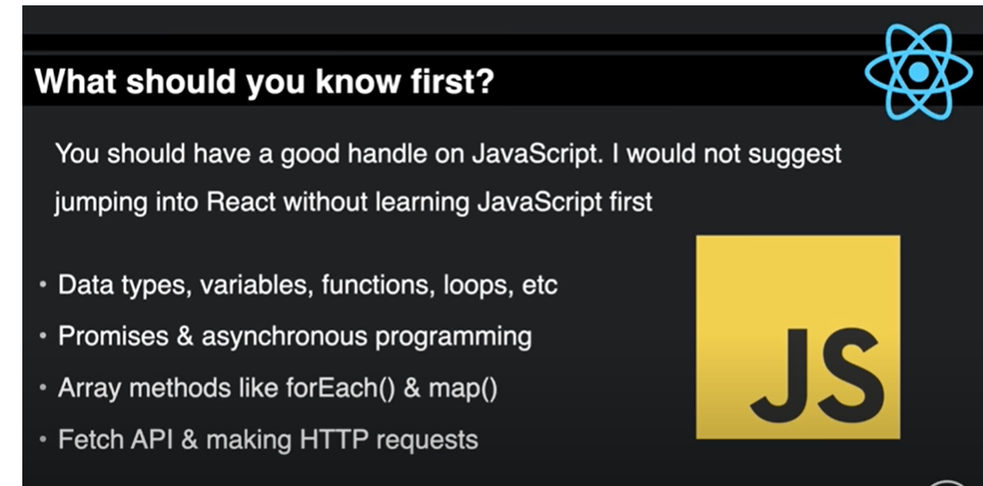

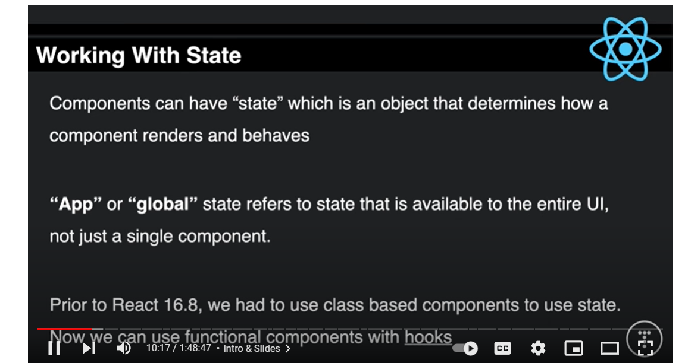

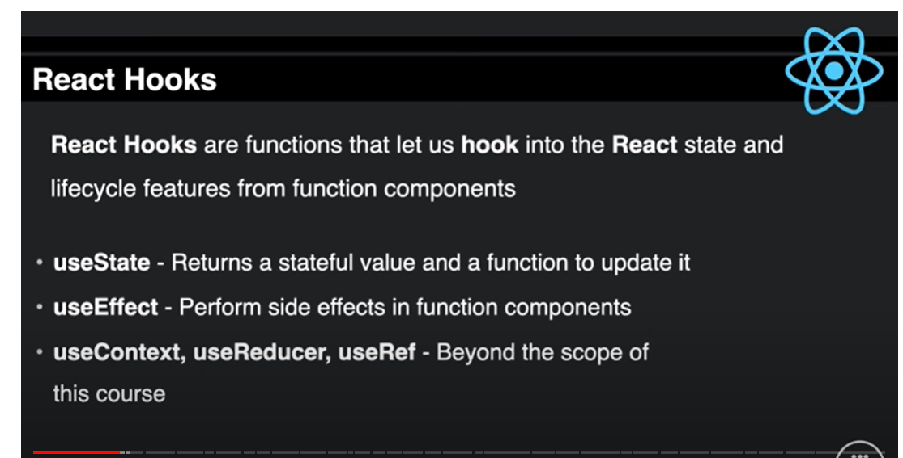

## React Query

```js

import { createBrowserRouter, RouterProvider } from 'react-router-dom';

import { QueryClient, QueryClientProvider } from '@tanstack/react-query';

import { ReactQueryDevtools } from '@tanstack/react-query-devtools';

const queryClient = new QueryClient({

  defaultOptions: {

    queries: {

      staleTime: 1000 * 60 * 5,

    },

  },

});

...

const App = () => {

  return (

    <QueryClientProvider client={queryClient}>

      <RouterProvider router={router} />

      <ReactQueryDevtools initialIsOpen={false} />

    </QueryClientProvider>

  );

};

export default App;

```

ES6 Features

<https://www.divami.com/blog/top-ecmascript-es6-features-every-javascript-developer-should-know#:~:text=ES6%20is%20the%20basis%20for,and%20is%20100%25%20backwards%20compatible>

<https://www.simplilearn.com/tutorials/reactjs-tutorial/reactjs-interview-questions>

Promises

<https://testbook.com/interview/javascript-promise-interview-questions>

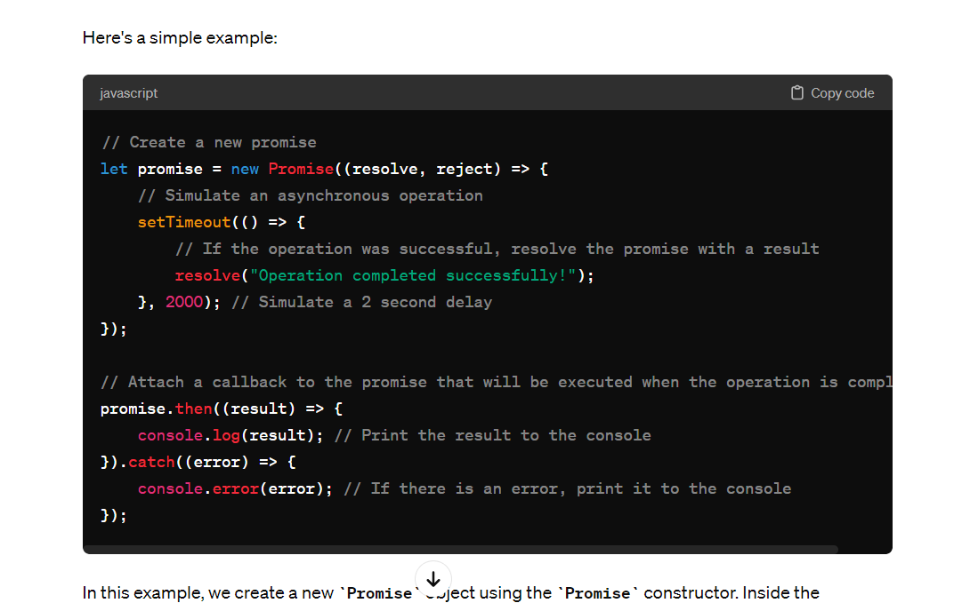

error handling : <https://www.freecodecamp.org/news/effective-error-handling-in-react-applications/#:~:text=Error%20Boundaries%3A,a%20fallback%20UI%20to%20users.&text=Wrap%20components%20that%20might%20throw,component%20to%20gracefully%20handle%20errors>.

.

## **Flatten array JavaScript recursion**

Simple example code when calling flatten recursively, you need to pass arr[i] to it and then concat the result with newArr.

Flatten nested arrays while preserving the order, e.g. [[1, 2], 3, [4, [[5]]]] should be converted to [1, 2, 3, 4, 5].

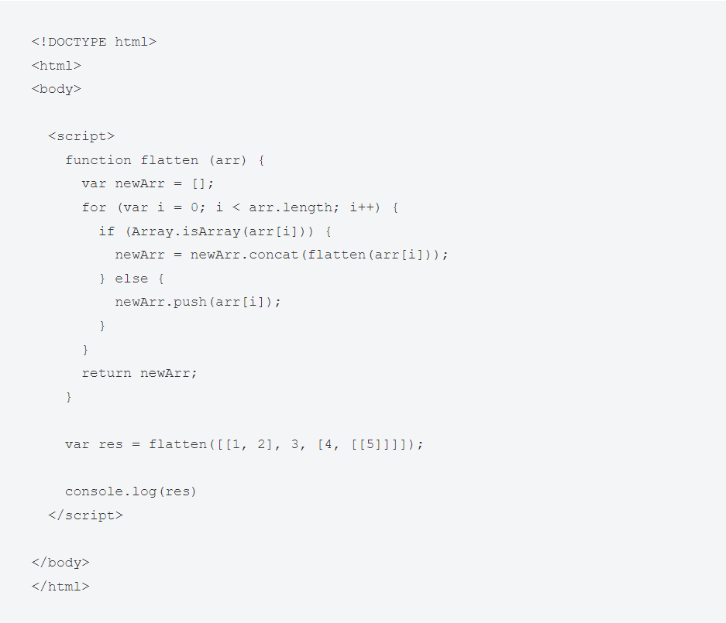

Remove duplicates from array

<https://builtin.com/software-engineering-perspectives/remove-duplicates-from-array-javascript>

controlled event and un controlled reactjs events

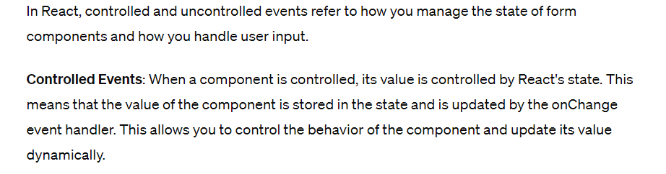

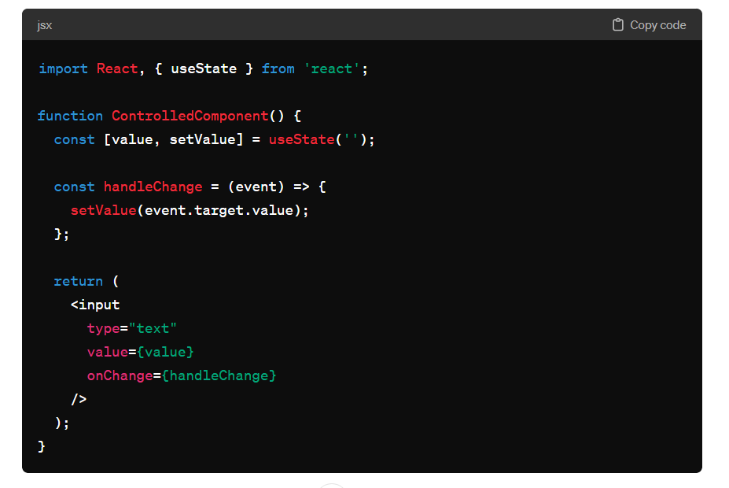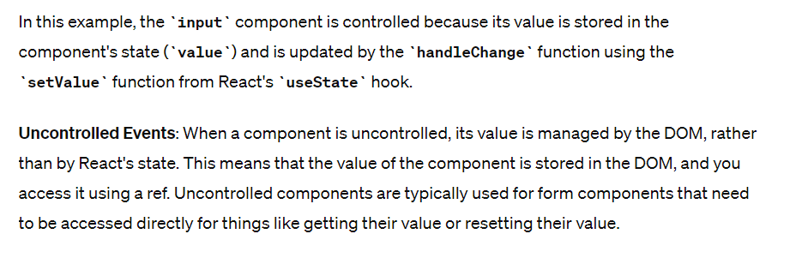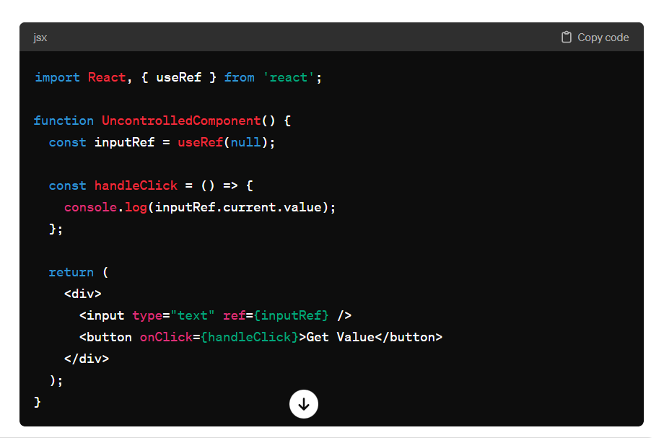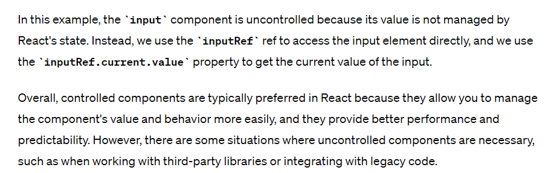

# Tricky Interview Questions

* Lifecyle of POM.xml

In a Java project using Maven, the **pom.xml** file plays a central role in defining project configuration, dependencies, and build settings. The lifecycle of the **pom.xml** file in a Maven project can be broken down into several stages, each representing a phase of the project's development and build process. Here's an overview of the lifecycle of the **pom.xml** file:

1. **Project Initialization**: When you create a new Maven project, you typically start by creating a **pom.xml** file. This file serves as the project's configuration file and contains information such as the project's group ID, artifact ID, version, and dependencies.
2. **Dependency Resolution**: Maven reads the **pom.xml** file to identify project dependencies. It then resolves these dependencies by downloading required libraries from remote repositories specified in the **pom.xml** file or configured in Maven settings.
3. **Project Build**: Maven uses the **pom.xml** file to execute the project build process. This includes compiling source code, running tests, packaging artifacts (e.g., JAR, WAR), and performing other build-related tasks specified in the **pom.xml** file.
4. **Plugin Execution**: Maven plugins defined in the **pom.xml** file are executed during various phases of the build lifecycle. Plugins can perform tasks such as code generation, resource processing, code quality checks, and deployment.
5. **Project Reporting**: Maven can generate project reports based on information collected during the build process. These reports, such as test reports, code coverage reports, and static analysis reports, provide insights into the project's health and quality.
6. **Project Deployment**: If configured, Maven can deploy project artifacts (e.g., JAR, WAR) to remote repositories or servers. Deployment settings are typically specified in the **distributionManagement** section of the **pom.xml** file.

Throughout these stages, the **pom.xml** file serves as the blueprint for Maven's behavior and dictates how the project is built, tested, and deployed. It's essential to maintain the **pom.xml** file accurately to ensure the project's dependencies and configuration remain consistent and up-to-

# JavaScript

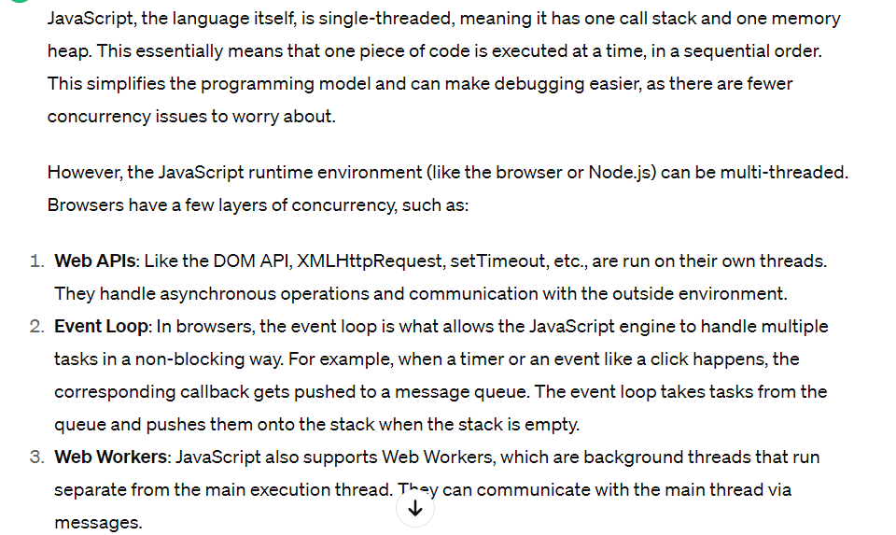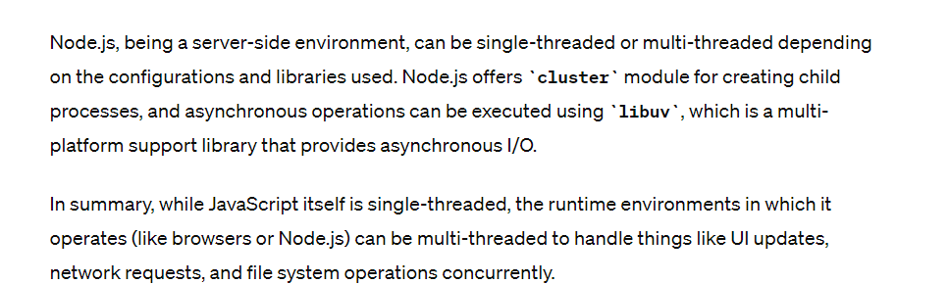

var a={},

b={key:'b'},

c={key:'c'};

a[b]=123;

a[c]=456;

console.log(a[b]);

## Clousers

